Snapshot Day 10/7/08 Data
(Salt Front RM 63.4)
RIVER MILE 28
Nyack Memorial Park
Tom Perry & Dinorah Hudson - Nyack High School APES Class & Earth Science – 60 students
Latitude 40°05.243’N, Longitude 73°54.988 ‘W
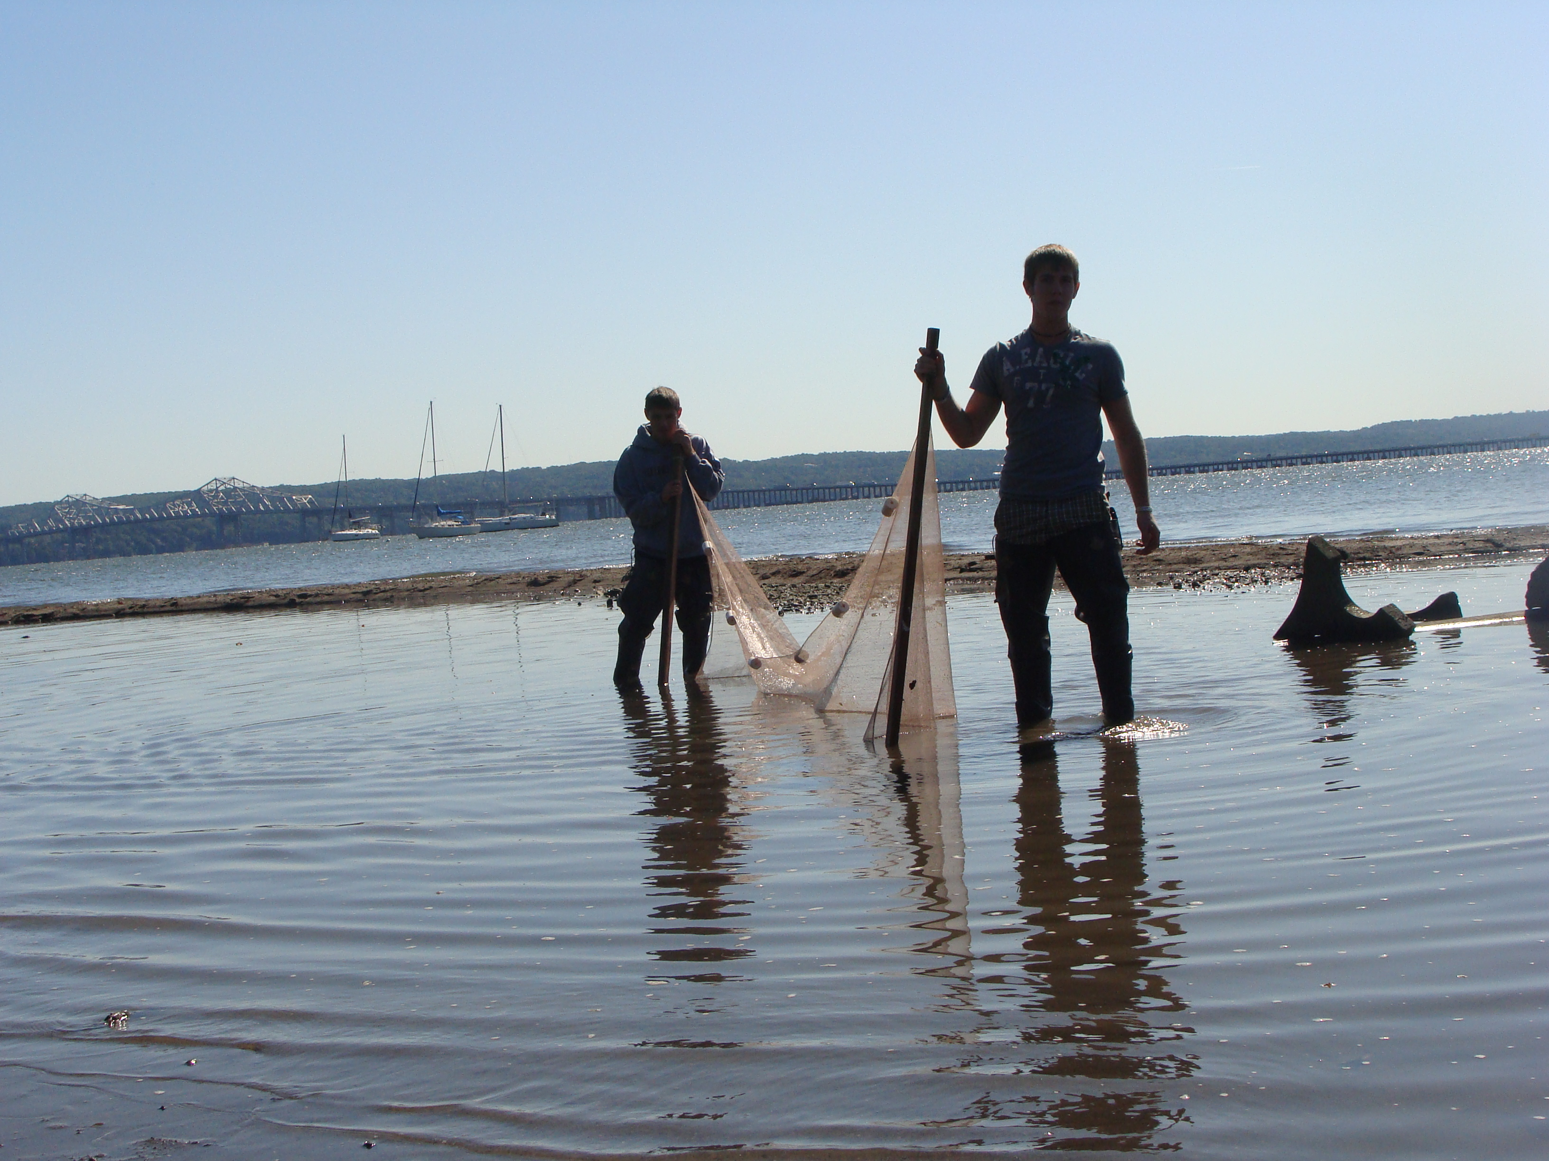
Location: Nyack Park where Nyack Brook feeds in
Area: Open and grassy, has a parking lot, used for picnics, fishing
Surrounding Land Use: 100% park
Sampling Site: beach, banks altered, riprap on shoreline, bulkhead
Plants in area: no water plants in area
Water depth: varied
River Bottom – sandy/muddy bottom , water calm
ITEM | Time |  | Reading 1 | Reading 2 | Comments
Physical
Air Temperature | 10:20 AM  1:15 PM |  | 19°C  21°C
Wind Speed
Cloud Cover | Clear
Weather today
Weather recently | Clear & warm
Chemical
Phosphate  10:30 AM |  | 0 mg/L
1:15 PM |  | 0 mg/L |  |  | .
Nitrate  10:30 AM |  | 0 mg/L
1:15 PM |  | 0 mg/L
Fish Catch  Seine 12X4 | Number Caught | Species |  | CPUE | Seine
Station #10 & 11 (near Hudson) | 27 | Atlantic Silversides |  | Menidia menidia
Station #7, 8, 9 | 30 | Banded Killifish |  | Fundulus Diaphanus
Station #10 | 1 | Blue-Claw Crabs |  | Callinectes Sapidus
Station #9 | 1 | Harris Crab
Sediment Cores  Station #10  Sandy Beach |  | Sandy, Pebbly Sediment
Tide | 10:20 | Low Tide |  | 1:15 PM | Rising Tide

Sketch Map of Sampling Site

1

2

3
4

Nyack Brook
5

6

7
8

9

10
11

Hudson River

Time: _______10:20 am___ Tide: ________Low_______

Station # | Distance (m) | Conductivity | Salinity (ppt) | Temperature (ºC) |  | D. Oxygen (mg/L)  Meter/probe |  | pH
 |  |  |  | Top | Bottom |  |  | pH
1 | 0 | 1400 | 0.3 | 14.4 |  | 6.9 | 7.9 | 8.2
2 | 20 | 1446 | 0.3 | 14.4 |  | 7.1 | 9.0 | 8.3
3 | 40 | 1436 | 0.7 | 14.2 |  | 6.9 | 8.9 | 8.2
4 | 60 | 1437 | 0.3 | 14.2 |  | 6.6 | 8.9 | 8.1
5 | 80 | 1485 | 0.7 | 14.3 |  | 6.3 | 8.4 | 8.1
6 | 100 | 1573 | 0.6 | 14.4 | 17.7 | 5.8 | 8.2 | 7.8
7 | 120 | 2140 | 0.7 | 16.4 | 19.8 | 5.6 | 8.0 | 7.8
8 | 140 | 1985 | ? | 19.3 | 20.6 | 6.8 | 7.7 | 7.9
9 | 160 | 2115 | 1.2 | 18.9 | 20.4 | 7.5 | 7.9 | 7.9
10 | 180 | 2156 | 0.5 | 16.4 | 16.6 |  | 8.1 | 7.9
11 | 190 | 2770 | 1.3 | 16.6 | 18.1 |  | 8.6 | 7.9

NOTE: Notice how conductivity was much higher at 1:15pm starting at station 6. This represents the saltier water of the rising tide. At stations 6,7 and 8, the bottom water is warmer than the surface water. Why doesn’t the warm water rise to the top? At 9,10 and 11, wave action has mixed the water more.
Data Table 2: Time ______1:15________ Tide _____Higher______

Station # | Distance (m) | Conductivity | Salinity (ppt) | Temperature (ºC) |  | D. Oxygen (mg/L)  Probe | pH
 |  |  |  | Top | Bottom | D. Oxygen (mg/L)  Probe | pH
1 | 0 | 1434 | 0.3 | 14.6 | 14.6 | 17.8 | 8.19
2 | 20 | 1438 | 0.7 | 14.5 | 14.5 | 18.0 | 8.26
3 | 40 | 1432 | 0.4 | 14.4 | 14.4 | 18.0 | 8.23
4 | 60 | 1435 | 0.3 | 14.5 | 14.4 | 17.9 | 8.16
5 | 80 | 1436 | 0.7 | 14.6 | 14.7 | 17.8 | 8.11
6 | 100 | 1700 | 0.8 | 13.7 | 14.7 | 17.6 | 8.01
7 | 120 | 2742 | 1.3 | 15.6 | 18.2 | 18.0 | 7.9
8 | 140 | 4278 | 1.0 | 19.9 | 21.0 | 18.2 | 8.09
9 | 160 | 4200 | 4.6 | 18.9 | 18.5 | 17.9 | 8.09
10 | 180 | 4218 | 4.6 | 19.6 | 18.3 | 17.9 | 8.12
11 | 190 | 4222 | 4.5 | 19.9 | 18.1 | 18.1 | 8.24

