Snapshot Day 10/8/09 Data
(Salt Front RM 60.3)
RIVER MILE 87
Eli Schloss & Esopus Meadows Environmental Center, Ulster Park, Ulster County
Donna Nageli, George Washington Elementary School – 4th grade – 41 students
 | 
Location: Esopus Meadows Preserve Town of Esopus. Ulster County
Area: A path along the beach with rising forested hills and yard with house and driveway
Surrounding Land Use: Forested 80%, Beach 20%
Sampling Site: Rocky shallow, sloping beach area covered with vegetation
Water depth: 2 ft.
River Bottom –rocky muddy weedy
Plants in area: Plants in less than half sample area - 100% are water chestnut

BLOW OUT TIDE AT EMEC
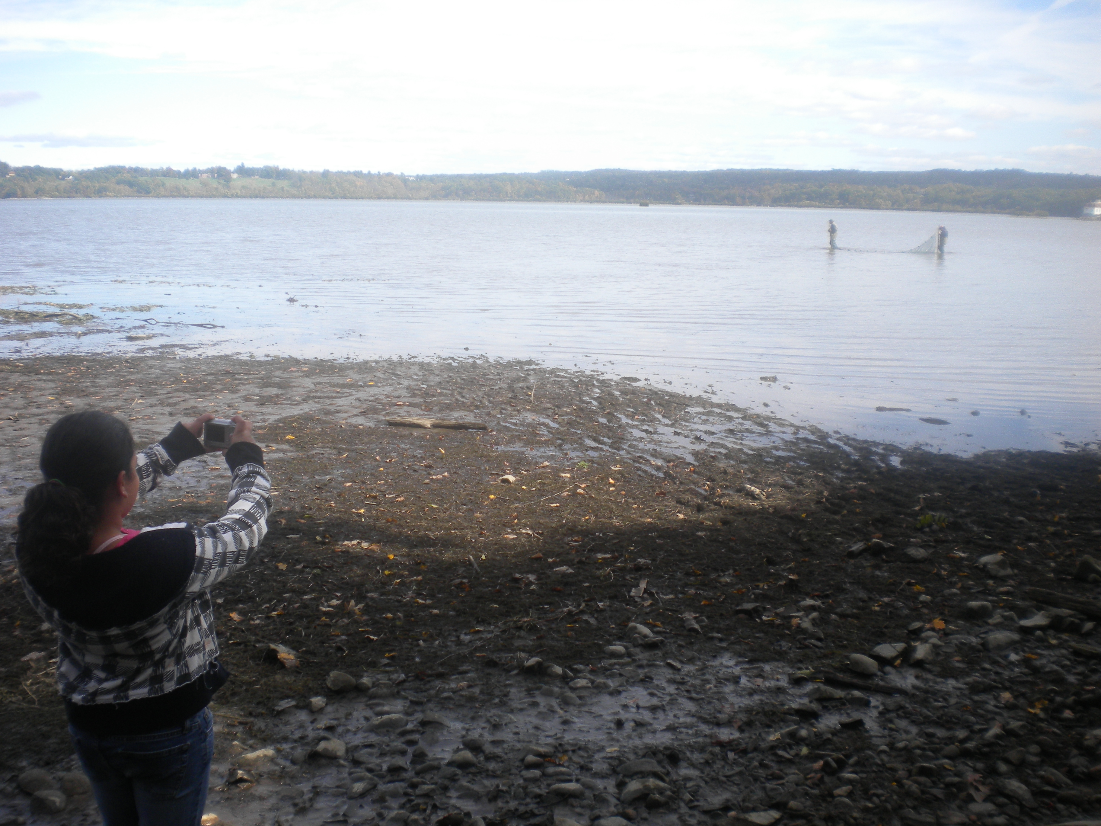
ITEM | Time |  | Reading 1 | Reading 2 | Comments
Physical
Air Temperature | 10:00 AM |  | 58°F  15°C | 12:20 PM | 62°F  20°C
Wind Speed | 3 Beaufort |  | 7-10 kts | North wind
Cloud Cover | Partly cloudy |  |  | Water Calm
Weather today | Bright and clear
Weather recently | Rain squalls yesterday
Water Temperature | 10:00 AM | 15°C  58 °F
 | 12:00 PM | 20°C  62 °F
Water calm | yes
Turbidity | 10:00 AM | 0 cm |  |  | Long Turbidity tube
Chlorophyll | 1:40 PM | .5
Chemical
DO  (drop count kit) | 10:00 AM | 8.0 mg/L |  | 15°C | 78%
pH | 12:20 PM | 7.5 |  |  | Indicator sol.
Salinity | 1:40 PM | 33 mg/L Cl |  | 41.25 ppm salinity
Fish Catch  25 ft.X 4 ft. X ¼ inch mesh - | Number Caught | Species |  | CPUE | Seine
50 ft pull  4 seines run | 14 | Banded killifish |  | 2.5 inch
 | 2 | Sunfish |  | 1.5 inch
 | 1 | Darter |  | 2 inch
 | 2 | Bullhead catfish |  | 3 inch
 | 1
Tides | 10:00 am | Falling
 | 10:20 am | Falling
 | 10:40 am | Falling
 | 11:05 AM | Rising
 | 11:25 AM | Rising
 | 12:00 PM | Rising
 | 1:00 PM | Rising
Currents
Traffic | 9:30 AM | Tug/Barge |  | Southbound | Light/rock
 | 11:30 AM | Tug/barge |  | Southbound | Light/oil
 | 12:00 PM | Cruise |  | Southbound | Loaded/leaf watchers
 | 12:30 PM | Cruise |  | Southbound | DK

