Snapshot Day 10/18/11 Data
(Salt Front RM 35.7)
RIVER MILE 61E
Riverfront Park, City of Beacon, Dutchess County
Susan Hereth, Scenic Hudson plus 2 Scenic Hudson Staff and SCA interns
Kelley Bender, Aaron Burke, Rebecca Ansen, Donna McGinley - South Ave. Elementary –
Terry Udell, J.V. Forrestal Elementary – 4th grade (25)
4th and 5th graders (71 students )
Latitude 41°50’ Longitude 73°98’
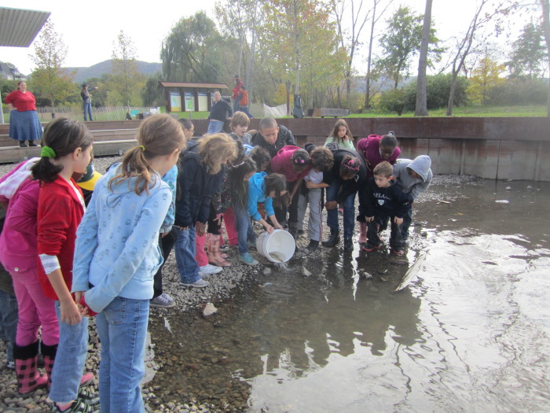
Location: Long Dock Park, Beacon, Dutchess County NY
Area: Long Dock Park - A former brownfield now public park used for fishing, launching kayaks, picnics, fieldtrips, enjoying scenic views of the Hudson River, Hudson Highlands and Hudson Valley. There is a kayak pavilion designed to withstand flooding, parking areas are not paved, a sculpture by George Trakas allows for interaction with the tides and provides a fishing pier, grassy areas and trails allow for interaction with nature and stunning views. Most of the shoreline on the south side is lined with trees.
Surrounding Land Use: Park 70%, Forested 15% shoreline, Shoreline 10%, recreational building 5%
Sampling Site: beach(sandy, small rocks), tree lined, riprap, sculpture bulkhead
Plants in water: no plants
Water depth: 6 inches
Bottom Surface: sandy, rocky bottom
Tidal Shallows Plants –
ITEM | Time |  | Reading 1 | Reading | Comments
Physical
Air Temperature | 10:00 AM  11AM  1:45 PM  2:25 PM |  | 18°C  14.4  16.6  23°C | 64.4°F  58°F  62°F  73.4
Wind Speed | 10 & 11 AM  1:45-2:23 PM |  | Beaufort (#2)  (#1) | S  SW
Cloud Cover | Mostly cloudy
Weather today | Dense fog 8:30-10:30 AM  Clear blue skies ~ 10:30 AM-noon  Cloud cover 100% after noon
Weather recently | Not really any different than today
water calm | calm
Water Temperature | Time | Test one
 | 10:50am | 17°C
 | 11:15am | 15°C
 | 11:40AM | 17°C
 | Noon | 16°C
Turbidity
Secchi disk in inches | Noon | 13 inches |  | 2:00 PM |  | 13 inch
Short site tube | 11:25 AM | 60 JTU |  | Noon |  | 80 JTU
Chlorophyll
Chemical | Kit 1 |  |  | Kit 2
DO  (drop kit) | 9:00 AM  10:50  1:50 PM | 7 ppm  9  9 |  | 11:00 AM  12:05 |  | 12 ppm  14 ppm
pH –  color match(Hach) | 10:50AM  11:30  Noon  1:55 PM | 7.5  7.1  8  8
Salinity –
Fish Catch  seine 30 feet | Number Caught | Species |  | CPUE |  | MACROs
10 AM | 52 | Herring |  | 3 inch
3 sweeps of net | 1 | Golden Shiner |  | 2 inch
10:30 AM | 30 | Herring |  | 3 inch
 | 3 | Golden Shiner |  | 3 inch
 | 1 | Striped Bass |  | 5 inch
12:45 PM | 4 | Herring |  | 2 inch
 | 6 | Spottail Shiner |  | 4 inch
 | 1 | Menhaden |  | 3 inch
TOTALS – 98 fish | 86 Herring | 4 Golden Shiner |  | 1 Striped Bass |  | 6 Spottail Shiner | 1 Menhaden
Tides | 10:00AM | Falling tide
 | 11:50AM | Rising
 | 1:50 PM | Rising
 | 2:20 PM | Rising
Currents | 10:15AM | Ebb
 | 10:50PM | Ebb
 | 11:50AM | Flood
 | 1:50 PM | Flood
 | 2:25 PM | Flood
Shipping | 12:30AM | Buchanan & barge |  | South |  | 3 flat barges pushed by a tug
Observation: Migrating monarchs throughout the day
On the southern side of the site, 7 cormorants offshore during the low tide drying off while standing on exposed pier posts
2 inch water scorpion in the first seine of the day

