Day in the Life of the Hudson River 1010/13 Data
(Salt Front RM 69.3)
RIVER MILE 145
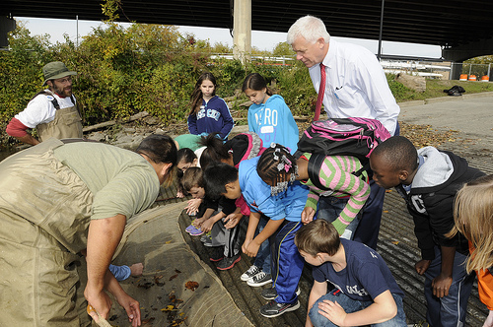
Karen Strong, Sean Madden NYDEC HREP, Corning Preserve, Albany Boat Basin, Albany (and DEC Commissioner Martens)
Natalie Aiello, Montessori Magnet School, 4th grade, 42 students
Latitude 43 Longitude 74
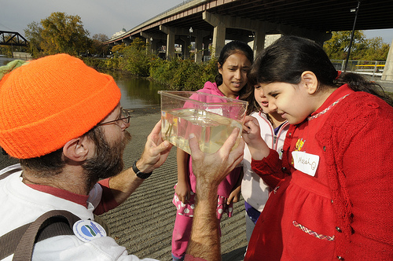
Location: Floating dock at riverfront park
Area: A path along the beach with rising forested hills, trees along both sides, plants along shore
Surrounding Land Use: 70% Industrail/commercial; 25% Urban/Residential, 5% Park
Sampling Site: vegetation, banks altered, shoreline with raprap – floating dock
Plants: no plants in water
River Bottom: muddy

ITEM | Time |  | Reading 1 | Reading 2 | Comments
Physical
Air Temperature | 9:43 AM |  | ° C  60° F | 12:15 PM | ° C  61° F
Wind Speed | 9:43 AM |  | Beaufort #1 | 2-2.5 mph | North
Cloud Cover | Partly foggy |  | overcast
Weather today | Overcast no rain
Weather recently | Heavy rain and wind Monday 10/7
Water calm | calm
Water Temperature | 10:55 AM | 18.3°C  65 ° F
 | 12:20 PM | 16.7°C  62 ° F
 | 12:38 PM | 17 °C  62.6° F
 | 1:00 PM | 17 °C  62.6 ° F
Turbidity – long site tube | 10:17 AM | 57 cm  79 cm  61 cm |  |  | Average 65.6 cm
Chemical
DO  (meter) | 10:55 AM | 10 mg/L |  | 17°C | 100%
 | 1:15 PM | 10 cm/L |  | 18°C | 105%
pH – indicator solution | 10:37 PM | 7.5
Salinity - quantab | 10:50 PM | 30 ppm Cl- |  | 54 Total Salinity
Fish Catch  Seine 20 ft. X 3 ft i | Number Caught | Species |  | Length | Seine
3 seines | 7 | Spottail Siner |  | 6.5 cm | Diversity 2
9:45AM-12:23PM | 4 | Banded Killifish |  | 5.5 cm | Total Catch =11
Tides | N/R
Currents – | Time | # Cm in X sec |  | cm/sec | N/S -  Ebb/Flood/Still
 | 10:00 AM | 25 ft./37 secs |  | 0.01 kts | South - Ebb
 | 10:05 AM | 25 ft./16.3 secs |  | 0.03 kts | South - Ebb
 | 10:08 AM | 25 ft/19 secs |  | 0.02 kts | South - Ebb
 | 12:30 PM | 25 ft/20.28 secs |  | 0.02 kts | South - Ebb
 | 1:15 PM | 25 ft./32.9 secs |  | 0.01 kts | South – Ebb
Shipping | 10:00 AM | Tugboat |  | Margot | South/ Loaded
 | 1:00 PM | Tugboat |  |  | North/ Loaded
 | 1:00 PM | Cruise |  |  | South

