Day in the Life of the Hudson River 10/10/13 Data
(Salt Front RM 69.3)
RIVER MILE 18
Vicki Garufi - Sarah Lawrence College Center for the Urban River @ Beczak
Alethea Lynch, Fox Meadow Elementary School
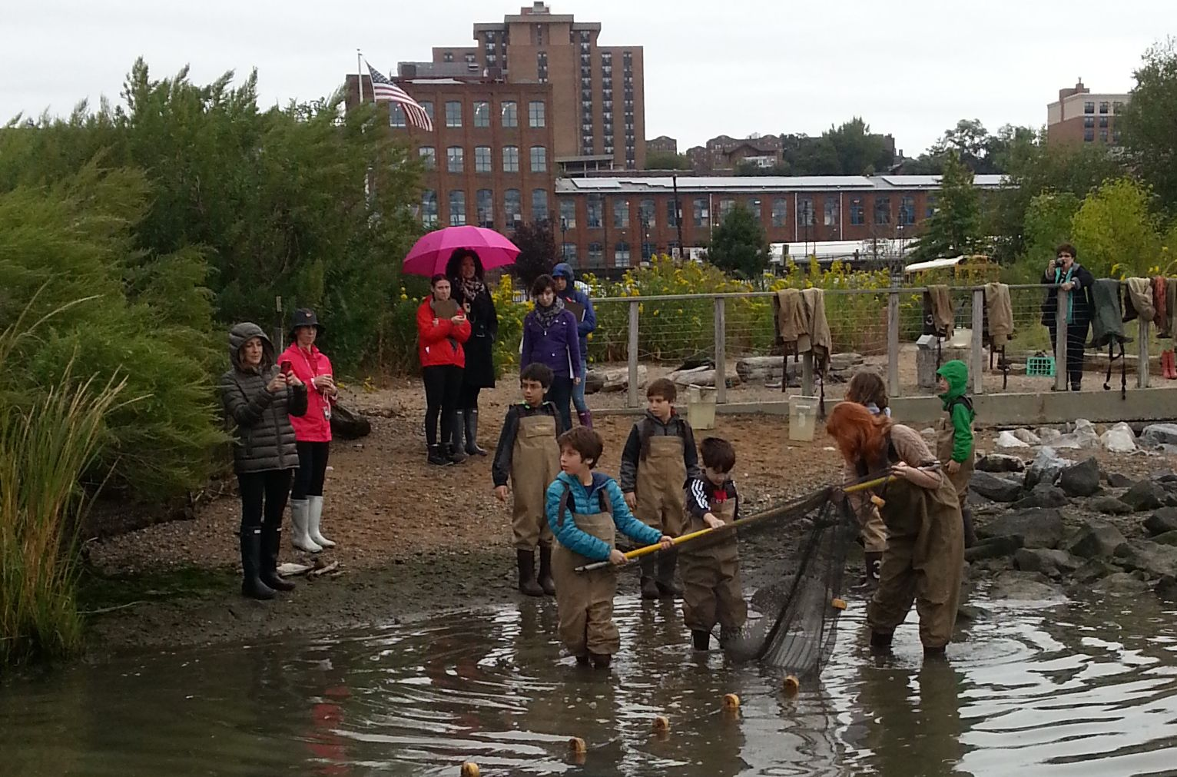
22 students 3rd graders, 4 adults
Sarah Lawrence College Art of Teaching graduate student helpers 20
Latitude – N 40.93813129121615 Latitude – W -73.90288889408111
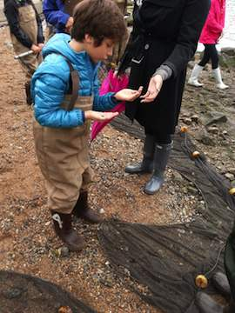 | 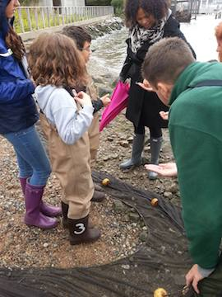
Location: Habirshaw County Park, Seining beach, SLCC@ Beczak, Yonkers, Westchester County
Area: 2 acre riverfront county park covered mostly by a grass lawn leading down to the river where it meets a tidal wetland and sandy beach. Property used for fishing, boats, seining, field trips and education programs - 60% grassy, 20% parking lot, 20% shore
Surrounding Land Use: urban/residential, beach uses
Sampling Site shoreline: sandy beach, tidal marsh area covered with vegetation, banks altered, large riprap on shoreline, collected wood/debris in area,
Plants in area: no plants in the water
Water depth – 3-4 feet
River Bottom – muddy (sticky
ITEM | Time |  | Reading 1 | Reading 2 | Comments
Physical
Air Temperature | 10:00 AM – |  | 14°C  60°F
 | 11:00 AM – |  | 16°C  60°F
Wind Speed | Beaufort #2 |  | 4-6 kts | 6-11 km/hr | NW
Weather today | Overcast and very little drizzle for one rotation but it passed
Weather recently | Rain Monday, last 2 days warmer than today
Water calm | Small wavelets, leaves rustle
Water Temperature – | 10:08 AM | 19°C  60°F
 | 10:36 AM | 20°C  65 °F
 | 11:05 AM | 20°C  65 °F
 | 11:35 AM ft. | 21°C  66°F
Turbidity – sight tube – | 10:26 AM  10:53 AM  11:19 AM  11:50 AM | 33 cm  27.5 cm  25 cm  31 cm
Chlorophyll | 10:30 AM | 0.4
 | 11:00 AM | 0.7
 | 11:23 AM | 1.0
Chemical – collected on the bridge by marsh | Time | Temp |  | DO | Saturated
DO – test tabs | 11:00 AM | 20°C |  | 5 mg/L | 50%
pH – litmus paper | 10:30AM | 6  6.5  7 |  |  | Average 6.5
Salinity – hydrometer | 10:30 AM – | 12 ppt  12 ppt  14 ppt |  |  | Average 13 ppt
Fish Catch | Number Caught | Species |  | Size of largest | Notes
Seine net 30 feet X 4 ft., 1.4 inch mesh | 40 | Atlantic Silverside
10:00 - noon | 1 | Banded Killifish
 | 2 | Blue Crab
 | 5 | Moon Jellies
 | 2 | Comb Jellies
Tides | 10:00 AM |  |  | rising
 | 10:30 AM |  |  | rising
 | 11:00 AM |  |  | rising
 | 1130 AM |  |  | rising
Currents
 | 10:00 AM. | North |  | flood
 | 10:30 AM | North |  | flood
 | 11:00 AM | North |  | flood
 | 11:30AM | North |  | flood
 | 12:00 PM | North |  | flood
Core Sample | Entire Length | Grain Size |  | Abiotic | Biotic
 | 2 layers in core | Mix of grain sizes |  | Rocks  Sand  Branch  Crab shell | Small mud crab  worms
Other Items | Monarch butterfly flew across sample area at 11:35 AM, Clam found in marsh sediment, Rat swam across marsh to beach! Canadian geese flying around park, Mallard ducks swim around marsh.

