Day in the Life of the Hudson River 10/10/13 Data
(Salt Front RM 69.3)
RIVER MILE 2.5
Hudson River Park’s Pier #45
Shino Tanikawa- New York City Soil & Water Conservation District
PS 3 Manhattan 2nd & 3rd – 60 students
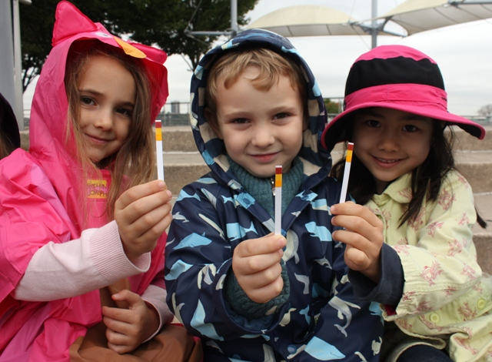
Location: Christopher Street Pier at the END of the pier where the “gazebo” is
Area: Pier, Banks altered – bulkhead – mainly metal and wooden pier
Surrounding Land Use: 100% Hudson River Park with walkway, some planted areas
Sampling Site: Recreational pier
Plants in area: None
ITEM | Time | Reading 1 | Reading 2 | Comments
Physical
Air Temperature | 9:30 AM  10:40 AM  12:45 PM | 14°C  14  16.6
Water Temperature | 9:30 AM  10:40 AM  12:45 PM | 16°C  14  19.4
Chemical
DO  (chemets ampules) | 9:30 AM  10:40 AM  12:45 PM | 6 mg/L  6  6
pH (ColorHast pH strip) | 9:30 AM  10:40 AM  12:45 PM | 7  7  7.3 |  | 7.1
Salinity (hydrometer) | Temp | Sp. Grav | salinity
 | 9:30 AM  10:40 AM  12:45 PM | 1.016  1.016  1.015 | 20.9 ppt  20.4  21.8

