Day in the Life of the Hudson River 10/10/13 Data
(Salt Front RM 69.3)
RIVER MILE 23
Kinnally Cove & MacEachron Waterfront Park, Hastings-on-Hudson
Melissa Shandroff, Hastings High School APES 11th-12th grade, 70 students, 4 adults
Latitude 40°59’52”N, Longitude 73°53.03”W
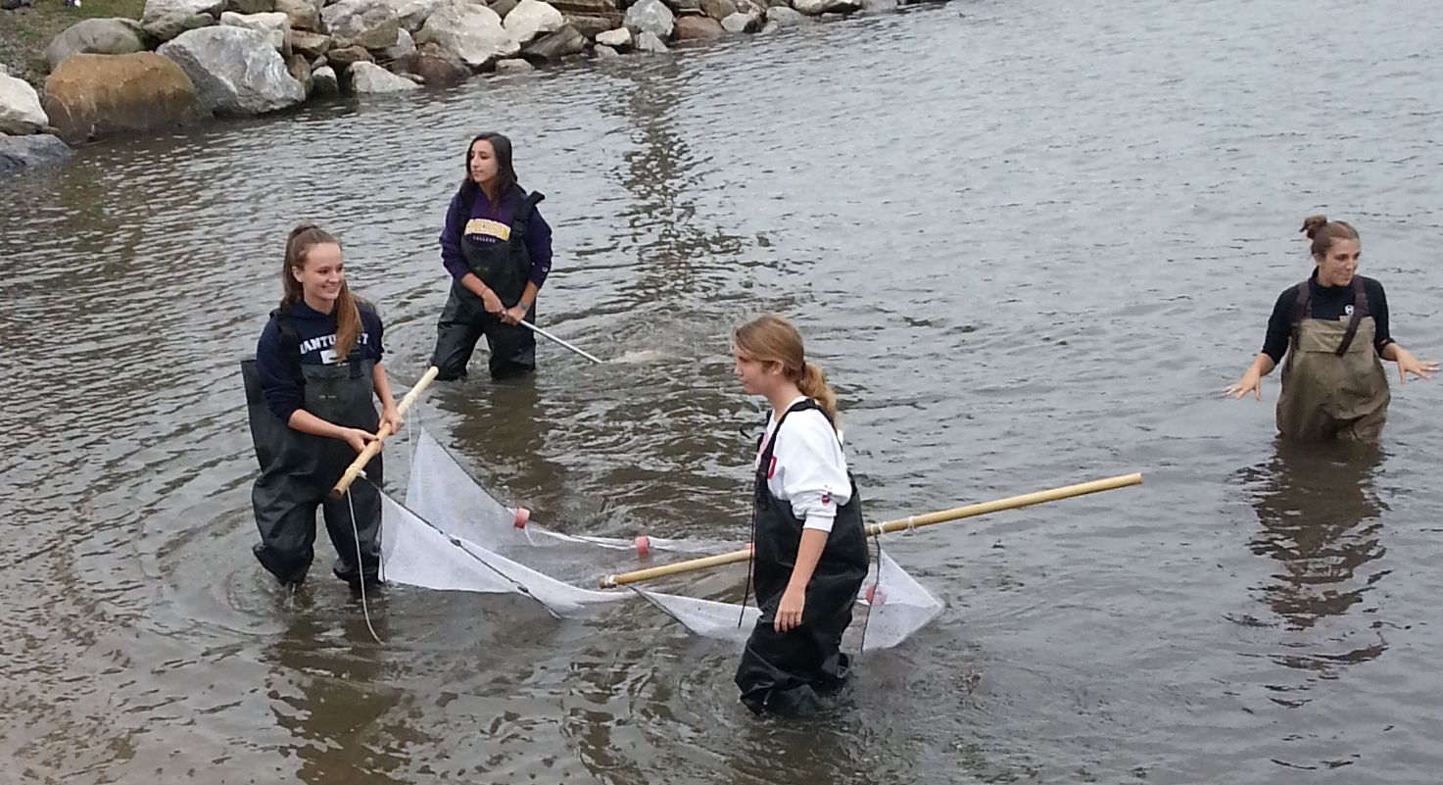
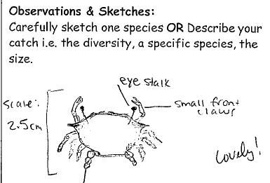
Location: Kinnally Cove, Hastings-on-Hudson, Westchester County
Area: Beach area with riprap shoreline, next to the park – used both spaces. Beach is totally covered during high tide.
Surrounding Land Use: 50% industrial/commercial (next to old Anaconda site) but mainly parking lot now, 15 % forested, 10% grassy, 25% beach
Sampling Site: beach, banks altered, riprap on shoreline, bulkhead
Plants in area: grass and weeds
Water depth:
River Bottom – sandy/rocky bottom

ITEM | Time |  | Reading 1 | Reading 2 | Comments
Physical
Air Temperature | 1:55 PM |  | 62.8 °F  17.12°C
Wind Speed | 1:58 PM Beaufort 2 |  | 7.2 kts | 28 °N
Cloud Cover | Overcast all day >75%
Weather today | 2:14 PM overcast and cool
Weather recently | Has been sunny and warm over the last 2 days
Water Surface
Turbididty – long site tube | 1:22 PM | 35.0 cm  40.0cm |  |  | Average 37.5 cm
 | 1:12 PM | 30 cm  30 cm |  |  | Average 30 cm
Chlorophyll | 1:45 PM | 0.4
Water temperature | 12:35 PM | 66.2 °F  69.8 °F |  | 19°C  21°C | Avg: 68°F  20°C
Very cloudy and hardly any sun | 1:14 PM | 66.2°F  67.1°F |  | 19°C  19.5°C | 66.65F  19.25°C
 | 1:50 PM | 64.4°F  65.3°F |  | 18°C  18.5°C | 64.85°F  18.25°C
Chemistry
pH - - 1:50 PM  3 methods | Strips  Kit- Wide  Pen | 6  6  7.6 |  | 6  7 | Average 6.5
DO | 1:18 PM | 10 ppm |  | 19.25°C | 106% saturation
 | 1:35 PM | 8 ppm |  | 16 | 80%
 | 2:08 PM | 8 ppm |  | 18.25 | 85%
Salinity - | 1:00 PM | Hydrometer  Refractometer |  | 11 ppt  12 ppt
Nitrate – LaMotte Kits | 2:03 PM | 2 ppm  2 ppm
Phosphate | 2:18 PM | 1.5 ppm  1 ppm
Fish Catch  Seine 9 ft. (20 ft. pull) Dip net, minnow trap | Number Caught -  Sadly no fish caught | Species |  | Macro-invertebrates
 | PM |  |  | Scud  Cranefly  2 Bluecrabs
 | 1:24 PM |  |  | Scud  Truefly  1 Bluecrab M
Sediment Cores | Length/ description | Abundant |  | Common | Rare
 | 12.8 cm  no layers  oil look | Sand |  | Gravel | Pebble
Tide | 1:20 PM |  |  | 90 cm
 | 1:35 PM | Falling |  | 89 cm | 0/067 cm/min
Currents
Time | Cm/60 secs | Cm/sec |  | Knots | N/S Ebb/Flood Still
1:28 PM | 450 cm/30 sec | 15 cm/sec |  | 0.292 knots | Flood
Shipping | 2:10 PM | Couldn't see name |  | White | North - light
Observations | A lot of rocks here seemed that they were placed rather than naturally occurring.  Students noted that the tides and weather will affect the amount of fish in the net  Saw seagulls!

