Day in the Life of the Hudson River 10/10/13 Data
(Salt Front RM 69.3)
RIVER MILE 30.5
Kingsland Point Park
Chris Adamo & Leana Peltier, Sleepy Hollow High School
100 students 11th & 12th graders, 3 adults
41°09N and 73°86W
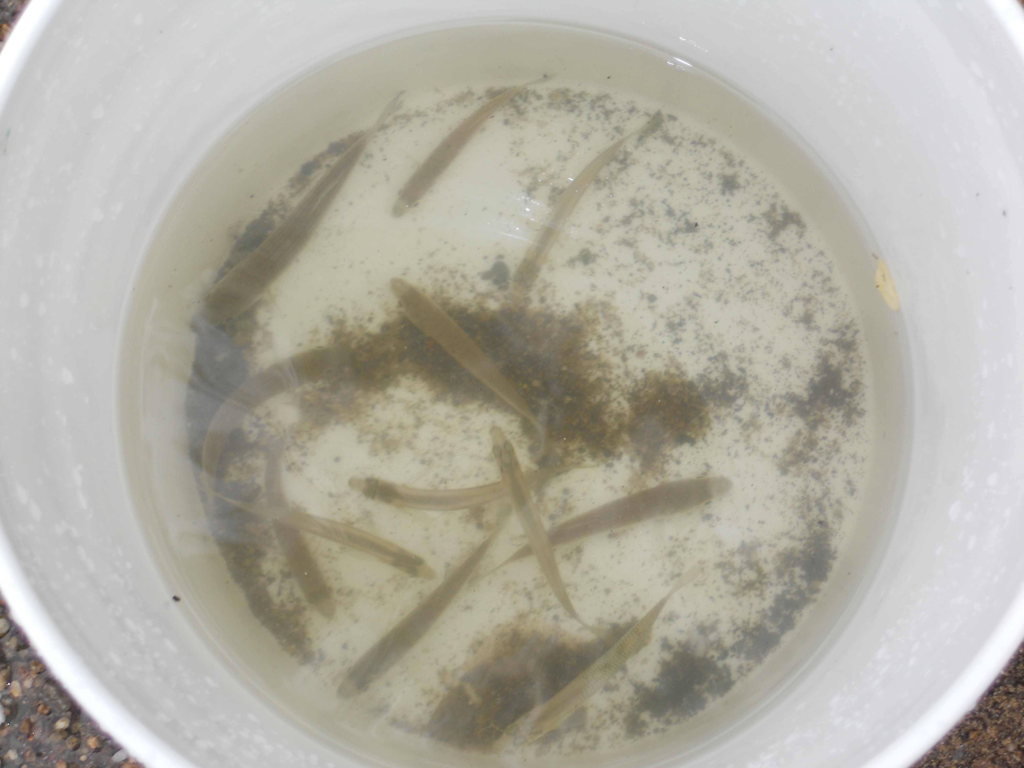
Location: Kingsland Point Park, Sleepy Hollow, Westchester
Area: Waterfront beach area on front of park
Surrounding Land Use: Parkland with open fields surrounded by trees 75%, Beach 25%
Sampling Site: Beach, shoreline riprap (rocks), concrete bulkhead
Plants in water: no
Plants in area: plants and poison ivy
Water depth: 1-3 meters
River Bottom – sandy, muddy

ITEM | Time |  | Reading 1 |  |  | Comments
Physical
Air Temperature | 10:00 AM |  | 14°C  16  15 | 51.2 °F  60.8  59 |  | Average: 15°C  57 °F
 | 10:30 AM |  | 18°C  20  19 | 64.4 °F  68  66.2 |  | Average:  18.6  66.2
 | 11:00 AM |  | 18°C  20  19 | 64.4 °F  68  66.2 |  | Average:  18.6  66.2
Wind Speed | Beaufort # |  | Mph | Direction
 |  |  | 1.8 | West
Cloud Cover | Mostly cloudy
Weather today | Rain off and on
Weather recently
Water surface | choppy
Water Temperature | 10:00 AM | 68°F  20°C
 | 10:40 AM | 67°F  19°C
 | 10:45 AM | 68°F  20°C
Turbidity - secchi | 10:23 AM | 20 cm  20 cm
Seining – 20 ft. X 4 ft. X 20 ft. pull | Total | Species |  |  | Length
Total Fish 16 | 1 | Winter Flounder |  |  | 3 inches
Total Fish Diversity 5 | 7 | Striped Bass |  |  | 4 inches
 | 5 | Atlantic Silversides |  |  | 4 inches
 | 1 | Killifish |  |  | 3 inches
 | 2 | Unknown |  |  | 3 inches
Macroinvertebrate | 1 | Blue crab |  |  | juvenile
Chlorophyll
Chemical
DO -  Other –green kit | 10:30 AM | 17°C  16°C |  |  | 2 ppm
pH – litmus paper | 11:03 AM | 6  7  7 |  |  |  | 6.7
Salinity – refractometer | 10:30 AM | 10 ppt T.S.
Nitrates – green kit | 11:31 AM | 5 ppm  5 ppm  5 ppm
Phosphates | 10:16 AM | 1.5 ppm  1.5 ppm  1.0 ppm |  |  | 1.33 ppm Average
Tides* | Time | Tide Stick
 | 10:04AM | 14 cm
 | 10:30AM | 20 cm |  |  | Rising
 | 10:45AM | 21 cm |  |  | Rising
Currents
Traffic

