Day in the Life of the Hudson River 10/10/13 Data
(Salt Front RM 69.3)
RIVER MILE 57
Donahue Memorial Park, Cornwall Landing, Village of Cornwall-On-Hudson, Town of Cornwall, Orange County, NY
Christopher O’Sullivan, NYSOPRHP Trailside Museums & Zoo
Tom Lake, NYSDEC
Deborah Gilson, Christine Cleeves, Caryn Mante, Karen Corby - Willow Ave. Elementary - 4th grade – 72 - students
GPS Latitude 41°26’36”N Longitude 74°0’1”W
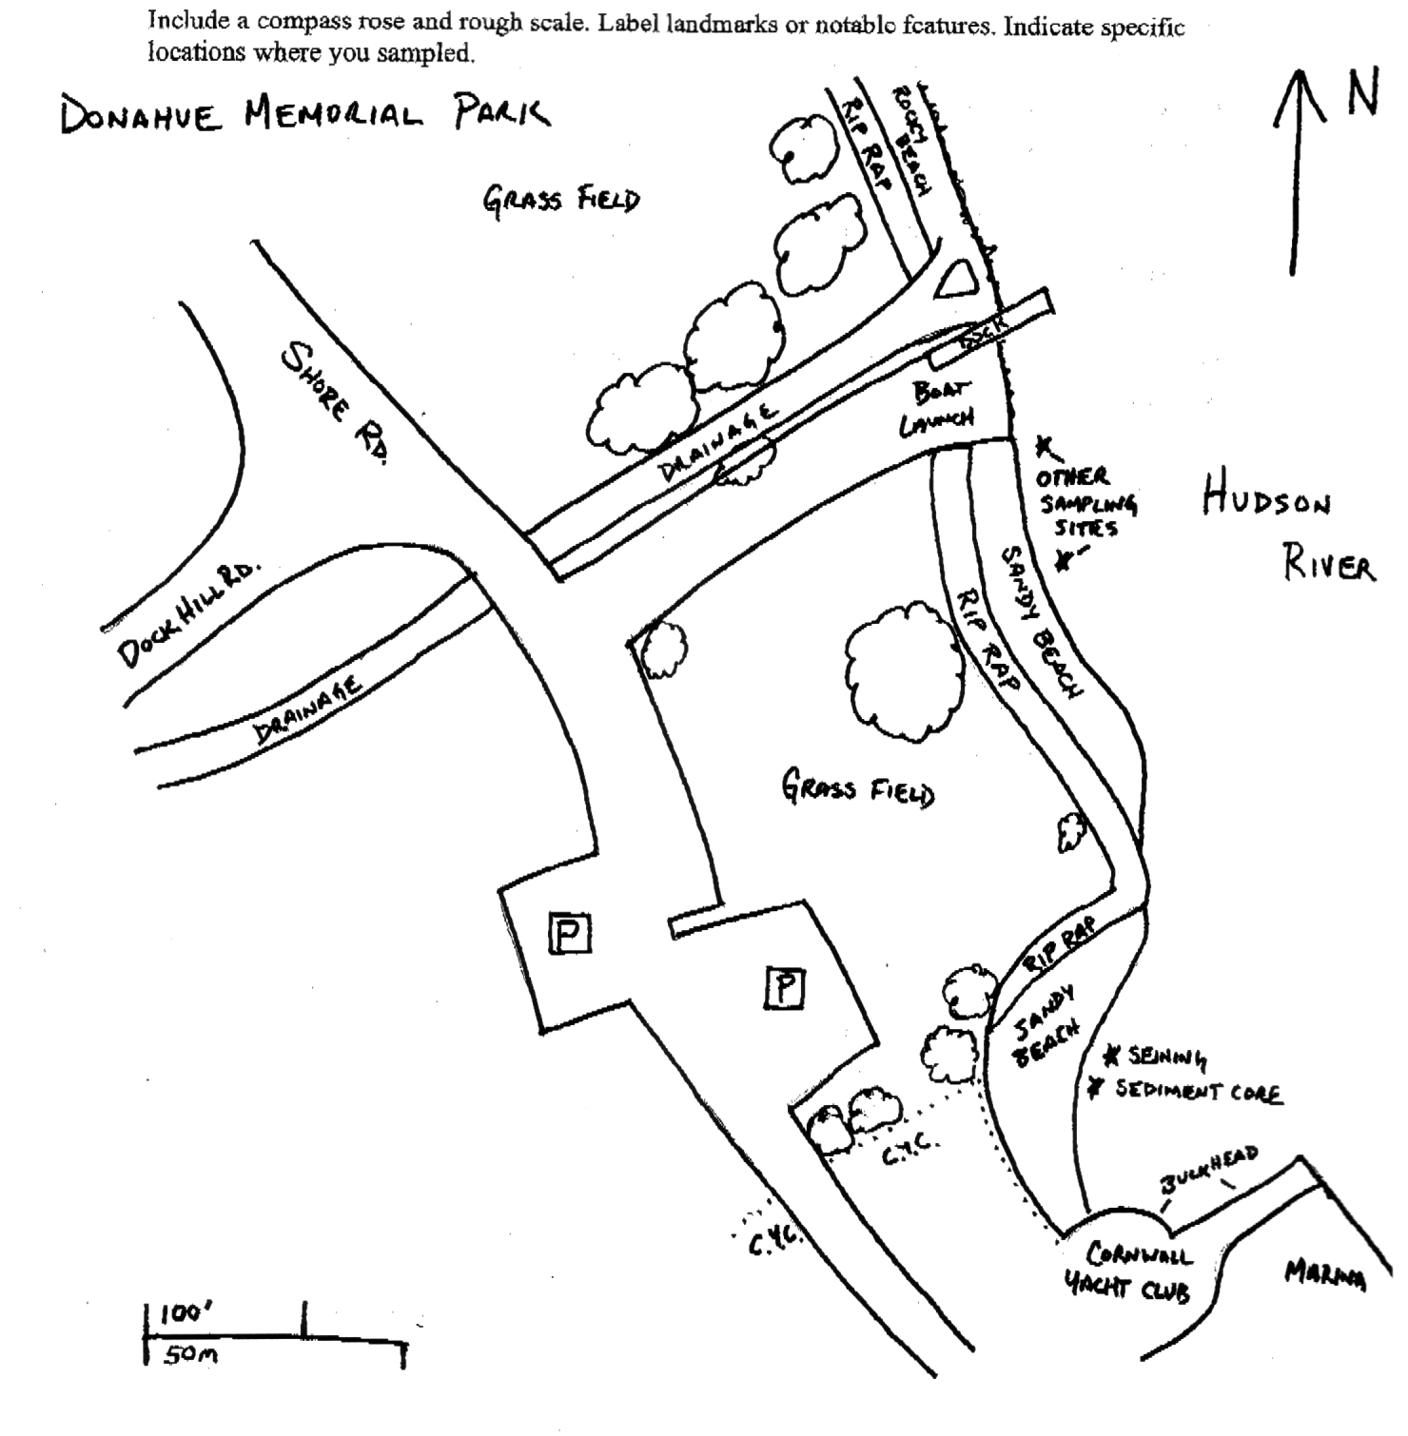
Location: Donahue Memorial Park
Area: Sandy beach used for seining & sediment core, 2nd beach are for other sampling.
Surrounding Land Use: 100% open and grassy park
Sampling Site: pier, sandy beach, altered banks, shoreline riprap, bulkhead, collected wood & debris in area,
Plants in area:
Water depth:
River Bottom – muddy, rocky

ITEM | Time |  | Reading 1 | Reading 2 | Comments
Physical
Air Temperature | NR
Wind Speed | 9:30 AM |  | #2 Beaufort
Cloud Cover | cloudy
Weather today | Cloudy and overcast- Mostly cloudy (51-75%)
Weather recently | A lot of rain the last few days
Water Temperature | 11:12 AM  11:20 AM (students) | 16°C  16°C |  | 11:30 AM (Tom Lake) |  |  | 18.8°C  66°F
Water Surface | Choppy
Turbidity  Long sight tube | 11:00 AM | 40 cm  42 |  |  |  | Average 41 cm
Chlorophyll | 11:00 AM | 0.0
Chemical
DO
Drop count kit
pH (indicator sol.) | 11:18 AM | 7.5  7.0 |  | Average 7.25
Salinity -  (Tom Lake meter) | 1l:30 AM | Salinity 2.5 ppt
Fish Catch  80 ft. seine X 4 ft. with bag – ¼ inch mesh - | Number Caught | Species |  | Size |  | Comment
11:30 AM | 2 | Spottail Shiner |  | 55-60 mm
 | 6 | White Perch |  | 116-153mm
 | 2 (yearling) | American Shad |  | 110-111mm
 | 1 | Redbreast Sunfish |  | 115mm
Total Catch | 11 | Diversity |  | 4
Tides | TIME | RISING/  FALLING |  | HEIGHT IN CM |  | RATE OF CHANGE
 | 10:00 AM |  |  | 0 cm
 | 10:30 am | Still |  | 0 cm
Currents | 10:30 AM |  |  |  |  | Ebb
Boat | 10:07 AM | Boat |  | White |  | South - light
Other Observations | * Flock (35-40) Brant in low flyover | * Immature Bald Eagle over beach

