Day in the Life of the Hudson River 10/10/13 Data
(Salt Front RM 69.3)
RIVER MILE 58a
Plum Point/Kowawese, New Windsor, Orange County, NY
Rebecca Foster-Faith, Bishop Dunn MS
28, 7th grade students, 6 adults
GPS Latitude 41°27’47.67”N Longitude 74°0'42.88"W
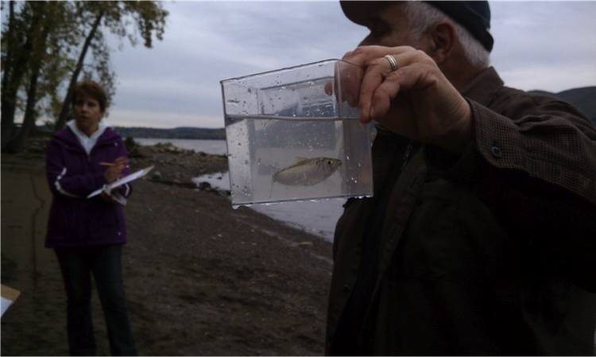
Location: Sandy beach at Kowawese, New Windsor, Orange County, Public Shore,
Area: Sandy beach bordered by forested area and parking lot. Used for picnic, fishing, kayaking
Surrounding Land Use: Forested 80%, Beach 20%,
Sampling Site: sandy beach (cove), rip rap in area of sampling site, debris in the area such as broken concrete, docking
Plants in area: 1% of area has plants
River Bottom – sandy, weedy, rocky
ITEM | Time |  | Reading 1 | Reading 2 | Comments
Physical
Air Temperature | 10:30 Am |  | 13°C  55°F
Wind Speed | Beaufort #2 |  | 3 mph | NE
Cloud Cover | overcast |  |  | light drizzle < 1”
Weather today | Minor drizzle
Weather recently | Raining Monday, slightly warmer
Water Surface | choppy
Water Temperature | 9:55 AM | 6 °C  °F
 | 10:48 AM | 17 °C
 | 10:30 AM Tom Lake | 18.3°C  65°F
 | 12:12 PM | 18 °C
 | 1:05 PM | 10 °C
Water Surface | Choppy
Turbidity  Secchi disk | 9:53 AM | 20 cm |  |  |  | Average of 3 18.3 cm
 | 10:46 AM | 15 cm
 | 12:35 PM | 20 cm
Chlorophyll | 10:00 AM | 0.1 color chart |  | 10:55 AM |  | 0.1
 | 12:10 PM | 0.2 |  | 1:00 PM |  | 0.1
Chemical
DO | TIME | Temp |  | DO |  | % Sat
Averaged data |  | 12.75 °C |  | 16.75* |  | *seems too high
pH – litmus paper | 9:36 AM  10:36 AM  12:22 PM  12:47 PM | 6.0  6.0  7.0  7.0 |  |  |  | Average 6.5
Salinity – Tom Lake reading | 9:30 AM |  |  |  |  | 2.50 ppt
Test strips | 9:42 AM  10:45 AM  12:32 PM |  |  | 642 ppm Cl-  all 3 times |  | 1160 mg/L TS
Fish Catch  30 ft. ‘ with ¼ inch mesh – circle pull | Species | Count |  | Size of largest |  | Totals
10:30 AM-11:45 AM | Spottail Shiner | 1 |  | 75 mm |  | DIVERSITY - 3
4 seines | Striped Bass | 1 |  | 60 mm (yoy) |  | TOTALS - 5
 | American Shad | 3 |  | 110-113 mm (yearling)
CPUE- | Seine 1 | 1 fish |  | 30 ft. pull |  | 0.003
 | Seine 2 | 0 |  | 30 ft. |  | 0
 | Seine 3 | 3 |  | 30 ft. |  | 0.01
 | Seine 4 | 0 |  | 30 ft. |  | 0
 | Seine 5 | 1 |  | 30 ft. |  | 0.003
Tides | Time | Height in cm |  | Rate of change |  | Rising/falling
 | 9:38 AM | 15 cm
 | 10:55 AM | 10 cm |  | Falling
 | 11:52 AM | 17.5 cm |  | Rising
 | 12:15 PM | 27.5 cm |  | Rising
 | 12:45 PM | 35 cm |  | Rising
 | 1:06 PM | 45 cm |  | Rising
Currents | Cm/30 sec | Cm/sec |  | Kts |  | N/S & E/F/S
9:50 AM | 317.5 | 10.6 |  | 0.21 |  | N Flood
10:40 AM | 142 | 4.75 |  | 0.09 |  | N Flood
12:05 PM | 200 | 6.7 |  | 0.13 |  | N Flood
12:55 PM | 245 | 82 |  | 0.16 |  | N Flood
Core – not work | TIME | Description |  | Common |  | Rare

