Day in the Life of the Hudson 10/10/13 Data
(Salt Front RM 69.3)
RIVER MILE 60 – Dennings Point
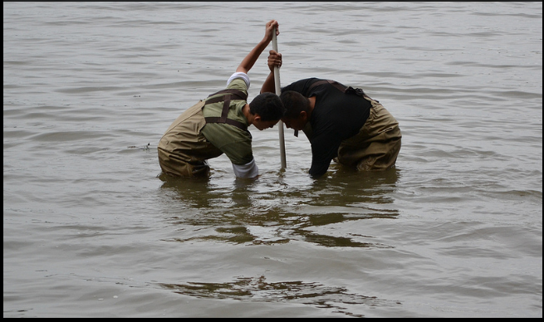
Sean Dickinson, Chad Cianfrani, Miriam Straus, Oakwood Friends School,
6th-9th grade, 40 students, 4 adults
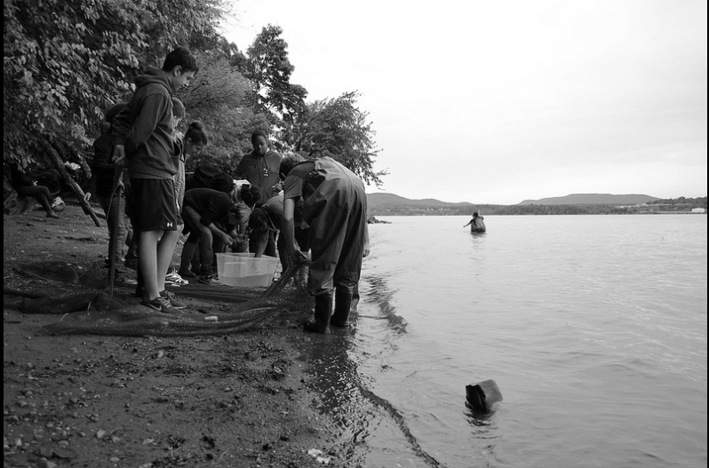 | 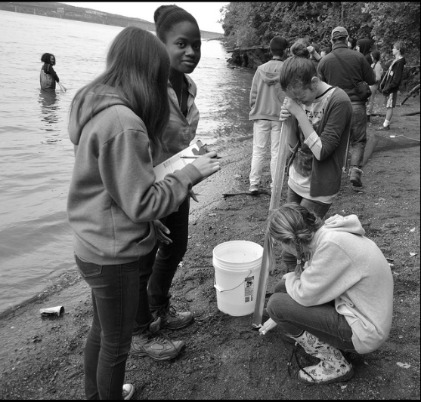

Location: Dennings Point, Beacon, Dutchess County
Area: Beach with large piping entering river. Believe area mostly used for sightseeing and fishing. Found a homemade crab trap on the beach!
Surrounding Land Use: Nature preserve with few buildings, 60% forested; 30% beach; 10% buildings
Sampling Site: Beach, covered with vegetation, rocky & sandy
Testing: 9:00-12:30 PM

ITEM | Time |  | Reading 1 | Reading 2 | Comments
Physical
Air Temperature
Wind Speed
Cloud Cover
Weather today
Weather recently
Water Temperature
Water Surface
Turbidity – long site tube | AM | 24 cm
Chlorophyll
Chemical
DO  (drop count kit) | AM | 7 mg/L
pH | AM | 7.5
Salinity - quantab | AM | 7.8 |  | 603 ppm Cl- | 1085 ppm T.S.
Fish Catch | Number Caught | Species |  | Length | Seine
 | 20 | Bay Anchovy
 | 4 | White Perch
 | 3 | Herring
 | 9 | Shiner
Total Catch | 36 | Diversity |  | 4
Macros | 1 | Crab

