Day in the Life of the Hudson River 10/10/13 Data
(Salt Front RM 69.3)
RIVER MILE 76W
Bob Shepard Highland Landing Park, Highland, Dutchess County
Kevin Rizzo, Highland, 31 students, 8th grade Living Environment
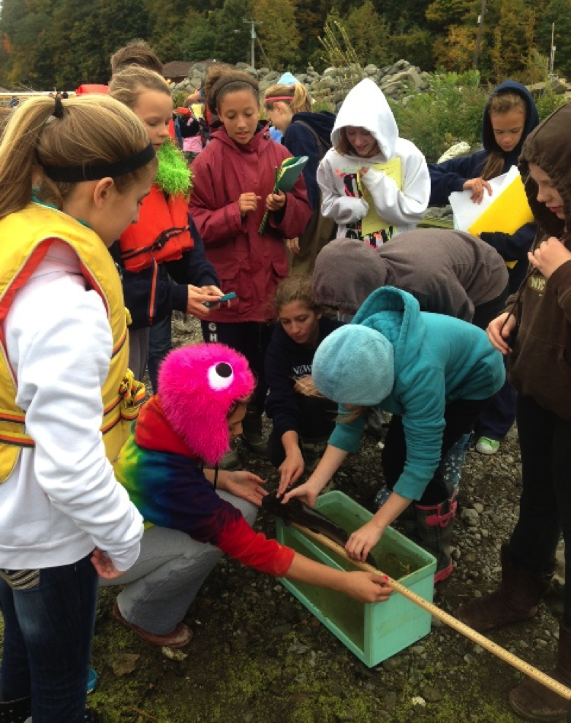 | 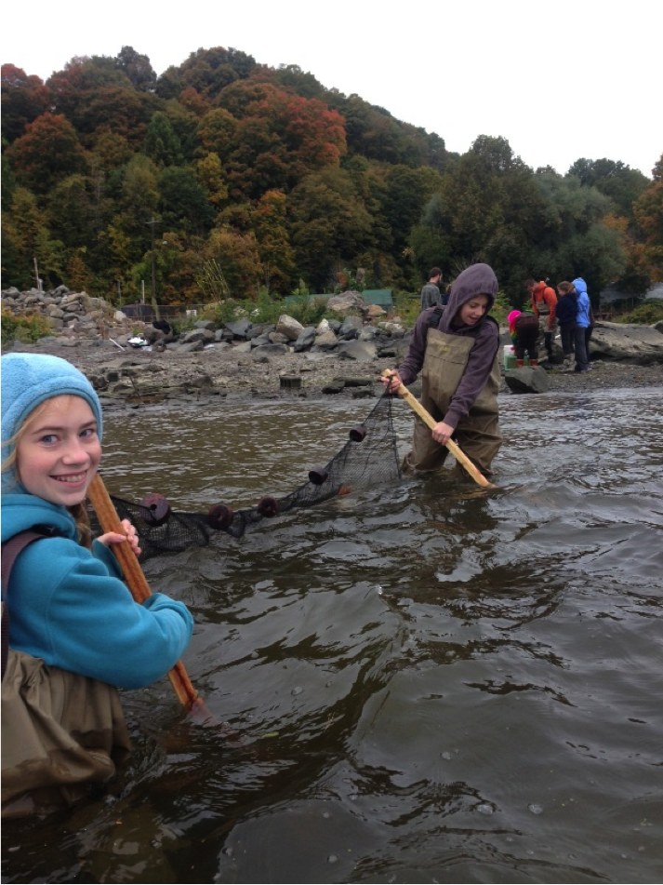

Location: Bob Shepard Highland Landing Park, Highland, New York.
Area: New park, pier, grassy, parking lot. Park used for fishing, boating
Surrounding Land Use: 10 % urban/residential; 90% park area with grass and waterfront docks
Sampling Site: shoreline is riprap, banks altered, concrete bulkhead, wood bulkhead, banks altered
Plants in area: 10% water chestnut, 30% cattails, 20% dotted smartweed, 40 % purple loosestrife
Water depth: pretty shallow
River Bottom –muddy, rocky
ITEM | Time |  | Farenheit | Celcius | Comments
Physical
Air Temperature | 10:45 AM  11:00 AM  11:15 AM |  | 51°F  51  53 | 12°C  12  13
Wind Speed | 11:15AM |  |  | Meter 5 mph |  | North
Cloud Cover | 11:15 AM |  | overcast >75%
Weather today | 11:00 AM some rain
Weather last 3 days | Rained hard one day. A little warmer than normal
Water Temp.  1 ft. H2O depth in shade, covered with plants | 9:50 AM | 56.7°F |  | 13.7°C |  | Measured twice same results
Turbidity – long site tube | 9:48 AM | 58 cm  28 cm
Chemical
DO - meter | 10:08 AM  11:19 AM | 9.2 ppm  7.8 ppm |  | 16°C  17°C |  | 90%  80%
pH – color match | 9:30 AM | 7.3  6.9  7.2  avg. 7.1 |  | 10:40 AM |  | 7.5  7.0  7.2  avg. 7.2
Salinity - | 10:19 AM |  |  | 113 ppm Cl- |  | 204 ppm total salinity
Phosphate | 9:50 AM | 0.2 ppm
Nitrate | 9:50 AM | 0.3 ppm
Fish Catch – 10feet net | Number Caught | Species |  | Largest
11:00 AM | 1 | Catfish |  | 45 cm |  | Diversity 2  Total Catch 2
 | 1 | Bluegill Sunfish |  | 5.1 cm
Tides | 10:42 AM  10:57 AM  11:12 AM | 0  -23 cm  -24.5 cm |  | Overall drop  24.5 cm |  | Ebbing (falling)
Currents | 11:25 AM | EBBING
Ship Traffic | 10:42 AM | Recreational |  | White & Black |  | Northbound/light
Observations | Living (Biotic): Geese and gulls,  Non Living (Abiotic): rocks, shells, glass and plastic

