Day in the Life of the Hudson River 10/4/13 Data
(Salt Front RM 69.3)
RIVER MILE 78
Quiet Cove, Poughkeepsie
Carolyn Klocker and Neil Curry from Cornell Cooperative Extension of Duchess County, plus 4 youth employees from Poughkeepsie HS as part of NCLI
Robert Adams & and another DEC Fisheries Staff
Skip Hoover, G. W. Krieger Elementary School (27) 4th & (26) 5th grade students,
41.44°N and 73.56°W
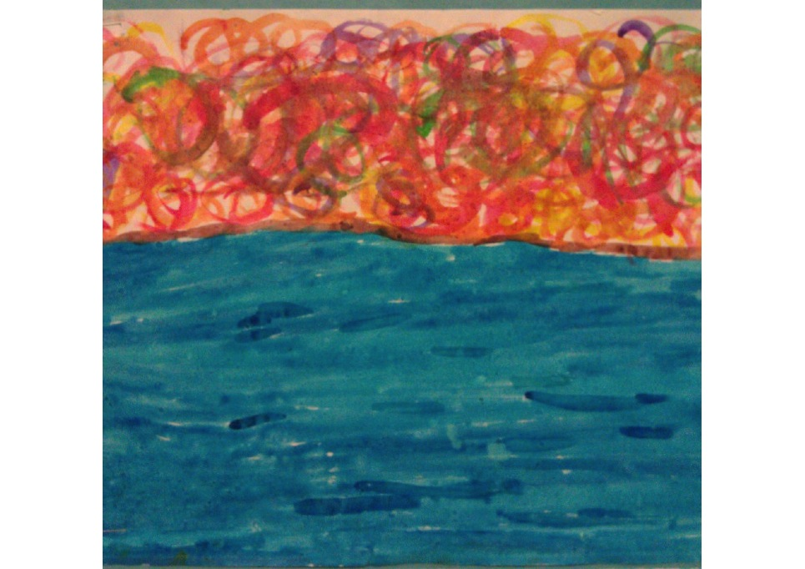
Inspiration from Quiet Cove Waters
Location: Quiet Cove, Poughkeepsie, Dutchess County
Area: Grassy area with parking lot, beach like waterfront
Surrounding Land Use: Picnics, boating and fishing – 60% is beach with rip rap banks, 40% previous industrial site
Sampling Site: An old industrial area that has been turned into a park. Used by people for picnics, fishing. Shoreline rocky, banks altered with rip rap and wooden bulkhead, boat launch for kayaks and canoes
Plants in area: none visible
Debris in area: remnants of industrial site and some papers in the water
Water depth: 160 cm in the area with concrete embankments
River Bottom – muddy in beach area
ITEM | Time |  | Reading 1 |  | Wind Speed | Precipitation & Clouds
Physical
Air Temperature | 10:14 AM |  | 56°F  °C |  | 1-3 mph N | heavy cloud cover
 | 10:38 AM |  | 56°F  °C |  | 4-6 mph N | heavy cloud cover
 | 11:34AM |  | 54°F  °C |  | 7-10 mph N | heavy cloud cover
 | 1:01 PM |  | 56°F  °C |  | 7-10 mph N | heavy cloud cover
Wind Speed
Cloud Cover | cloudy
Weather today | Cool and cloudy
Weather recently | Mostly sunny temps in the high 60s
Water Description
Water Temperature | 1:15 PM | 17°C
Turbidity – long site tube | 10:00AM  10:30 AM  11:00 AM  12:30 PM | 30 cm  31 cm  34 cm  24 cm |  | 32 cm  34 cm  23 cm |  | 30 cm Avg  31.5 cm Avg  34 cm Avg  23.5 cm Avg
Chlorophyll
Chemical | TIME | DO (LaMotte elementary kit tablets) |  | Temp |  | %Saturation
 | 9:51 AM | <4 ppm |  | 16 °C |  | 37% saturated
 | 10:30 AM | <4 ppm |  | 16 °C |  | 37% saturated
 | 11:10 AM | <2 ppm |  | 16 °C |  | 12% saturated
 | 12:35 PM | <4 ppm |  | 22 °C |  | 37% saturated
(LaMotte kit color match ) | Time | PH |  | NITRATES |  | PHOSPHATES
 | 9:30 AM | 8 |  | <5 ppm |  | <1 ppm
 | 10:25 AM | 8 |  | <5 ppm |  | 2 ppm
 | 11:05 AM | 8 |  | <5 ppm |  | 2 ppm
 | 11:40 AM | 7.5 |  | <5 ppm |  | <2 ppm
Salinity
Fish Catch- 25 ft. – 3 pulls | Number Caught | Species |  | Length of largest |  | Seine - beach seine
9:30-11:00 AM | 2 | Banded Killi |  | 5 cm
 | 1 | Spottail Shiner
Total seine count | 3 | Total diversity - 2

Tides – | Time | Top of water to top of pier | water depth | Rising/Falling
 | 10:00 AM | 79 cm | 215 cm
 | 10:36 AM | 35 cm | 185 cm | falling
 | 11:21 AM | 45 cm | 185 cm | falling
 | 12:44 AM | 40 cm | 198 cm | Nearly unchanged
Currents | TIME | Time over 15 meters | Cm/sec | Direction
 | 10:00 AM | 52 secs | 3.47 cm/sec | Ebb
 | 10:36 AM | 47 secs | 3.13 cm/sec | Ebb
 | 11:21 AM | 67 secs | 4.46 cm/sec | Ebb
 | 12:44 AM | 143 secs | 9.53 cm/sec | Flood
Traffic | 9:55 AM | Sailboat |  | Southbound
 | 10:44 AM | Speedboat |  | Northbound
Sediment Core – student descriptions | The mud was fun to play with. It smells like clay dough and smells like iron, |  | The mud feels squishy with little rocks. It smelled like mold. | .

