Snapshot Day 10/10/13 Data
Mohawk River Valley
SCHOHARIE RIVER SITE RIVER MILE
Middleburgh, NY
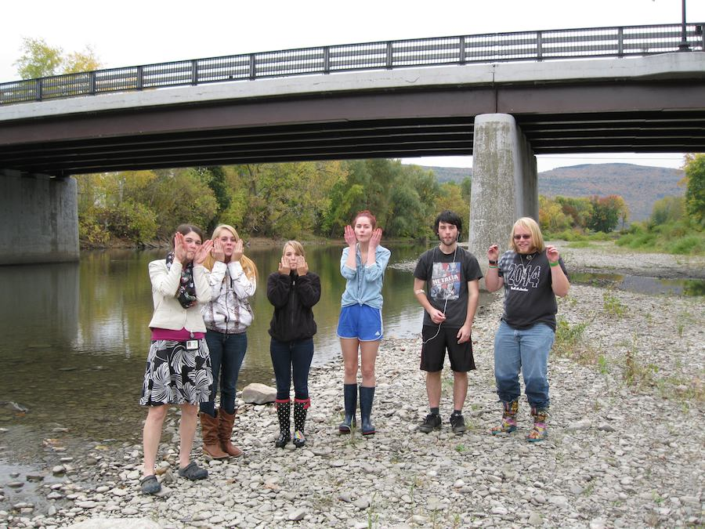
Mollie Burgett, Middleburgh High School & 5 students 12th grade
42.599156 Lat and -74.337029 Long
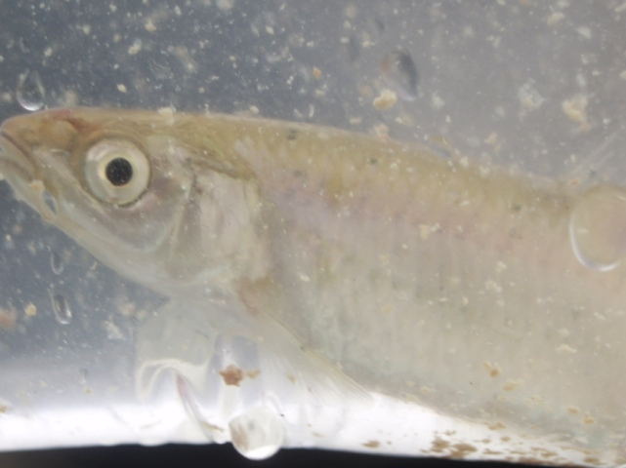 | 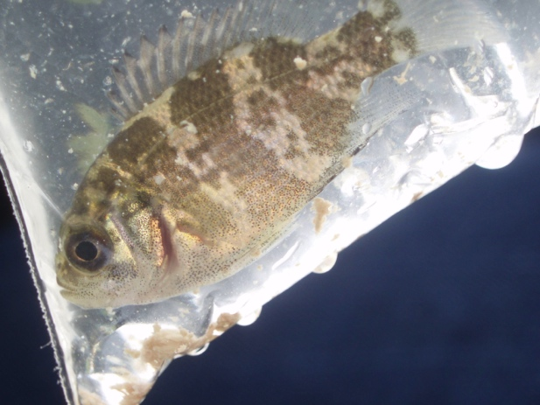
Redside Dace | Rockbass

Location: On the Schoharie Creek by the Bridge Into Middleburgh
Sample location runs right along river street (one of the main streets in the village) and is
full of cobbles, some grasses and short shrubs under 4 feet tall. The trees along the bank on one side make a break between the road and the creek and the other side divide the creek from farm fields.
Surrounding Land Use: 50% residential, 50% farmland
Shoreline: Riprap, Concrete blocking, stormdrain of some sort occasionally discharges in to the creek just down from the sample site. Lots of cobbles in stream channel.
Storm Drains: Several were flowing into the water when we were sampling
River Bottom: Rocky and covered in cobbles
Water Depth: 50 cm
Plants in water: No but a thin film of algae

ITEM | Time |  | Reading 1 | Reading 2 | Comments
Physical
Air Temperature | 1:15 PM |  | 59°F  15°C
Wind Speed |  |  | Beaufort #1 | SW
Cloud Cover | 100% overcast
Weather today | No rain, cool
Weather recently | Rain yesterday
Water Surface | Water calm (where not bubbling over rapids or in riffles)
Water Temperature | 1:00 PM | 13°C |  | 55.4°F | Riffle area
 | 1:03 PM | 11°C |  | 51.8°F | Slow deeper area
Turbidity  Site tube | 1:00 PM | 60 cm  60  51 |  |  | Average 57 cm
Chlorophyll | 1:15 PM | 0.1
Chemical
DO – titration kit  riffle section | 1:00 PM | 13°C |  | 9.1 mg/L | 85%
Slow deep section | 1:03 PM | 11°C |  | 15.8 mg/L | 140%
pH –* used widerange pH paper – one student did test w/o consultation | 1:10 PM | 5  5  5 |  |  | Average 5*
Flow Rate (not current) | 1:00 PM | 895 cm/30 sec |  | 29.8 cm/sec | 0.579 kts
 | 1:03 PM | 940 cm/30 sec |  | 31.5 cm/sec | 0.612 kts
 | 1:10 PM | 805 cm/30 sec |  | 26.8 cm/sec | 0.512 kts
Fish –4 ft. net – 2 tries X 10 meters- caught 4 fish & 3 crayfish | 3  1 | Redside dace  Rockbass |  | ~3 inch  2-2.5 inch | DIVERSITY 2  TOTAL 4
 | 4 | Crayish |  | (one rusty crayfish - invasive)
Macroinvertebrates from DEC WAVE kick-net sampling | Number | Species
 | 3 | Perlidae |  | Stonefly
 | 1 | Helgramite |  | Cranefly
 | 4 | Ephemerellidae |  | Mayfly
 | 30 small ones | Heptageniidae |  | Mayfly
 | 200 | Isonychiidae |  | Mayfly
 | 2 | fishfly
 | 3 | Caddisfly
 | 1 | Water penny
 | 1 | Riffle Beatle

