Day in the Life of the Hudson River 10/16/14 Data 9AM-2PM
(Salt Front RM 65.9)
RIVER MILE 98
Bard College Site, South Tivoli Bay (in/around the Bard Field Station between the mouth of the Sawkill Creek and Blithewood Manor)
Debbie Beam, Red Hook High School 11th/12th grade IB Biology
Tom O’Dowd, Bard College – Environmental and Urban Studies (EUS) students
45 students and 2 adults

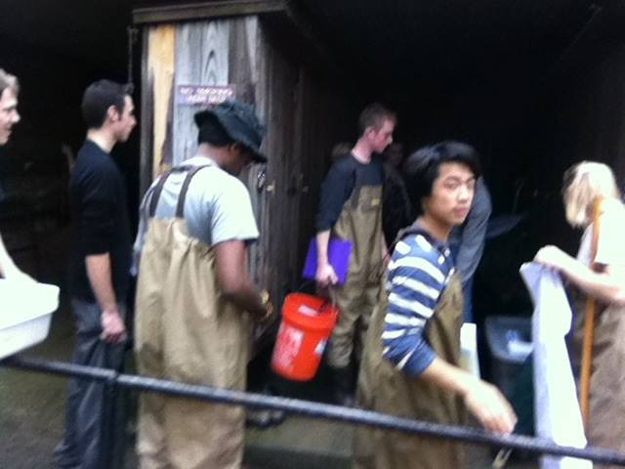
Above: RHHS and Bard students prep to sample fish & Macro-invertebrates (prep at Field Station; seine and sample at the mouth of the Sawkill Creek)
Below: A little song/dance to get us started in the morning (in front of Blithwood Mansion)
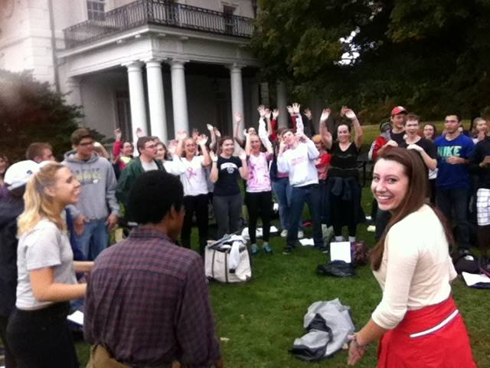
Photos on this page by Tom O’Dowd.

Observing Surroundings
- Photos of student artwork and students observing their surroundings.
(photos by Bard student Anna Linden)
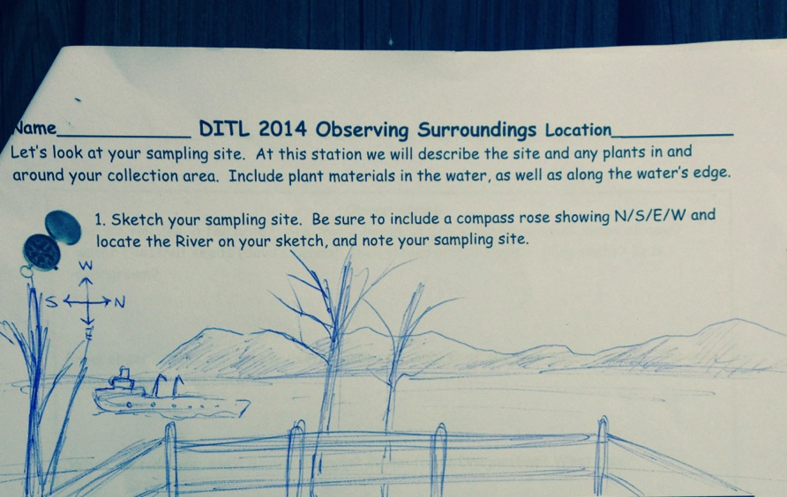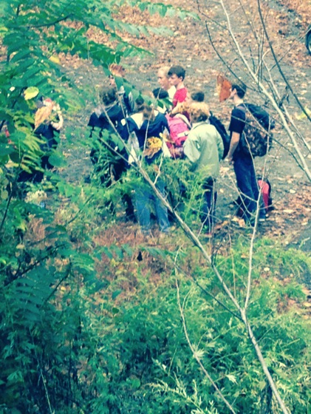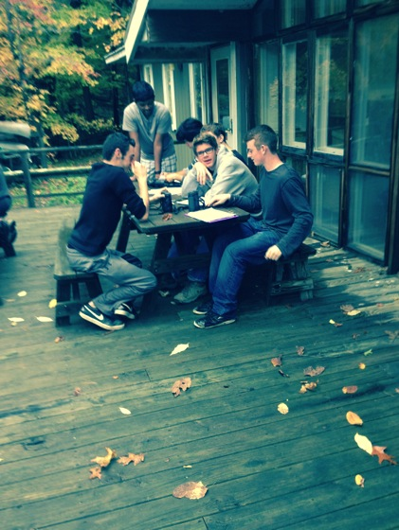
- Forested
- Boating, Picnics, Fishing, Jogging
- 10% residential, 90% forested
- Muddy and Rocky and Covered in Vegetation.
- Bottom muddy and rocky.
- Water Calm
- 50% Water Chestnuts (dying--it’s 90% during the summer). Some “Devil’s Heads”.

Environment:

Air temperature – 64.4 degrees F 71.5 degrees F (~10AM ~1PM)
18 degrees C 22 degrees C

Wind Speed
The wind was consistently still throughout the day, with the very rare gust. One such gust recorded at ~12:30pm measured at 1.2 fpm (feet per minute).

Cloud Cover
~75% all day (but still beautiful!)

Chemical Description
Time | Dissolved Oxygen | Water Temp | D.O. Saturation | pH
10:05 | 9ppm | 20° C | 100% | 7.9
10:40 | 8ppm | 20 °C | 85% | 7.9
11:10 | 8ppm | 20 °C | 85% | 8
12:03 | 9ppm | 20 °C | 95% | 8
12:40 | 9ppm | 20 °C | 95% | 8
Note: Sun blocked by trees/clouds in morning; just by clouds in the afternoon.

Physical Description
Salinity:
Quantabs Units: 1.6
NaCl: .007
Cl-: 43 ppm
Total Salinity 78 ppm

Temperature:
Water temperature – 68 °F - 20°C

Water elevation:
Note: High rain the night before lead to higher water levels than expected.
~10am: 18 inches Ebb
~11am: 15 inches Ebb
~12 noon: 12 inches Ebb
~12:40pm: 8 inches Ebb
~1p: 5.5 inches Ebb

Fish and Macro-invertebrates
Catch of the day:
 | Blue Gill Sunfish | Pumpkinseed Sunfish | Atlantic Silverside | Black Crappie | Spottail Shiner | Tessellated Darter | Banded Killifish | Stickleback | Northern Kingfish | Blueback Herring | Small Mouth Bass | Large Mouth Bass | White Catfish
10 AM | 5 | 5 | 1 | 2 | 0 | 0 | 0 | 0 | 0 | 0 | 0 | 0 | 0
1030 AM | 0 | 0 | 0 | 0 | 0 | 0 | 0 | 0 | 0 | 0 | 0 | 0 | 0
11 AM | 0 | 0 | 0 | 0 | 1 | 1 | 2 | 1 | 1 | 1 | 0 | 0 | 0
12 PM | 0 | 1 | 0 | 1 | 0 | 0 | 0 | 1 | 0 | 0 | 2 | 1 | 1
1230 PM | 0 | 0 | 0 | 0 | 0 | 0 | 0 | 7 | 0 | 0 | 4 | 0 | 1
Total | 5 | 6 | 1 | 2 | 1 | 1 | 2 | 9 | 1 | 1 | 6 | 1 | 2
 | Blue Gill Sunfish | Pumpkinseed Sunfish | Atlantic Silverside | Black Crappie | Spottail Shiner | Tessellated Darter | Banded Killifish | Stickleback | Northern Kingfish | Blueback Herring | Small Mouth Bass | Large Mouth Bass | White Catfish

Macro-invertebrates: 1 dobsonfly larva (a “hellgrammite”)
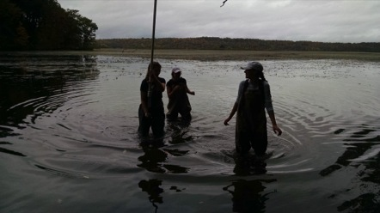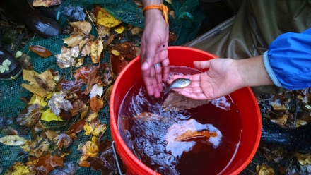
Photos by DITL Runner Lisa DiMarzo (thanks Lisa!)

Turbidity
Long Sight Reading: 45 cm
Observations: the water is relatively calm and relatively easy to see through, though muck is easily stirred up, clouding the water.
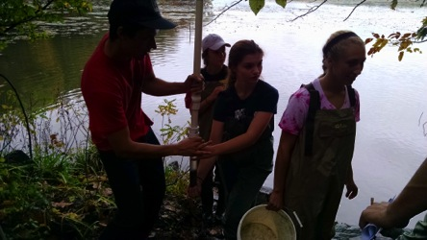
Sediment Log
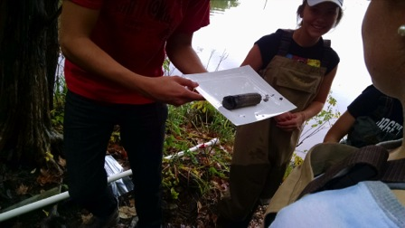
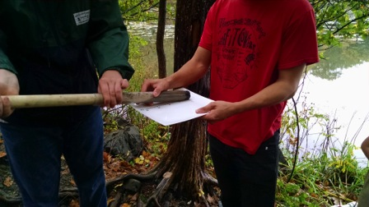
H2S Smell -- Yes
Oil -- No
Oxidized Top -- Yes
Clay -- Absent
Mud -- Common
Sand -- Common
Gravel -- Rare
Pebbles -- Rare
Leaves -- Rare
Wood -- Rare
Shells/Oysters -- Absent
Freshwater Mussel -- Absent
Zebra Mussels -- Absent
Macro-invertebrates -- Absent
Brick -- Absent
Coal -- Absent
Slag -- Absent
Living Vegetation -- Absent
Length of Core -- 10cm
Blog from the MUCK CITY Station:

Other Observations: Birds seen: Bald Eagle, Belted Kingfisher, Great Blue Heron, Tufted Titmouse, Downy Woodpecker, White-breasted Nuthatch, American Crow, Blue Jay

Shipping: 9:20 AM. Container ship. Blue with red beneath. Northbound. Light.
Other Transit: 9:25 AM. Amtrak. Silver. Northbound.
12:00 PM. Amtrak. Silver. Southbound.
Funny Quotes/Observations
“Muck City!!!”
Nick = Brent
“Don’t let the groups mix—the river’s an estuary, not the groups!”
Bardian Marina got “fully immersed” in the South Tivoli Bay (oops!)
“Can I get a Beam buck for this?!”
Photos on this page by DITL Runner Lisa DiMarzo (thanks Lisa!)

