A Day in the Life of the Hudson River 10/20/15 data
East River; Pier 16 South Street Seaport - AM group
Diane Pisani & the Blue School
Laura Norwitz, South Street Seaport Museum
20 – 2nd grade, 4 adults
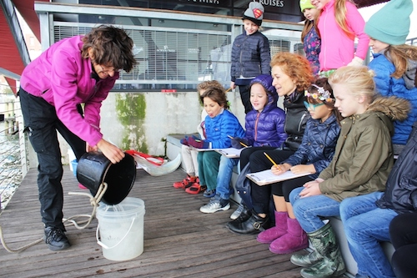
Location: South Street Seaport, Pier 16
Area: East River; Pier 16
Surrounding Land Use: Museum, Pier for boat access, Urban/residential and industrial/commercial
Shoreline: Pier, large docking with concrete and wood surface,
Bottom: Rocky shoreline
Water: Choppy
ITEM | TIME | Reading | Comments
Physical
Cloud Cover |  | clear
Weather Today |  | Cool in the AM
Weather Recently | Cool and dry
Water Surface | Choppy
Turbidity – long tube | 10:30 AM | 244 cm
Chemical
Salinity | 10:30 PM | 24 ppt  salinity | Plastic Hydrometer
Dissolved Oxygen, Wards’ Kit | 10:30 AM | 6.5 ppm
Current | Flooding

