Day in the Life of the Hudson River 10/20/15 Data
RIVER MILE -1
Governor’s Island, Upper NY Bay/Buttermilk Channel
Jeremy Lynch & Roy Arrezzo - New York Harbor School
32 students 9th graders, 4 adults
Latitude N 40°41’29” - Longitude W074°1.14’
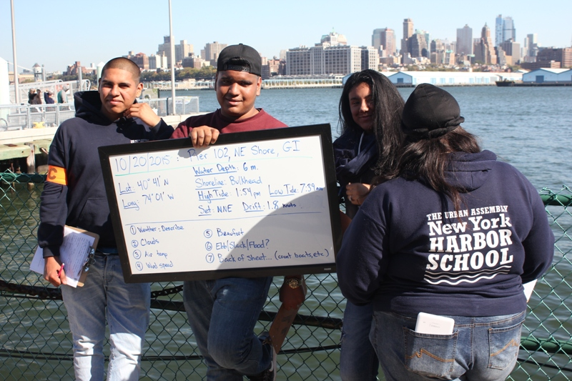 | 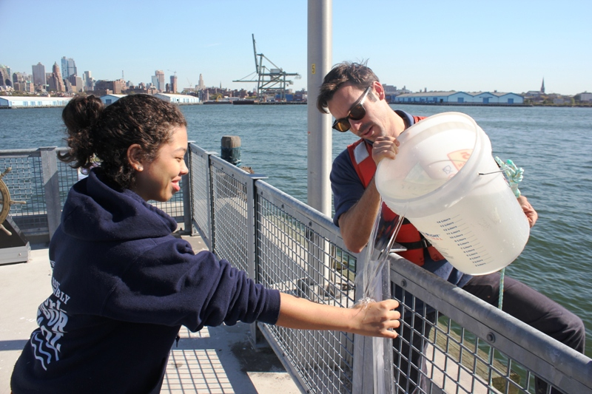
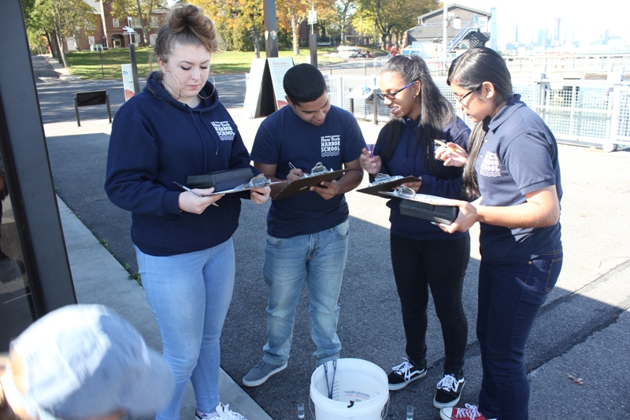 | 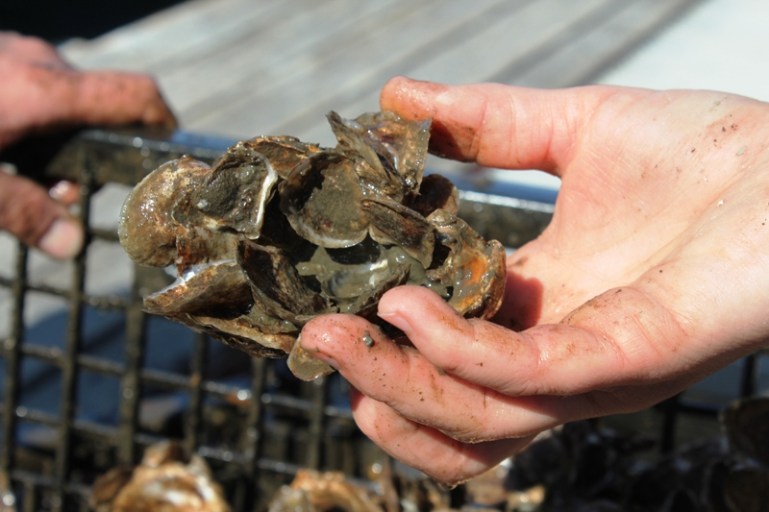

Location: Pier 101, NE Governor’s Island – Upper NY Bay
Area: Pier along waterfront of the island
Surrounding Land Use: 100% converted to public access programs (education, boating, recreation)
Sampling Site: Pier, shoreline is bulkheaded
Plants in area: None
Water depth: surface samples
Times: Data collected throughout the day
High Tide: 1:54 PM – LT 7:59 AM
ITEM | Time |  | Reading 1 | Reading 2 | Comments
Physical
Air Temperature | 1:30 PM |  | 22°C  71°F
Wind Speed | windy |  | 8 mph | Beaufort #1
Cloud Cover | Clear <25% |  | Cirrostratus and Haze | Isolated clouds
Weather today | Sunny mild temperatures
Weather recently | cool
Water depth | 6 meters deep
Water Temperature |  | 17 °C  59°F
Turbidity – turbidity tube |  | 93 cm
Chlorophyll | 0.3
Chemical
DO  (chemmet kit) |  | 8 mg/L |  | 17 °C | 80% saturation
pH – Lamotte colormetric |  | 7.5
Salinity  (Refractometer) |  | 29 ppt
Tides |  | HT 1:54 PM
Currents | 1:30 PM | SLACK |  | 1.8 kt
Organisms – oyster traps | Mud crabs | Green crabs |  | Oyster drills | Black fish
 | Oyster toad fish

