Day in the Life of the Hudson River 10/20/15 Data
RIVER MILE -4.2
Bayridge American Veterans’ Memorial Pier
N 40. 38’22.-416 , W-74 .2’18.4308
Alicia Smith & International School of Brooklyn
22 Fifth graders, 4 adults
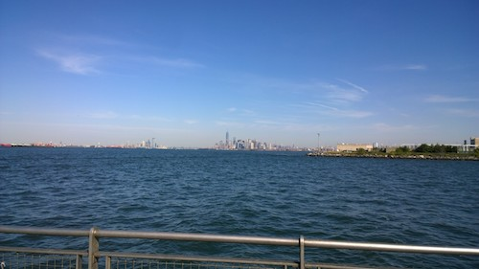
View from the pier. Owl Sewage treatment plant visible in the foreground.

Location: Pier American Veterans’ Memorial Pier, by highway, Park, 2 water treatment plants
Area: Pier – bulkhead – mainly concrete & wood. Two parks – Owl’s head and Shore Road Park
Surrounding Land Use: 70% urban/residential, 10% Industrial Commercial, 20% park
Sampling Site: Recreational pier – rocks near the edge, banks altered /riprap, all hard edged, steep wall dividing water from land, pipe entering water from treatment plant
Shoreline: Rocky
Depth: could not see bottom
Plants in area: No plants
Water: Calm

ITEM | Time |  | Readings
Physical
Air Temperature | 11:21 AM  11:45 AM  12:06 PM  12:37 PM |  | 18.9°C  17.2°C  18.3°C  19.8 °C | 66 °F  63 °F  65°F  68°F
Wind Speed | 11:21 AM |  | Beaufort 3 | 9 kts | E/SE
Cloud Cover | 11:21-12:31 |  | Clear all day | <25% cloud cover all day
Weather today | Clear no rain, warm and windy |  |  | Water surface
Weather recently | No rain for past 3 days. Sunday 10/18 unusually cold and windy. Monday 10/19 seasonal temperatures but still a bit windy.
Water Temperature | 11:21 AM  11:42 AM  12:26 PM | 18°C  18°C  18°C |  | 64 °F  64 °F  64 °F | <1 ft. depth, shade from pier, water choppy
Turbidity
Chemical | Time | ppm |  | Temp | % Sat
DO  Drop count kit | 11:21 AM | 7 |  | 18°C | 72%
pH  meter | 11:21 AM  11:42 AM  12:20 PM  12:34 PM | 7.95  7.96  7.96  7.96
Salinity -hydrometer | 11:21 AM  11:42 AM  12:20 PM  12:34 PM | 25.5 ppt  26 ppt  25 ppt  25 pptå
Fish Catch | Time | Species |  | # caught | Size
Tides - water depth | Time | Distance to water |  | Rate of change | Flood or Ebb
Measuring down from pier using a secchi disk | 11:20 AM  11:40 AM  11:56 AM  12:15 PM  12:30 PM | 300 cm  225 cm  275 cm  350 cm |  | Flooding  Ebbing  Ebbing
Currents | Time | Cm/30 sec |  | Cm/sec | Knots &  Ebb/Flood
 | 11:21 AM | 1676.4 |  | 55.88 | 1.09kts F
 | 11:45 AM | 411.48 |  | 18.75 | 0.24kts F
 | 12:06 PM | 701.04 |  | 23.37 | 0.45kts F
 | 12:31 PM | 792.48 |  | 0.51 | 0.51kts F
Note on recording sheet: Wind blowing east, current moving east, tidal flow moving east up the east river. Ebb on the Hudson.
Traffic- Commercial | 11:19-12:40 | 17-20 boats visible in area |  | Mainly cargo & ferry | 12:02 – 1 police boat
Recreational Traffic | 11:19 AM  11:19 AM  12:08 PM  12:26 PM | Sailboat speedboat  Speedboat  sailboat
Observations | Observed gatherings of ducks and gulls.  Oyster cage hanging from pier into the water

