Day in the Life of the Hudson River 10/20/15 Data
RIVER MILE -4.2
Bayridge American Veterans’ Memorial Pier
Pier 69th St.
N 40. 38’22.-416 , W-74 .2’18.4308
Katie McCarthy & Sunset Park HS
25 Eleventh graders, 3 adults
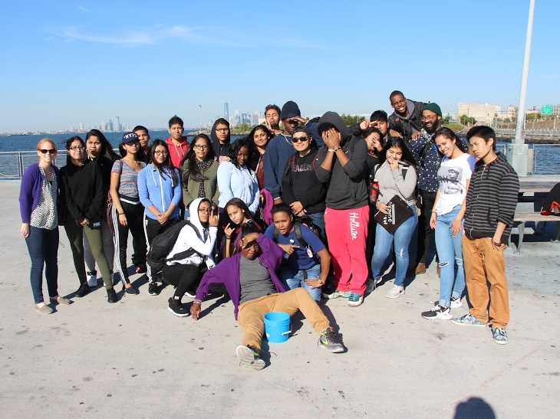 | 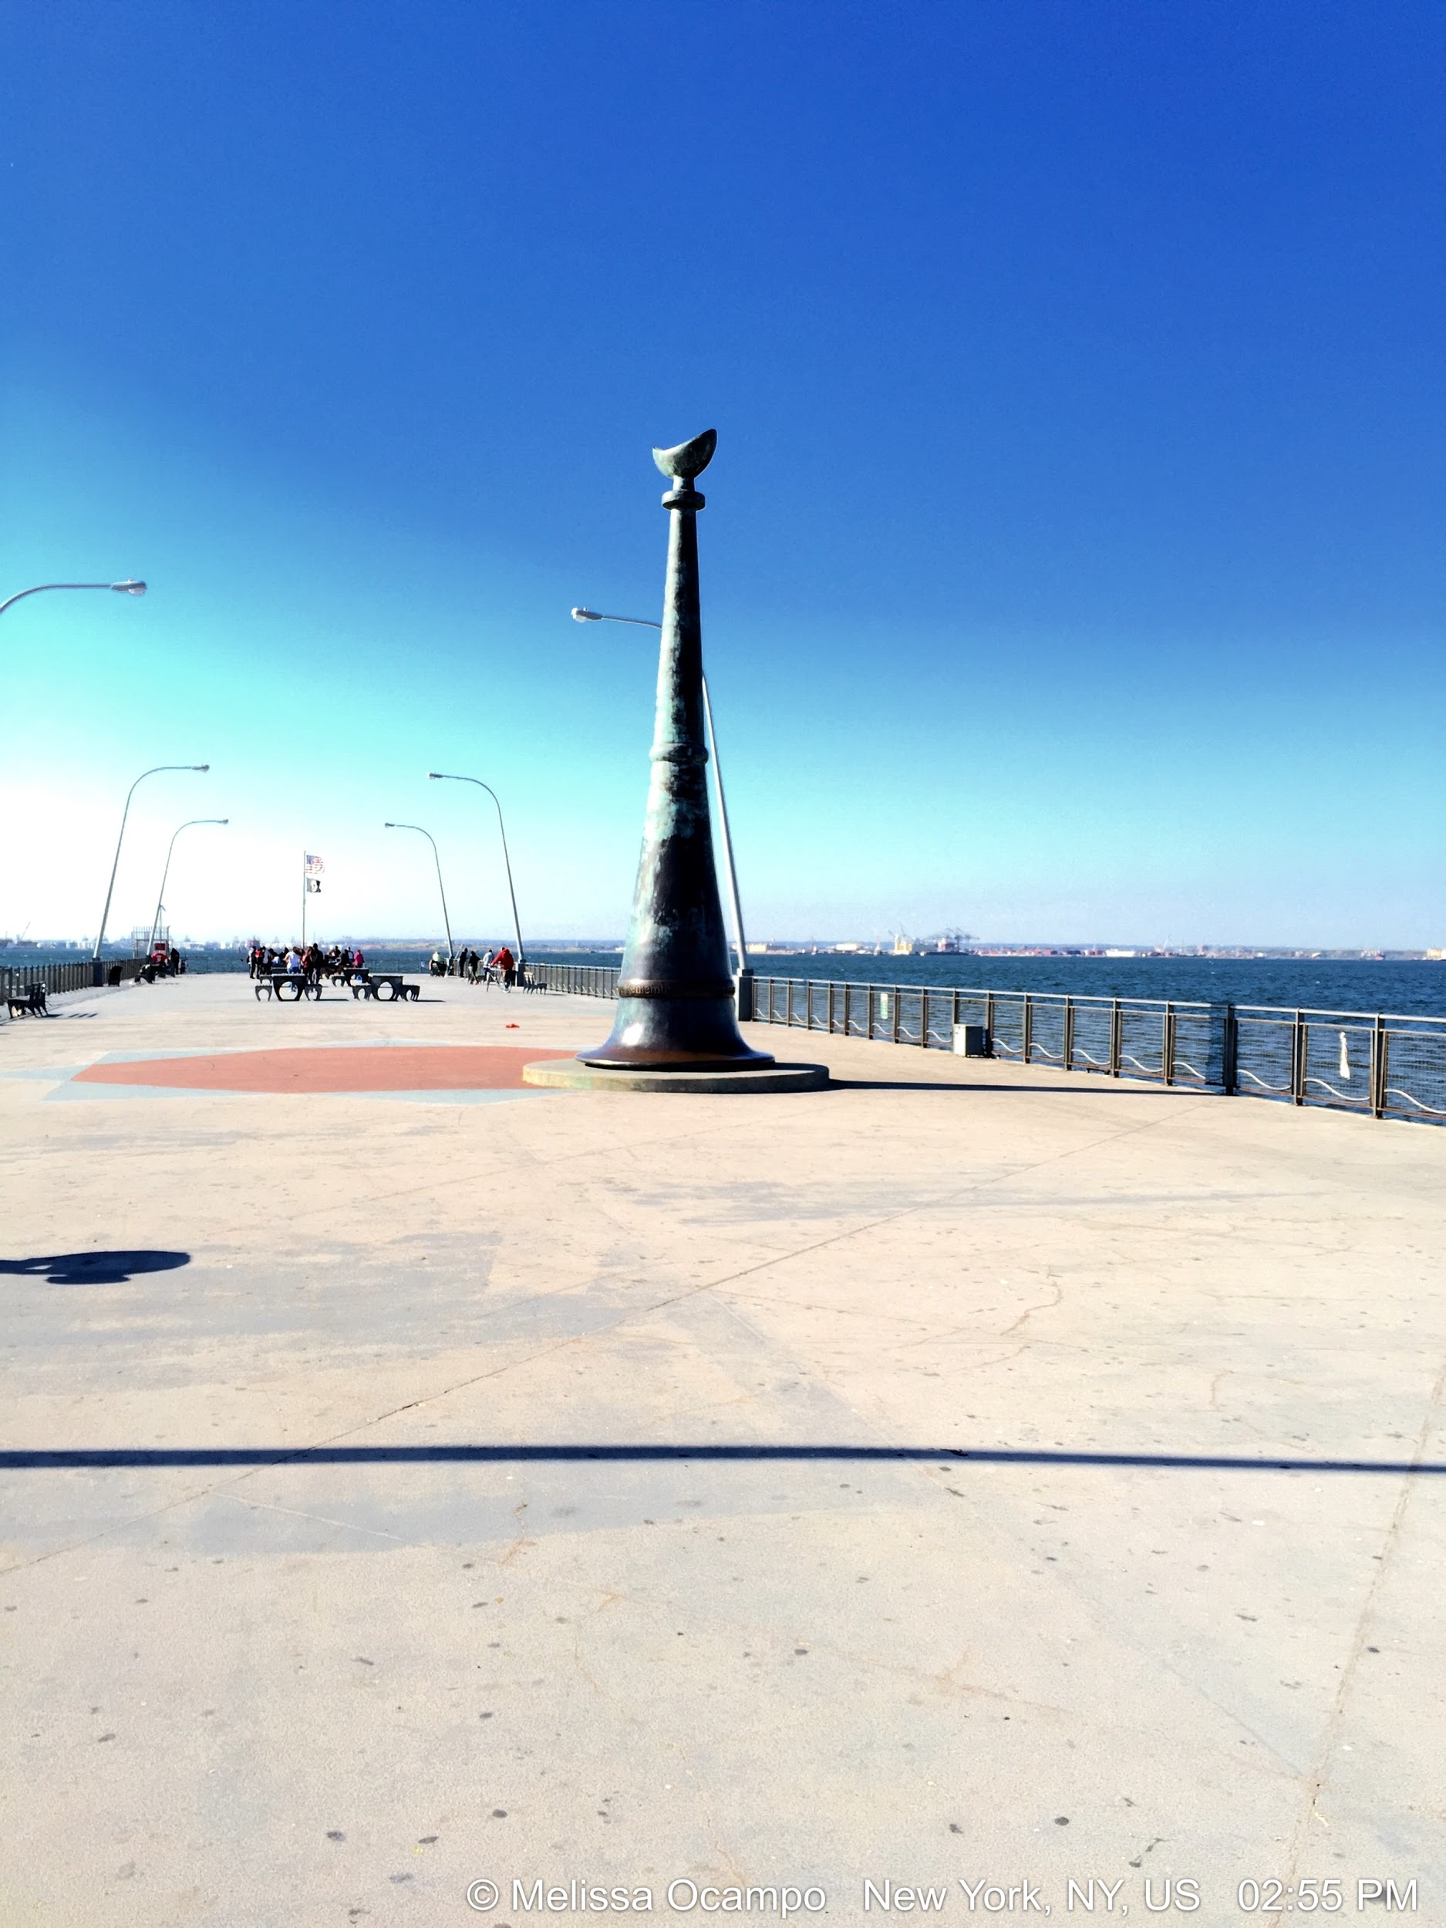

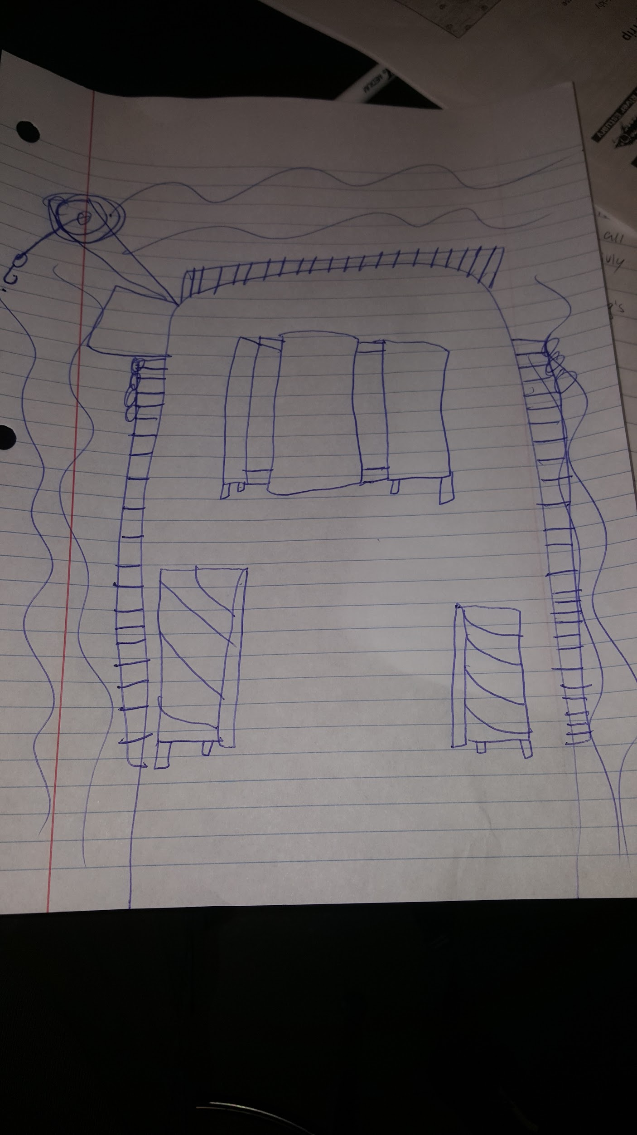
Location: Pier American Veterans’ Memorial Pier, by highway, Park, 2 water treatment plants
Area: Pier – bulkhead – mainly concrete & wood. Two parks – Owl’s head and Shore Road Park Fishermen use the pier and bikers out enjoying the view.
Surrounding Land Use: 70% urban/residential, 10% Industrial Commercial, 20% park
Sampling Site: Recreational pier – rocks near the edge, banks altered /riprap, all hard edged, steep wall dividing water from land, pipe entering water from treatment plant
Shoreline: Rocky
Depth: could not see bottom
Plants in area: No plants
Water: Calm
Sampling Times: 1:30 -3:15 PM

ITEM | Time |  | Readings
Physical
Air Temperature | 2:18 PM  2:48 PM  3:18 PM |  | 18.9°C  18.9°C  19.8 °C | 66 °F  66 °F  68°F
Wind Speed | Some wind
Cloud Cover | 1:30-3:15 PM |  | Clear all day | <25% cloud cover all PM
Weather today | Nice, sunny |  |  | Water surface
Weather recently | Cool
Water Temperature | 2:18 PM | 19.8°C |  | 68 °F
Turbidity
Chemical | Time | ppm |  | Temp | % Sat
DO  Drop count kit | 2:30 PM  2:50 PM  2:56 PM | 8  5  6 |  | 16°C  13.2  13.3 | 80%  57%  50%
pH  meter | 2:10 PM  2:27 PM | 8  8
Salinity -hydrometer | 2:30 PM | 24 ppt
Turbidity | 2:30 PM | 198.12 cm  167.64 cm  198.12 cm |  |  | Average 187.96 cm
Fish Catch | Time | Species |  | # caught | Size
 | 2:30 PM | Black Seabass |  | 1
Tides - water depth | Time | Distance to water |  | Rate of change | Flood or Ebb
Measuring down from pier using a secchi disk | 2:26 PM  2:53 PM | 112cm  106 cm |  | 6 cm/27 mins | Flooding
Currents | Time | Cm/30 sec |  | Cm/sec | Knots &  Ebb/Flood
 | 2:30 PM | 14cm/90 seconds |  | 0.15 cm/sec
Traffic- Commercial | 2:22 PM | Staten Island Ferry |  | Orange | Southbound Loaded
Observations | Gulls flying around looking for food. Construction on way to pier.

