Day in the Life of the Hudson River 10/20/15 Data
RIVER MILE -4
Bush Terminal Pier Park
Alexa Sloan, Counseling in School & JHS 223
20 Sixth-Eighth graders, 2 adults
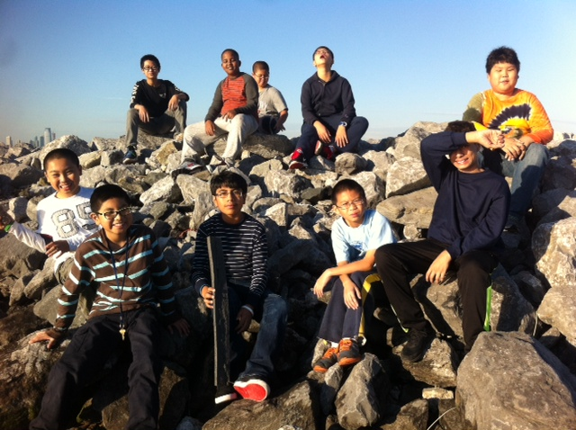
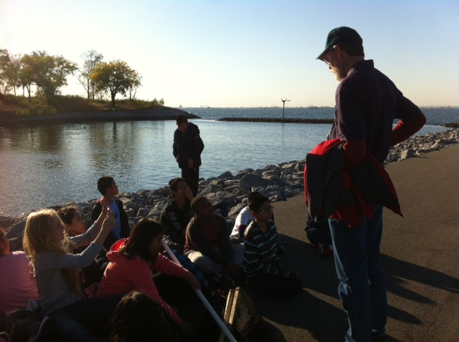 | 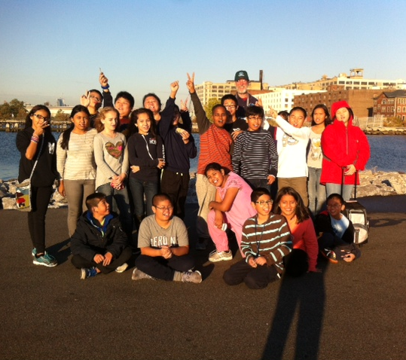

Location: Bush Terminal Pier, North West Brooklyn waterfront
Area: Pier – Large rock rip/rap along the waterfront
Surrounding Land Use: 90% Industrial Commercial, 10% park
Sampling Site: Recreational pier – rocks near the edge, banks altered /riprap, all hard edged, steep wall dividing water from land
Shoreline: Rocky, Sandy
Plants in water: yes some – 1%
Plants in area – planted beds and natural areas include yellow flag, sweet flag (in Port Authority plant selection list for its storm water management capability)

ITEM | Time | Readings
Physical
Air Temperature | 4:20 PM | 17°C | 65 °F
Wind Speed
Cloud Cover
Weather today | Clear no rain |  | Water surface
Weather recently | No rain for past 3 days. Cold
Water Temperature | 4:20 PM | 19°C*
Turbidity – long sight tube | 4:20 | 70 cm
Chemical | Time | ppm | Temp | % Sat
DO | 4:20 PM | 9 ppm | 19°C | 95%
pH - meter | 4:20 PM | 8
Salinity | 4:20 PM | 23 ppt

