Day in the Life of the Hudson River 10/20/15 Data
RIVER MILE 100
South Cove at Falling Waters, Glasco, Ulster County
Brian Robinson, Saugerties High School, 13 AP Env. Sci. 11th-12th grade students and 2 adults
N 42. 049457 , W-73.939081

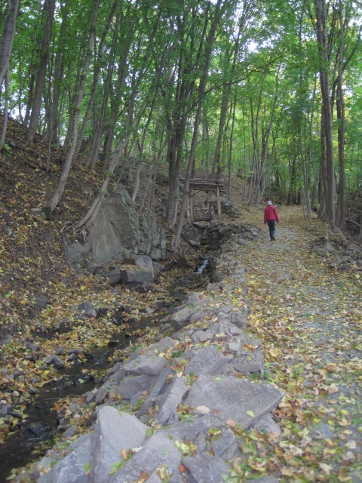
Location: Falling Waters South Cove
Area: Forested
Surrounding Land Use: 100% forested
Sampling Site: Parkland, beach covered in vegetation, concrete bulkhead
Shoreline: Sandy, muddy, rocky
Depth: could not see bottom
Plants in area: water is 40% covered with water chestnut
Site Observations: Old brick pieces on the ground names on bricks are Wasburn, Lent, …Bury, lots of old washed up logs, seaweed
Water: Choppy

ITEM | Time |  | Readings
Physical
Air Temperature | 10:47 AM |  | 12.6°C | 54 °F
Wind Speed | 10:42 AM |  | Beaufort 3
Cloud Cover | 10:45 AM |  | Mostly Cloudy | 51-75%
Weather today | Clear no rain, warm and windy |  |  | Water surface
Weather recently | No rain for past 3 days. Sunday 10/18 unusually cold and windy. Monday 10/19 seasonal temperatures but still a bit windy.
Water Temperature | 10:51 AM  11:03 AM | 12°C  12°C |  | 54 °F  54 °F | 1 ft. depth,
Turbidity | 10:51 AM | 40 cm  41 cm  38 cm |  | 39.6 cm average | Water was very cloudy, with small black particles
Chemical | Time | ppm |  | Temp | % Sat
DO  Drop count kit | 11:00 AM | 9 |  | 12.2°C | 80%
pH  color match test | 10:53 AM  11:00 AM | 8  8
Salinity –titration strips | 11:57 AM  12:08 PM  12:14 PM | 1.6 strip  1.4  1.4 |  | 34 ppm Chl | 61 ppm TS
Fish Catch | Time | Species |  | # caught | Size
 | 11:15 AM | Blueback herring |  | 5 | Y-o-y 4-5 cm
Tides - water depth | Time | Distance to water |  | Rate of change | Flood or Ebb
 | 11:06 AM  11:08 AM  11:10 AM  11:11 AM 11:15 AM  11:18 AM | 15 cm  14 cm  13 cm  13 cm  11 cm  11 cm |  | ebbing
Currents | Time | Cm/30 sec |  | Cm/sec | Knots &  Ebb/Flood
 | 10:50 AM | 60 cm |  | 2 cm/sec | Ebb
Recreational Traffic | 10:55 AM | Pleasure boat |  | Blue/white | Docked – carrying small sailboat
 | 11:21 AM | Luxury boat |  | White | South - light
Observations | Bricks, spiders, water chestnut in the area. And lots of logs and valissneria (‘seaweed’)

