Snapshot Day 10/20/15 Data
(Salt Front RM 78.2)
RIVER MILE 124.5
Nutten Hook, Green County NY
Michelle Vedder-Drew, Mud Creek ELC/Columbia County Soil & Water
Liz Pagnini & Kendra Mallow, Rock Solid Foundations School
4th (4 students) & Younger (4 students) and 4 adults
GPS Latitude 42.35841 N Longitude -73.787952 W
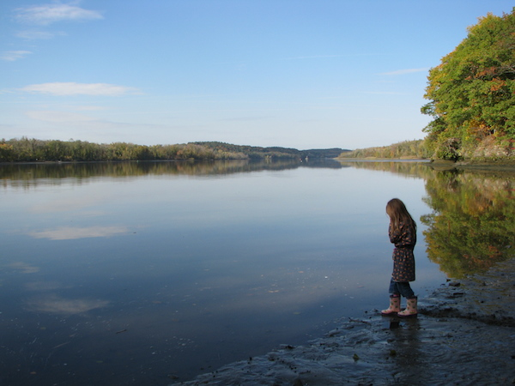 | 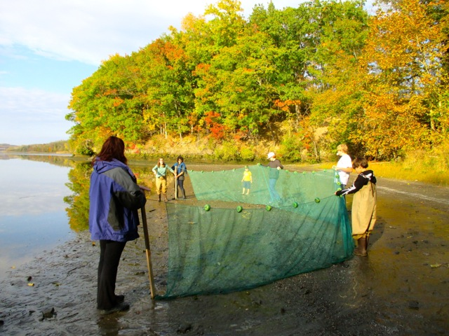

Location: Nutten Hook, Green County, NY
Area: Beach, forested bluff, large marsh behind bluff, DEC public access, used for picnics, water access
Surrounding Land Use: Beach - shoreline is sandy and rocky, riprap, banks altered in some areas with bulkhead
Shoreline: Sandy, Muddy
River Bottom: Muddy
Plants in area: very small amount of water milfoil and water chestnut

ITEM | Time |  | Reading 1 | Reading 2 | Comments
Physical
Air Temperature | 3:25 PM |  | 13.5°C
Wind Speed | 3:25 PM |  | Beaufort 0 | No wind
Cloud Cover | 4:15 PM |  | 51-75%
Weather today | Cloudy but no rain
Weather recently | cool
Water Temperature | 3:50 PM | 12.5°C |  | 6 inch depth
 | 10:19 AM | 18°C
Water calm | NR
Turbidity – short site tube | 3:42 PM | 15 JTU
Chemical
DO  (drop count kit) | NR
pH | 3:34 PM | 8.2
Salinity | NR
Fish Catch | Number Caught | Species |  | length | Seine  10 seines
40 ft. seine net X 3/8 inch mesh | None caught
Tides | 3:18 PM | 24.13 cm |  | No second measure
Currents | 3:22 PM | Ebb tide
Boat Traffic | 2 small recreational boats – both traveling north
Core | Abundant mud, common leaves
Other Items | Birds, water chestnut seeds, small shell bits

