Day in the Life of the Hudson River 10/20/15 Data
RIVER MILE 133
River Park, Schodack Island, Troy
Dawn Baldwin, Children’s Museum of Science and Technology
Susan Marie Keough, Abram Lansing Elementary–46 students 5th graders, 9 adults
N 42.517994 W -73.759697 (from park website)
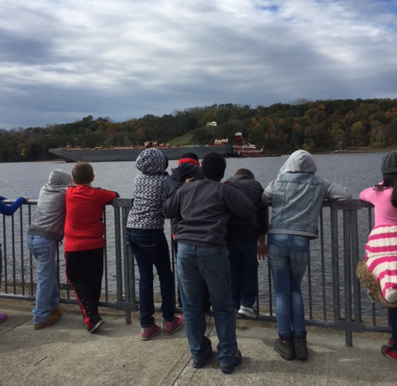
Location: Schodack Island State Park, Schodack Landing, Rensselaer County
Area: 1052 acres – park and boat launch area – grassy area with concrete walkway and boat launch
Surrounding Land Use: Forested, Boat launch, playground, parking lot, used for picnics, fishing, open and grassy
Sampling Site: Forested 70%; recreation state park with grass, trees, parking area, picnic area 15%,urban/residential 5%; Industrial/commercial 10%
Shoreline: banks altered, rip rap, bulkhead,
Plants in area: none visible from shore – some water chestnut seeds found onshore
Water depth: 4-6 ft. – water is deeper but we are bucketing from this depth
River Bottom: rocky (sharp drop off beyond bulkhead

ITEM | Time |  | Reading 1 | Reading 2 | Comments
Physical
Air Temperature | 10:35 AM  10:50 AM  11:15AM  12:30 PM |  | 46 °F  48°F  48°F  50°F | 7.8°C  8.9°C  8.9°C  10°C
Wind Speed | 10:40 AM Beaufort #2
Cloud Cover | 76-100%
Weather today | Mainly dry, 2 sets of sprinkles
Weather recently | Unseasonably cool temps on 10/18 and 10/19
Water Temperature -  Water depth ~1.5 ft. | 10:30 AM | 51 °F  50.5 °F  51 |  | 10.5°C  10.3°C  10.5 | AVERAGE  50.8°F  10.4°C
 | 11:20 AM | 49 °F  52  52 |  | 9.4°C  11.1  11.1 | 51 °F  10.5 °C
 | 12:00 PM | 53.5 °F  53 °F  52 |  | 12°C  11.7°C  11.1 | 52.8°F  11.6°C
Water | Slightly choppy | Small wavelets, no foam
Turbidity – small site tube | 11:30 AM | 0 JTU  0  10 |  |  | 3.33 JTU average
Chlorophyll | 10:40 AM  11:15 AM  11:50 AM | 0  0  0 |  | 1
Chemical
DO  (Drop count kit | 10:55 AM | 11.5 mg/L* |  | 11°C | 105%
pH  (ind. Sol.) | 10:40AM | 7.0  7.0  7.0 |  |  | 7.0 avg.
 | 11:35 AM | 7.0  7.0  7.5 |  |  | 7.16 avg.
Salinity – hydrometer* | 11:25 AM | .024  .021  .020 |  | Average .0216 ppt  (216 ppm) | *area too fresh for hydrometer
Nitrates | 11:42 AM | 0.05 ppm  <0.05 ppm  <0.05 ppm |  |  | Average 0.02 ppm
Fish Catch seine – 30 ft. X 4 net, 20 ft. pull – 2 seines | Number Caught | Species |  | Length | Seine
12:30 PM – 4 fish 1st pull | 1 | Striped Bass |  | 8 cm | Div - 3  Total - 4  CPUE 0.65
 | 1 | White Perch |  | 6 cm
 | 2 | American Shad |  | 5 cm
12:45 PM – 3 fish 2nd pull | 3 | American Shad |  | 5 cm | Div – 1  Total 3  CPUE 0.49
TOTAL DIVERSITY | 3 | TOTAL CATCH |  | 7
Tides | Time | Height cm |  | Rise/Fall/still | Cm/min
 | 10:00 AM | 80 cm |  | Falling
 | 10:33 AM | 75 cm |  | Falling | 0.1515
 | 10:45 AM | 71 cm |  | Falling | 0.333
 | 11:00 AM | 65 cm |  | Falling | 0.4
 | 11:14 AM | 58 cm |  | Falling | 05
 | 11:31 AM | 53 cm |  | Falling | 0.2941
 | 11:48 AM | 46 cm |  | Falling | 0.4117
 | 12:15 PM | 38 cm |  | Falling | 0.2962
Currents | Cm/30 sec | Cm/sec |  | North/South | Flood/Ebb
10:38AM | 517.19 | 17.23 cm |  | S | Ebb
10:48 AM | 772.29 | 25.74 |  | S | Ebb
11:18 AM | 956.48 | 31.88 |  | S | Ebb
11:34 AM | 1380.61 | 44.35 |  | S | Ebb
11:51 AM | 1342.33 | 44.74 |  | S | Ebb
Traffic | 11:00 AM | CNAN NORD – (Algier) |  | North | Light
10:15 AM | Boat coming out of the river via boat launch – Bridge Inspector
11:00 AM | Cary Institute for Ecosystem Studies entered river ro so water testing and take someone to repair weather station
Dawn Comments | As always, the river is my favorite place to be. It is made even better when I am introducing children to the wonders of the world around them. True to form, the 5th graders from Abram Lansing School in Cohoes were amazed at what they were seeing. Nothing brought this closer to home than the sweet girl who told me she saw a fish jump out of the water. She asked me. “Did you know they could do that? I never knew a fish could come up in the air. It was sparkly and beautiful”. I asked what it looked like, thinking we might be able to identify what she had seen. Her response touched my heart, “It was the most beautiful thing I have ever seen”. This is why A Day in the Life is so important to me. Dawn Baldwin CNSE CMOST

