Day in the Life of the Hudson River 10/20/15 Data
RIVER MILE 153
River Park, Green Island Park, Green Island NY
Kate Perry, Robert C. Parker School
42 students - 2nd & 3rd and 6th and 7th grade students, 14 adults
42.75 N -73.69 W
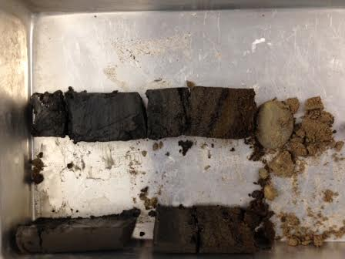
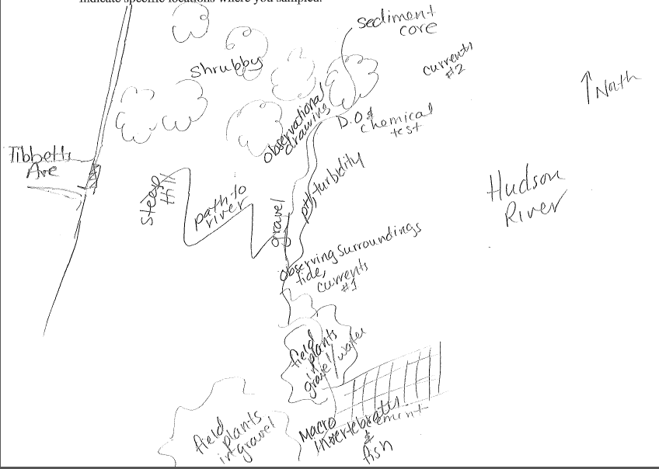
Location: Green Island Park boat ramp, below the Troy Dam, Albany County, NY
Area: Park above bluff and then beach below just south of the Troy dam
Surrounding Land Use: Forested, Rocky, Fishing access, gravel, some vegetation
Sampling Site: 25% urban/residential, 75% industrial/commercial
Shoreline: Rocky, broken concrete docking, very rocky shoreline, slag, concrete at the launch, brick pieces, vegetation, pipe directly across sampling site
Plants in water: very few plants in the water – 1%
Plants in area: 10% of sample area had goldenrod, smartweed, ox eye daisy, grasses, speckle alder, purple loosestrife
Water depth: 0-10 cm along shore
River Bottom: mainly rocky, some muddy & weedy
ITEM | Time |  |  | Reading 1 | Reading 2 | Comments
Physical
Air Temperature | 10:23AM |  |  | 41 °F  6°C | 10:59 AM | 41 °F  8°C
Wind Speed | #2 Beaufort |  |  | 4-7 mph | 4-6 kts. | South
Cloud Cover | Overcast
Weather today | Light rain on and off <1 cm collected 9:30 -11:30 AM – light periods of showers
Weather recently | Cold 3 days ago 10/17 – snow and small amount of hail. Sunnier yesterday
Water surface | Mostly calm
Water Temperature | 10:00 AM  10:20 AM |  | 10°C  10 |  | 50°F  50
Turbidity –long site tube | 10:00 AM |  | 28.33 cm  20.07 cm  31.67cm |  | 26.69 cm average
Chemical | 10:00 AM |  | 1.0
DO  (Drop count kit | 10:25 AM |  | 10°C |  | 16 ppm | 140%
pH - paper | 10:10 AM |  | 6.0 X 3 |  |  | Average 6.0
Salinity –meter | 10:25 AM |  | 250 ppm  230  230 |  | 236.6 ppm* expect this might be conductivity u/S
Salinity quantab | 1.2 reading |  | 30 ppm Cl-
Nitrates | 10:00 AM |  | 0 ppm
Phosphates | 10:00 Am |  | 0 ppm
Fish Catch –  DEC shocked & shared catch | Time |  | Number Caught |  | Species | Size Largest
 |  |  | 2 |  | Sucker | 40 cm
 |  |  | 4 |  | Striped Bass | 220 cm
 |  |  | 2 |  | Largemouth bass | 16 cm
 |  |  | 2 |  | Catfish | 54 cm
 |  |  | 2 |  | Redhorse | 48 cm
 |  |  | 1 |  | Walleye | 39 cm
 |  |  | 1 |  | Pumpkin seed | 13 cm
 |  |  | Diversity 7 |  | 14 Total
 | TOTAL CATCH |  | 25 |  | TOTAL SPECIES | 4
 | Macro- invertebrates |  | Waterboat man |  | snails
Sediment Core | Length |  | RARE |  | NOTES | COMMON
9:45 Am  Water 70 cm deep | 17 cm |  | Gravel  Pebbles  Leaves  Wood  Shells  Zebra Mus. Shell  Macroinv  Brick  Coal |  | Lowest 2 cm  Lowest 2 cm  Lowest 2 cm  Lowest 4 cm | Clay  Sand  Living Vegetation
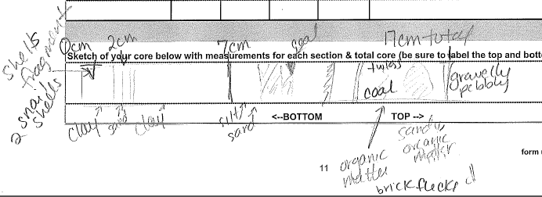
Tides | Time |  | Height in c |  | Rising/Falling | Rate of change
 | 9:50 AM |  | 10 cm
 | 10:17 AM |  | 12 cm |  | Rising 12 cm | 0.06 cm/min
 | 10:34 AM |  | 11.5 cm |  | Falling
 | 10:43 AM |  | 12 cm? |  | Falling
 | 10:48 AM |  | 8 cm |  | Falling
 | 10:54 AM |  | 5 cm |  | Falling | 0.17 cm/min
Currents | Time | Cm/30 secs | Cm/sec |  | Knots | N/S Ebb/Fld/Still
Shoreline* | 10:23AM | 45 cm | 1.5cm/sec |  | 0.029 | S- Ebb –
Channel* | 10:55AM | 1000 | 33.3cm/sec |  | 0.65 | S Ebb
Changed location for sampling current to compare shoreline to center channel
Traffic commercial | 10:30 AM |  | Tan |  | North | Loaded
 | 10:30 AM |  | DEC Boat |  | Stopped here | Fishing Boat
Recreational | 10:30 Am |  | White |  | North & South | People
Other Items | Bald eagle soaring overhead, many gulls, few crows, pigeons, squirrel - too much garbage
Almanac | Troy Dam – Cold rain greeted us at the river’s edge. We put up a tarp, got out our equipment and delved into the data collection A gift or time and effort, the DEC fisheries shocked fish, parents & teachers coordinated groups of inquiring students, and busy data collectors, set to work as official scientists. We were thrilled by a bald eagle, biting walleye and boat traffic.
Marissa DeMartino – 7th grade  Robert C. Parker School | As the footprint steps on the Hudson River  We come to see how she is.  As the trees blow and the rain comes down  We go to the water and check her for problems to see if she is OK.  Soon after, we find that all is good  As we leave, the great river looks back at us.  She thanks us and waves goodbye  She might just be a river to you but she is my everything.

