Day in the Life of the Hudson River 10/20/15 Data
RIVER MILE 18
Vicki Garufi - Sarah Lawrence College Center for the Urban River @ Beczak (3 staff)
Kathleen Ruen, Sarah Lawrence College and 7 Graduate Students in the Art of Teaching
Cooper Miller, The Ella Baker School 24 sixth students, 4 adults
Sarah Curtis, St. Ann’s School, 20 second graders, 3 adults
Latitude – N 40.93813129121615 Latitude – W -73.90288889408111
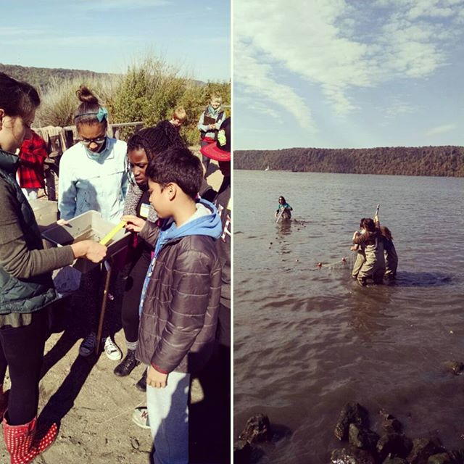

Location: Habirshaw County Park, Seining beach, SLCC@ Beczak, Yonkers, Westchester County
Area: 2 acre riverfront county park covered mostly by a grass lawn leading down to the river where it meets a tidal wetland and sandy beach. Property used for fishing, boats, seining, field trips and education programs – Park and some urban – 75% urban residential, 25% waterfront/beach,
Surrounding Land Use: Beach – 2 acre park
Sampling Site shoreline: sandy beach, tidal marsh area covered with vegetation, banks altered, large riprap on shoreline, collected wood/debris in area,
Plants in area: no plants in the shoreline waterfront however in the marsh area there is:
Arrow arum. mud wort, saltwater cordgrass, phragmites, water celery
Water depth –
River Bottom – muddy, rocky
ITEM | Time |  | Reading 1 | Reading 2 | Comments
Physical
Air Temperature | 12:23 PM |  | 19°C | 67°F
Wind Speed | Beaufort 3 |  | 7-10 kts | 8-12 mph | NE
Weather today | Partly cloudy 26-50%, No rain
Weather recently | Cold
Water calm | choppy
Water Temperature – | 12:23 PM | 18°C  63°F
Turbidity – sight tube – | 12:31PM  12:40 PM | 8 cm  10cm
Chemical – | Time | Temp |  | DO | Saturated
DO – ampules | 12:30 PM | 18°C |  | 8.5mg/L | 85%
pH – indicator solution | 12:31 PM | 8
Salinity – hydrometer | 12:29 PM – | 10 ppt  8 ppt  11ppt |  | 9.6 ppt average
Fish Catch - Seine net 30 feet X 4 ft., 1.4 inch mesh- | Number Caught –  10:30 AM – 12:30 PM | Species |  | Size of largest | Notes
FISH | 1 | American Eel |  |  | 5 FISH DIVERSITY
 | 1 | Atlantic Silverside |  |  | 12 TOTAL FISH
 | 4 | Banded Killifish
 | 3 | Striped Bass
 | 3 | White Perch
MACRO INV | 3 | Comb Jellies |  |  | 4 OTHER DIVERSITY
 | 1 | Moon Jelly |  |  | 15 TOTAL OTHER
 | 7 | Shrimp
 | 4 | Blue Crab
Tides | 10:30 AM | Rising
*dead low 8:41 AM | 11:00 AM | Rising
 | 11:30 AM | Rising
 | 12:00 PM | Rising
 | 12:30 PM | Rising |  | 11 cm
 | 12:45 PM | Rising |  | 15 cm
Currents | NR
Core Sample | Entire Length | Grain Size |  | Abiotic | Biotic
3 layers - black, brown, clear | 11 inches  Smells sulfur like | Larger grain |  | Rocks, dirt | phytoplankton
Other | Bald eagle flying over the Palisades, flock of hawks circling above beach

