Day in the Life of the Hudson River 10/20/15 Data
RIVER MILE 25E
Matthiessen Park, Irvington, NY
Joanna Morabito, Irvington High School
19 Marine Science Students, 43 AP Environmental Science Students
Latitude 41 ͦ 2’ 30” N Longitude 73 ͦ 52’ 32” W
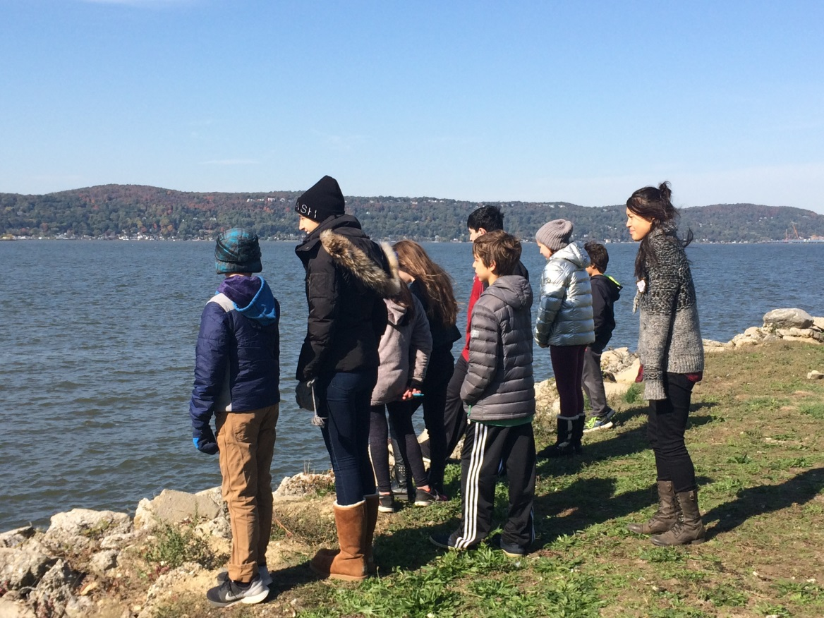 | 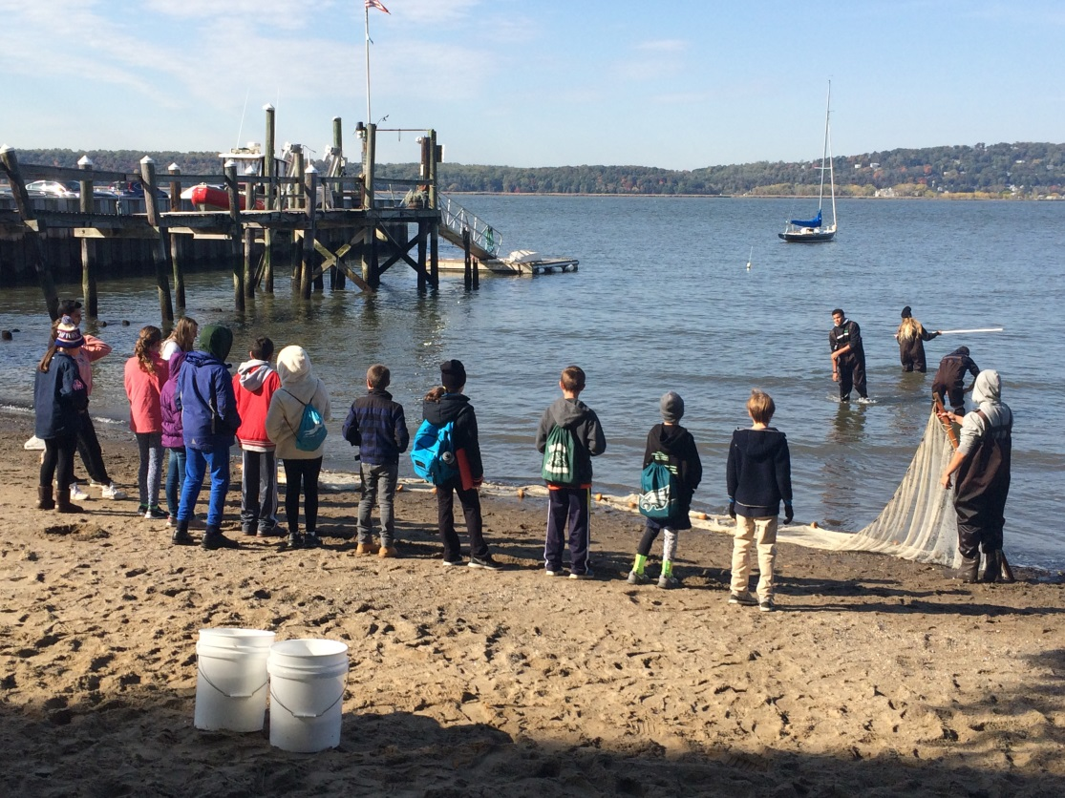
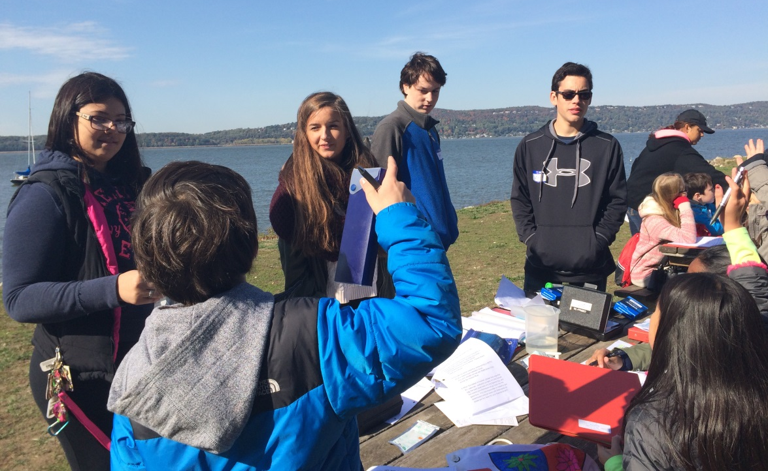

Area: Hudson River, grass, rocks bordering (river), mini beach, dock
Percentages: 40% grass, 10% beach, 5 % forested, 45% river
Surrounding Land Use: Park
Sampling Site: Mini beach at Matthiessen Park,
Plants in area: Moss, maple tree, oak tree, grass
Water Depth: varied; depth increased as the day progressed
River Bottom: Rocky close to the beach and muddy farther away
Weather Conditions: Sunny

ITEM | Reading 1  Time: 9:24am | Reading 2  Time: 9:56am | Reading 3  Time: 10:26am | Reading 4 Time: 10:56am
Air Temperature | 43 F | 51 F | 51 F | 52 F
Wind Speed | 4 (Beaufort #) | 3 | 3 | 2
Cloud Cover | Small Amount | Small Amount | Clear | Clear
Current Weather | Partly Cloudy | clear | clear | clear
Describe the recent weather over the past TWO days: Cloudy but no Rain

Currents | Time of Reading | Length from Start to Finish line (cm) | Amount of time from Start to Finish | Rate (length/time) | Direction of Current
Reading 1 | 9:45 am | 1000 | 2 min 47 sec | 5.988cm/sec | South
Reading 2 | 10:14 am | 1000 | 3 min 17 sec | 5.154cm/sec | South
Reading 3 | 10:40 am | 1000 | 1 min 37 sec | 7.299cm/sec | North
Reading 4 | 11:07 am | 1000 | 1 min 29 sec | 7.751cm/sec | North
Other comments: We had fun throwing oranges into the river.
River Traffic (note time): none
WATER CHEMISTRY: LaMotte Kit

 | Reading 1  Time:  9:24 AM | Reading 2  Time:  9:51 AM | Reading 3  Time:  10:24 AM | Reading 4  Time:  10:52 AM
Water Surface Temperature (degrees Celsius) | 11 | 8 | 12 | 11
Turbidity  (Use Turbidity Tubes) (centimeters) | 18 | 15.2 | 26 | 24
DO (tablet kit-PPM)  **This Test was performed incorrectly- students did not place appropriate number of tablets in tube.** | 3 | 2 | 5 | 5
pH (tablet Kit) | 7 | 7 | 7 | 7
Salinity Meter (PPT) | 11 | 6 | 7 | 6
HIGH SCHOOL WATER CHEMISTRY TESTS ONLY
CHEMets Kits
 | Reading 1  Time:  9:25  9:25 | Reading 2  Time:  9:52  10:00 | Reading 3  Time:  10:09  10:25 | Reading 4  Time:  10:23  11:00
DO  (PPM) | 6 | 10 | 8 | 6
Nitrate  (PPM) | 0 | 0.1 | 0 | 0.1
Phosphate  (PPM) | 1 | 0 | 0 | 1
pH meter | 7.7 | 7.8 | 7.8 | 7.9

FISH ID/ SEDIMENT CORE/ TIDES
 | Species Caught | Number of each Species Caught
Fish Catch 1  Time: 9:06 am | Silverside  Blue Crab  Shiner  Shrimp  Anchovy | 6  4  1  2  1
Fish Catch 2  Time: 9:20 am | Shiner  Silverside  White perch  silverback  Blue Crab | 2  3  1  3  2
Fish Catch 3  Time: 9:31 am | Shiner  Silverside  White Perch  Silverback  Blue crab | 2  3  1  3  2
Fish Catch 4  Time: 10:01 am | Small mouth bass  flounder  silverside | 1  1  5
Sediment Core
 | Time core was taken | Rare components | Common components | Abundant components
Core 1 | 9:40 am | wood  leaves  shells | pebbles  slug | mud  gravel
Core 2 | 10:00 am | Wood | Mud | Gravel  Sand  Mud
Core 3 | 10:35 am | Leaves  Wood  Shells | Mud | Gravel  Sand  Mud
Core 4 | 11:05 am | Wood  Shells | Pebbles | Gravel  Sand  Mud

TIDES (Multiple groups measured 4 times.)
 | Reading 1 and Time When Taken | Reading 2 and Time When Taken | Reading 3 and Time When Taken | Reading 4 and Time When Taken
Right Side Stick | N/A | N/A | N/A | N/A
Left Side Stick | 8:30am: 13cm:  9:50am: <13cm  11:10am: <13cm  12:24pm: 33 cm | 8:50am: <13cm  10:10am: <13cm  11:30am: 15cm | 9:10am: <13cm  10:30am: <13cm  11:50am: 27cm | 9:30am: <13cm  10:50am: <13cm  12:10pm: 28cm
Is it an incoming or outgoing high tide or an incoming or outgoing low tide?
The high tide was incoming.

