Day in the Life of the Hudson River 10/20/15 Data
RIVER MILE 4
Pier 84
N 40. 40.76408, W-74 .001893
Tina Walsh and staff from the Hudson River Park
Julie Taegel, City Knoll Middle School, 15 6th graders and 1 adult - AM
Lavonne Hunter, CASA, 45 sixth graders and 5 adults – Mid Day
Christine Kecskemeti, PS 51 Elais Howe School 60 4th graders and 8 adults - PM

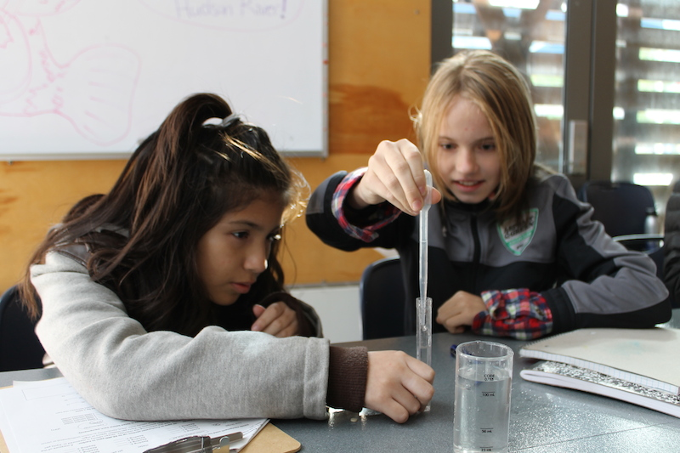 | 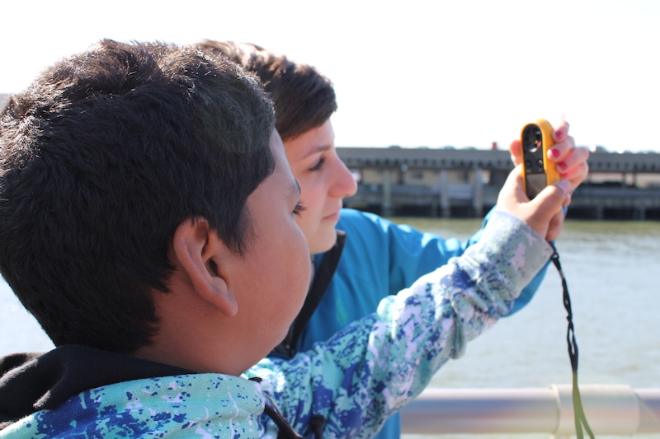

Location: Pier 84, is an educational pier used for picnics, boating, jogging, fishing
Area: Pier – bulkhead – mainly concrete & wood
Surrounding Land Use: 60% urban/residential, 40% Industrial Commercial
Sampling Site: Recreational pier – rocks near the edge, banks altered – all hard edged, muddy bottom
Depth: ~12 feet off pier
Plants in area: No plants
Water: Calm

ITEM | Time |  | Readings
Physical
Air Temperature | 10:30 AM  11:30 AM  12:00 AM  1:15 PM  1:45 PM  2:00 PM |  | 11°C  12°C  16°C  20 °C  19°C  14°C
Wind Speed | 10:30 AM  11:00 AM  11:30AM  12:15 PM  1:15 PM  1:45 PM  2:15 PM |  | Beaufort 2 Beaufort 2  Beaufort 3  Beaufort 2  Beaufort 2  Beaufort 3  Beaufort 2 | 4.7 mph  3.9 mph  5 mph  4 mph  4 mph  7 mph  4 mph | SW  SW  SW  S  SW  SW  S
Cloud Cover | 10:30 AM  11:00 AM  11:30AM  12:15 PM  1:15 PM  1:45 PM  2:15 PM |  | Clear all day | <25% cloud cover all day
Weather today | Clear |  |  | Water surface
Weather recently | Cool some rain
Water Temperature | 11:00 AM  11:40 AM  12:00 PM  1:15 PM  1:45 PM  2:00 PM | 14°C  13°C  12°C & 11°C  14°C  12°C  12 °C
Turbidity  Turbidity tube – cm | 10:30 AM  11:00 AM  11:50 AM  12:15 PM  PM  PM | 47 cm  35 cm  39 cm  30 cm  56 cm  57 cm
Chemical | Time | ppm |  | Temp | % Sat
DO  Estuary wide monitoring Kit – | 10:30 AM  11:00 AM  11:30 AM  11:45 AM  1:15 PM  1:45 PM  2:00 PM  2:15 PM | 8  8  6  7  8  9  8  8 |  | 14°C  14°C  13  13  14  12  12  12 | 78%  78%  56%  65%  78%  80%  75%  75%
pH  kit as above | 0:30 AM  11:00 AM  11:30 AM  11:45 AM  1:15 PM  1:45 PM  2:00 PM  2:15 PM | 7  7  7  7  7.5  7.5  7  7
Salinity -hydrometer | 10:30 AM  11:00 AM  12:00 PM  12:15 PM  1:20 PM  1:45 PM  2:15 PM | 18  18  15.5  15.5  16  15  15
Fish Catch | Time | Species |  | # caught | Size
Fishing rod with circle hook & clam bait |  | Striped Bass  Silverside  Blue Crab |  | 6  1  1 | 23 cm  5 cm  5 cm
Tides - water depth | Time | Distance to water |  | Rate of change | Flood or Ebb
 | 10:15AM  11:15AM  1:00 PM | 183cm  213 cm  244 cm |  |  | Flooding
Currents | Time | Meter/sec |  | Cm/sec | Ebb/Flood

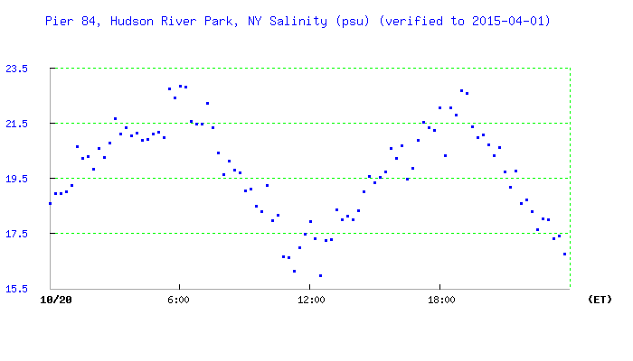
Salinity at Pier 84

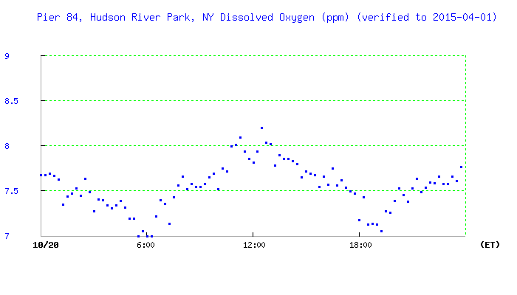
DO at Pier 84

