Day in the Life of the Hudson River 10/20/15 Data
RIVER MILE 5
Pier i - 59th Street/Riverside Park
Kimberly Schwab, Speyer Legacy School – 10 adults total
42 students - 7th & 8th graders
N 40.799 W-73.99
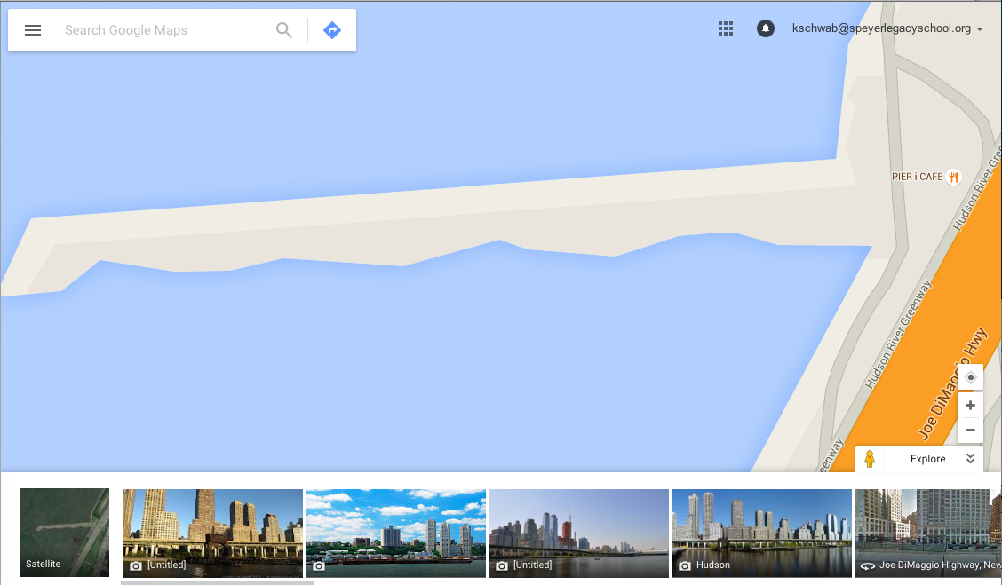
Sampling took place on the western tip of the pier
Location: Pier i, New York NY
Area: Restored former railroad pier
Surrounding Land Use: Urban/residential 100%
Sampling Site: Except for seining and taking core samples, all sampling took place on pier i.
Shoreline: tiny beach area, shore with bulkhead, riprap, covered with vegetation, Old RR pilings
Plants in area: no submerged aquatic plants in the water but lots of plants on shore
Water depth: ~6 meters
River Bottom – sandy
Plants in water: No plants in the water

ITEM | Time |  | Readings
Physical
Air Temp.å | NR
Wind Speed | 10:08 AM  10:35 AM  11:00 AM  11:30 AM  12:00 PM  12:30 PM  1:00 PM  1:30 PM  2:00 PM  2:30 PM |  | Beaufort 1  Beaufort 2  Beaufort 1  Beaufort 3  Beaufort 2  Beaufort 3  Beaufort 4  Beaufort 4  Beaufort 3  Beaufort 3
Cloud Cover | Clear <25%
Weather today | No rain, temp rose and Wind increased during the day |  |  |  |  | Water surface | Choppy
Weather recently | Cool and clear with highs in the 50s
Water Temperature
Turbidity  site tube | Time | Surface Sample cm |  | Depth Sample cm
 | 10:00 AM  10:30 AM  11:00 AM  11:30 AM  12:00 PM  12:30 PM  1:00 PM  1:30 PM  2:00 PM | 56.5  52  NR  NR  40  31  43  38  37 |  | NR  38  27  32  NR  22  44  32  23
Chemical | Time | mg/l |  |  |  | Temp | % Sat
*Water sampled at surface and at depth with niskin bottle reported in two separate sets of readings below. Depth for bottom samples ranged from surface to depth
 | TIME | SURFACE  mg/L |  | BOTTOM  mg/L  (~14 ft.) |  | DEGREES C | % Saturation  Surf - Bot
DO - Hach – | 10:00 AM  10:30 AM  11:00 AM  11:30 AM  12:30 PM  1:00 PM  1:30 PM  2:00 PM | 8  8  8  6  5  7  8  6 |  | 8  6  8  8  7  6  8  6 |  | 15  16  15  14  13  17  15  14 | 78%  80%  78%  58%  47%  70%  78%  58% |  | 78%  60%  78%  79%  65%  60%  78%  58%
pH- LaMotte precision pH | N/R
Salinity – | Time | Surface sample  refractometer –  PPT  (~14 ft) |  |  |  | Depth Sample refractometer - PPT
 | 10:00 AM  10:30 AM  11:00 AM  11:30 AM  12:00 PM  12:30 PM  1:00 PM  1:30 PM  2:00 PM | NR  10  10  NR  8  8  9  7  10 |  |  |  | 20  13  14  14  NR  10  11  8  10
Fish Catch – Rod & Reel | Number | Species |  |  |  | Size | Time
DIV – 2 | 1 | Striped Bass |  |  |  | 18 cm
Total @ | 1 | America Eel |  |  |  | 38 cm
MACROS- | 5 | Blue crab – 3 M, 2 F |  |  |  | 18 cm largest
DIV - 3 | 50 | Periwinkles
TOTALS 73 | 18 | Ctenaphore (Comb Jellies)
Tides (from pier to water) | Time | Distance to water surface |  |  |  | D/T | Cm/min
 | 10:15 AM | 14’10”
 | 11:01 AM | 13’11” |  |  |  | 28 cm/46 minutes | 0.61cm/min
Currents | Time | Ft./sec |  |  | Meter/sec | Cm/sec | S/N | E/F/S
Current speeds were measures at the tip of Pier 1 in between the shoreline and the channel | 10:08 AM | 37.5 |  |  | 11.43 | 1143 | S | E
 | 10:35 AM | 18 |  |  | 5.49 | 549 | S | E
 | 11:00 AM | 30 |  |  | 9.144 | 914 | S | E
 | 11:30 AM | 25 |  |  | 7.62 | 762 | S | E
 | 12:00 PM | 30 |  |  | 9.14 | 914 | N | F
 | 12:30 PM | 50 |  |  | 15.24 | 1524 | N | F
 | 1:00 PM | 57 |  |  | 17.37 | 1737 | N | F
 | 1:30 PM | 68 |  |  | 20.73 | 2073 | N | F
 | 2:00 PM | 125 |  |  | 38.1 | 3810 | N | F
 | 2:30 PM | 94 |  |  | 28.65 | 2865 | N | F
Sediment Cores | Length | H2S smell/oil |  |  | Rare | Common | Abundant
12:30 PM  location 1 | 12.7 cm | No |  |  | Clay  Leaves  wood | Mud,  Gravel  pebbles | Sand
Shipping Commercial
Name | Time | Direction |  |  | Load | Type | Color
NY WATERWAY | 9:54 AM | SOUTH |  |  | LOADED | FERRY | WHITE
NJ 6249HB | 10:54 AM | SOUTH |  |  | LIGHT | TUGBOAT | WHITE AND BLUE
B. M. L. P. | 10:56 AM | SOUTH |  |  | LOADED | BARGE | RED
NY POLICE DEPARTMENT | 10:59 AM | NORTH |  |  | LIGHT | MOTORBOAT | WHITE
NY WATERWAY | 12:15 PM | NORTH |  |  | LOADED | FERRY | WHITE
MONICO | 12:20 PM | SOUTH
CIRCLE LINE SIGHT SEEING CRUISE | 12:27 PM | SOUTH |  |  | LOADED | CRUISEBOAT
NR | 12:48 PM | NORTH |  |  | LIGHT
SLOOP | 12:57 PM | NORTH
NR | 12:57 PM | NORTH
LUX SPEED | 1:25 PM | NORTH |  |  | LOADED
NYPD | 1:55 PM | NORTH
Shipping Recreational
POSITIVE CARRY | 9:48 AM | NORTH |  |  | HEAVY | CRUISEBOAT | WHITE
FIREFLY | 9:49 AM | NORTH |  |  | LIGHT | SAILBOAT | BLUE
NR | 12:13 PM | NORTH |  |  | LIGHT | TUGBOAT
RED BALTEMORE HOOK | 12:20 PM | SOUTH |  |  | LIGHT
DOUBLE SKIN 307 | 12:25 PM | NORTH
SLOOP | 12:55 PM | SOUTH |  |  | LIGHT
HOOK | 1:14 PM | SOUTH |  |  | LOADED
RTC 106 | 1:29 PM | NORTH |  |  | LIGHT

