Snapshot Day 10/20/15 Data
RIVER MILE 51.5
Garrison Landing Park
Cathy Bakker, Hudson Highlands Land Trust
Kevin Keegan, Garrison Union Free School
7th graders 30 students, 5 adults
41 22 57 N – 73 36 93 W
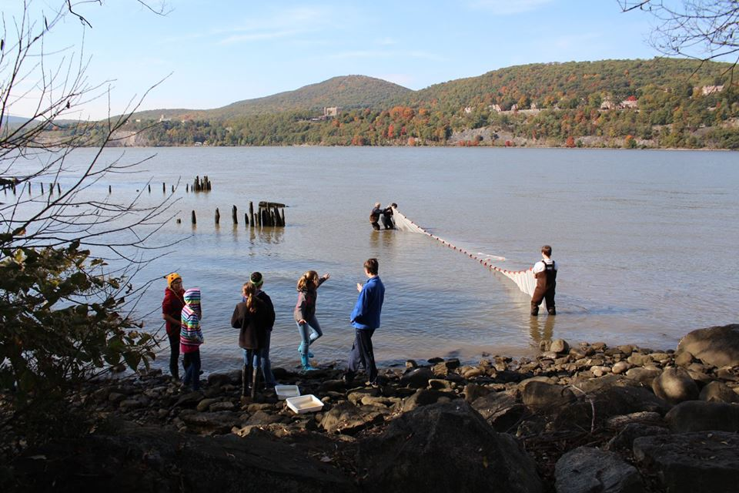
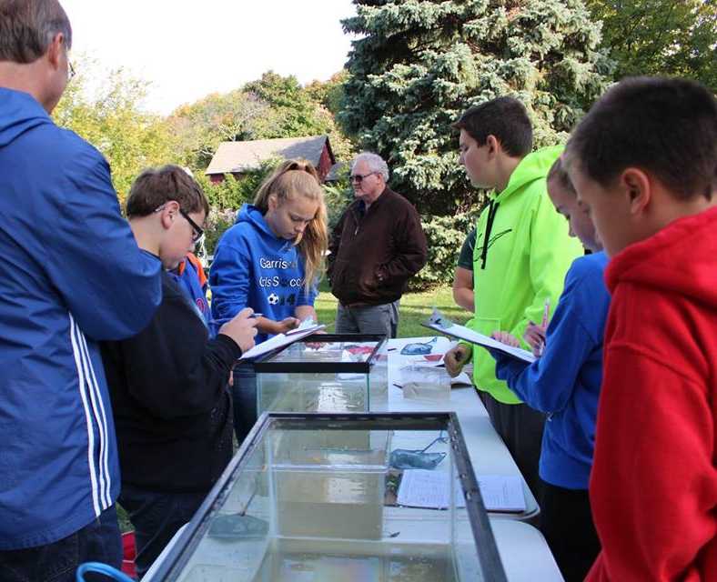 | 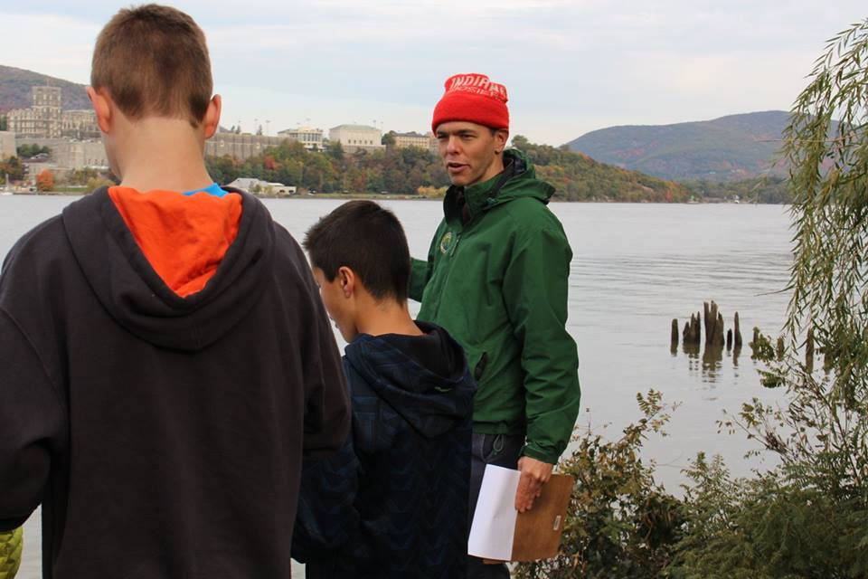

Location: Garrison Landing Park, Garrison, Putnam County, NY
Area: Waterfront beach area on front of grassy park primarily used for boating & picnics
Surrounding Land Use: Beach 10%, Urban/residential 40%, Forested 50%
Sampling Site: Rocky shoreline, Pier, shore with bulkhead, forested, riprap, grassy, parking lot
Shoreline: Sandy, muddy, rocky
Plants in area: no plants in the water but evidence of water chesnut
Water depth: 39.5 inches
River Bottom – muddy/rocky bottom

ITEM | Time | Reading 1 |  | Comments
Physical
Air Temperature | 10:11 AM  11:08 AM  11:57 AM | 48 °F  63  57 | 9°C  17  14
Wind Speed | Beaufort # | Knots | Mph | Direction
11:14 AM | Force #1.5 |  |  | S,S,NE
Cloud Cover | 10:15 AM  12:00 PM | 0-25% cover
Weather today | No rain
Weather recently | Windy and cold
Water Surface | Calm & choppy at times
Water Temperature | 9:20 AM  10:30  11:35 | 17.5°C  16  20 | 1-2 ft water
Turbidity – short site tube | 12:04 PM | 88 JTU  130 JTU  200 JTU
Chemical
DO -colormetric analysis | 9:36 AM  10:46  11:49 | 7 mg/L  8  10 | 17.5°C  16  20 | 72.5 %  80%  107%
pH – color match test | Time | Reading |  | Averages
 | 9:25 AM  9:29 AM  10:30 AM  11:32 AM | 6  7  6.5, 7.5  7, 7.5
Salinity - quantab | 9:49 AM  10:39 AM  11:52 AM | 780 ppm Cl  675  675 | 1409 ppm  1219  1219 | Total Salinity
Tides | Time | Inches
 | 9:29 AM  9:45  10:00  10:15  10:52  11:14  11:35 | 42 “  43  44  46  6 below original  1.3 below  5.75 below | Flood  Flood  Flood  Flood  Ebb  Ebb  Ebb
Currents/Time | Cm/30 secs | Cm/Sec | Knots | Ebb/Flood/ Still
10:10 AM  10:58 AM  11:55 AM  12:15 PM | 165/30  210 cm  120/30 | 5.5 cm/sec  7 cm/sec  4 cm |  | Ebb  Flood  Still
Seine – 60 ft. X 94.2 ft. pull – ¼ inch mesh | SPECIES | 9:30 SEINE | 10:40 SEINE | 11:06 SEINE
 | Hog Choker | 4 | 4 | 0
 | White Perch | 5 | 8 | 0
 | Alewife | 36 | 0 | 0
 | American Shad | 4 | 0 | 0
 | Smallmouth Bass | 1 | 0 | 0
 | Atlantic Silverside | 16 | 1 | 5
 | Striped Bass | 3 | 2 | 1
 | Pumpkinseed | 1 | 2 | 0
 | Spottail Shiner | 1 | 5 | 0
 | Channel Catfish | 2 | 0 | 0
 | American Eel | 2 | 0 | 0
 | Yellow Perch | 11 | 0 | 0
 | Tessellated Dater | 1 | 0 | 0
Fish TOTALS 115 | DIV 13 | 87 | 22 | 6
Macroinvertebrates | Blue Crab | 0 | 5 | 0
Macro totals |  | Diversity 1 | Totals 5
Traffic – Commerical
Sediment Core – | Length/ Description | Abundant – | Common | Rare
Core 1 | 3 inches  H2S smell  Oil | Clay | Mud | Sand
Core 2 | 12 inches  H2S smell | Clay | Mud | Sand

