Day in the Life of the Hudson River 10/20/15 Data
RIVER MILE 52.5
Constitution Marsh Audubon Center & Sanctuary, Cold Spring, Putnam
Rebecca Schultz, Constitution Marsh Audubon Center & Sanctuary
Kerry DiMeo, San Miguel Academy, Newburgh
11 fifth graders & 6 adults
Latitude N 41°402766 - Longitude W -73°939834
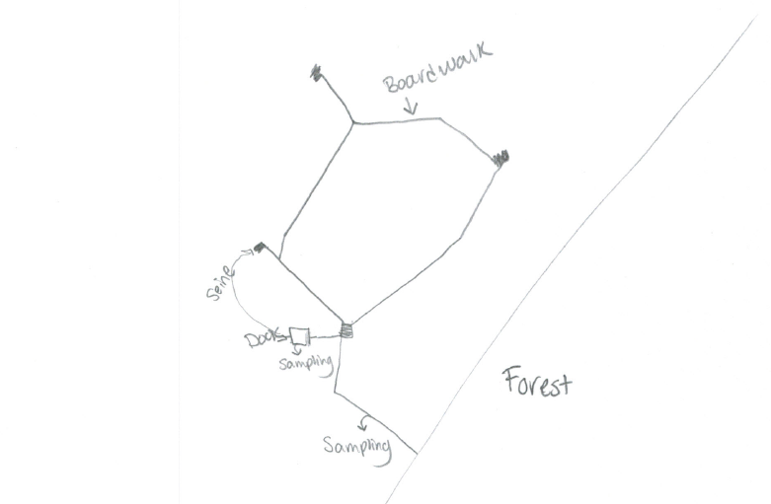
Location: Boardwalk at Constitution Marsh, Cold Spring, Putnam County
Area: located in a emergent marsh, range of herbaceous plants
Surrounding Land Use: 100% Tidal Marsh
Sampling Site: In the midst of plant material off a boardwalk. Covered with vegetation
Shoreline: Sandy, muddy, rocky
Plants in area: Narrow leaf cattail 60%, Arrow Arum 10%, Arrowhead 5%, Wild rice 10%, Pickerelweed 5% water hemp, swamp rose mallow >5%, Jewelweed >5%
Percent of site covered with vegetation: 40%
Tidal Shallows: Water Milfoinl
Water depth: 6 inches to a few feet
River Bottom – muddy, weedy
ITEM | Time |  |  | Reading 1 |  |  | Reading 2 | Comments
Physical
Air Temperature | 1:00 PM  1:27 PM |  |  | 60 ºF  69 ºF |  |  | 15.56 ºC  20.56 ºC
Wind Speed | 1:30 AM |  |  | Beaufort 1
Cloud Cover | 1:00 PM |  |  | Clear 26-51% partly cloudy
Weather today | No rain, warmed up during sampling
Weather recently | Very cold weekend
Water Surface | Calm
Water  Temperature | 1:45 PM |  | 58 ºF |  |  |  | 14.44ºC
Turbidity – | 1:13 PM |  | >30.5 cm  *secchi |  |  |  | *Hit bottom so could not do accurately
Chemical
DO  (drop kits) | NR
pH  Indicator solution | 1:24 PM |  | 6  6 |  |  |  | Average 6
Salinity -  refractometer | 1:30 PM |  | 4 ppt  4.0 |  |  |  | Average 4.0 ppt
Fish Catch- 12:05 AM | Number Caught |  | Species |  |  |  | Size of largest |  | Seine
60 ft net X 4ft– 50 ft. pull | 1 |  | Brown Bullhead |  |  |  | 7 cm |  | Seine #1  11:00 AM
 | 2 |  | Pumpkinseed |  |  |  | 12.5 cm |  | Diversity 4
 | 3 |  | Banded Killifish |  |  |  | 7.8 cm |  | Totals 32
 | 26 |  | Spottail Shiner |  |  |  | 10.2 cm
 | 1 |  | Atlantic Silverside |  |  |  | 8.1 cm |  | Seine #2 11:25 AM
 | 14 |  | Spottail Shiner |  |  |  | 10.5 cm |  | Diversity 5
 | 1 |  | Brown Bullhead |  |  |  | 8.7 cm |  | Totals 19
 | 1 |  | Striped Bass |  |  |  | 7 cm
 | 2 |  | Banded Killifish |  |  |  | 8.9 cm
Total Catch 51 |  |  | Total Diversity - 6 |  |  |  |  |  | 2 Seines
Seine #1 | 11:00 AM |  | Catch 32 |  |  |  | 55 ft. pull |  | CPUE 0.032
Seine #2 | 11:25 AM |  | Catch 19 |  |  |  | 55 ft. pull |  | CPUE 0.019
Macro | 1 |  | Crangon Shrimp
Tides | 12:58 PM |  | Rising |  |  |  | 20 cm |  | Set point
 |  | 1:20 PM | Rising |  |  |  | 31 cm |  | 0.5 cm/min
 |  | 1:31 PM | Rising |  |  |  | 33 cm |  | Set Point
 |  | 1:42 PM | Rising |  |  |  | 39 cm |  | 0.54 cm/min
Current * |  | Time | Cm/30 sec |  | Cm/sec | Kts | North/  South |  | Ebb/Flood
Note the wind was definitely ‘speeding things up’ |  | 1:07 PM | 76 |  | 2.53 | 0.05 | North |  | Flood
 |  | 1:20 PM | 45 |  | 1.50 | 0.03 | North |  | Flood
 |  | 1:33 PM | 35 |  | 1.17 | 0.02 | North |  | Flood
Birds |  | Crows, wood ducks, dragonfly and other waterfowl

