Day in the Life of the Hudson River 10/20/15 Data
RIVER MILE 76
Waryas Park, Poughkeepsie, Dutchess County
Sharon Ellis, Walkill HS, 25 students, 9th gr Living Environment, 3 adult
N 41°7056’ – W -73°9403’

Location: Waryas Park, Poughkeepsie, New York.
Area: public park, pier, grassy, parking lot. Park used for fishing, small boat launch, another pier for small boat launching
Surrounding Land Use: 75 % industrial/commercial; 25% park area with grass and waterfront docks
Sampling Site: shoreline is 100% riprap along the water with vegetation, banks altered, pier, alongside and behind
Plants in area: No plants in water area
Tidal Shallows:
River Bottom - rocky

ITEM | Time |  | Reading 1 | Reading 2 | Comments
Physical
Air Temperature |  |  | Chillier than expected!
Wind Speed | 11:23 PM |  | #2
Cloud Cover | 10:30 AM |  | Partly cloudy | 26-50%
Water | choppy
Observations
Water Temp. | 10:41 AM | 17 degrees C |  | 60 degrees F |  | Direct sun
Turbidity – long site tube | 11:19 AM | 33 cm  34 cm  30 cm |  |  |  | 32.3 average
Chemical
DO - LaMotte kit | Unable to collect | Chemicals expired
pH – color match | 10:50 AM  11:20 AM  11:36 AM | 7.5  7.5  7.5 |  | 7.5  7.5  7.5 |  | 7.5 Averages  7.5  7.5
Salinity - | 10:38 AM | 1.5 on strip |  | 41 ppm Cl- |  | 74 ppm total salinity
Fish Catch – 10feet net | Number Caught | Species |  | Largest
Unable to catch anything
Tides
Currents | 10:15 AM | 180cm/30sec |  | 3cm/sec |  | 0.06 kts. EBB
Core – 10:30 AM | Length of Core | Rare |  | Common |  | Abundant
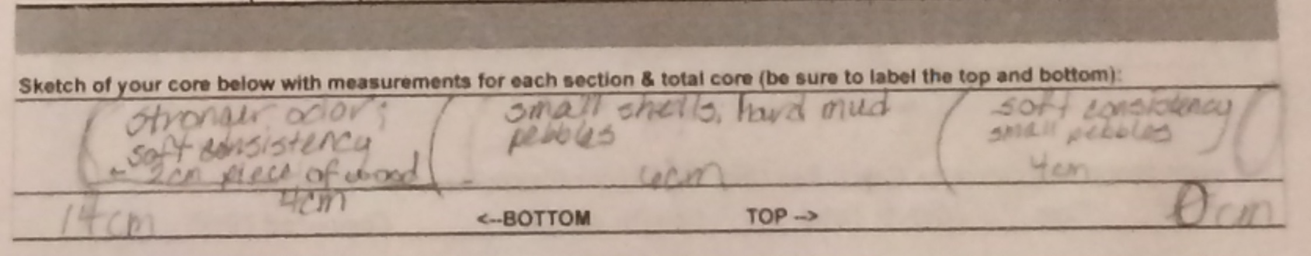
Description - strong odor, soft consistency, 2 cm piece of wood, small shells hard mud | 14 cm long – H2S smell | Brick  Coal  Slag  Living Vegetation |  | Mud  Pebbles  Wood  Shells
Shipping | 12:00 PM | Barge – Black |  | southbound |  | Loaded
 | 12:18 PM | Barge – Gray |  | Northbound |  | Loaded
Observations | Brick, water chestnut seeds

