Day in the Life of the Hudson River 10/20/15
RIVER MILE 84.5
Mills-Norrie Point Environmental Center, Staatsburgh, NY, Dutchess County
Jim Herrington, Norrie Point Environmental Center
Maribel Pregnall, Arlington High School
22 High School 12th graders, 5 adults
Shannon Considine, Poughkeepsie High School
18 High School students
41.8319 N – 73.9425W
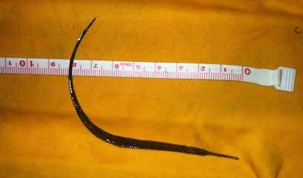
Northern Pipefish Netted well up into the freshwater section of the Hudson!
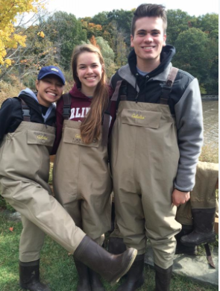
Location: Sampling done Norrie Cove and the SW corner of Norrie Point Env. Center Patio. East side of Hudson far from the main channel in a protected cove
Area: Substantial paved areas nearby, large environmental center building adjacent to the water. Shallow cove, facing south onto the HR, bordered by RR embankment, parking lot & the environmental center.
Surrounding Land Use: 90% Forested; 10% Parking lot, road and building
Sampling Site: Front banks altered, Rip Rap. Cove is very muddy with some riprap and west side is rocky
Shoreline: beach area, shore with bulkhead, shoreline rip rap, banks altered for EEC building, riprap along RR tracks, collected wood and debris in shallow cove, piping entering river area
Plants in area: All water chestnut had died back leaving only detritus; some water milfoil (several big patches 10X10 ft.; Some water celery in rocky river side but none in cove.
River Bottom –50% muddy and 50% rocky
Water Depth – 2 ft.

ITEM |  | Time | Reading 1 |  |  |  | Reading 2 | Comments
Physical |  | Time
Air Temperature |  | 10:19 AM  11:00 AM  12:40 PM | 14°C  14°C  20°C |  |  |  | 57.2°F  57.2°F  68°F
Wind Speed |  | 10:25AM | Anemometer 4.3 mph |  |  |  | SE
Cloud Cover |  | Partly cloudy 26-51%
Weather today |  | No precip
Weather recently |  | Very cold both 10/18 and 10/19 snow flurries and temps. Down to teens
Water Surface |  | Choppy
Water Temperature – cloudy |  | 10:19 AM  11:00 AM  12:00 PM |  | 14°C  14  14 | 57.2°F  57.2°F  57.2°F
Turbidity |  | TIME |  | Cm
When 2 barges went by visibility went to 6-8 cm |  | 10:19 AM  11:00 AM  12:00 PM |  | 34 cm  34 cm  34 cm
Chemical
DO - (Hach drop count) |  | ALL DAY |  | 8 mg/L | 14°C |  |  | 80%
pH – indicator solution |  | Time |  | Reading #1 | Reading #2 |  |  | Average
 |  | 10:19 AM  11:00 AM  12:00 PM |  | 7.2  7.2  7.4 | 7.4  7.5 |  |  | Avg 7.3  Avg 7.35  Avg 7.4
Salinity |  | Time |  | Chl-units | Chloride |  |  | Total Salinity
Quantabs |  | 10:19 AM  11:00 AM  12:00 PM |  | 1.4  1.5  1.5 | 39 ppm  46 ppm  46 ppm |  |  | 70 ppm  83 ppm  83 ppm
Fish Catch – 9 pulls  ~50 ft. net | 10:20 AM |  |  | 11:19 AM |  | 12:30 PM |  |  | Species Totals
Striped Bass | 2 |  |  | 3 |  |  |  |  | 5
Banded Killifish | 6 |  |  | 1 |  | 1 |  |  | 8
White Catfish | 2 |  |  |  |  | 4 |  |  | 6
Brown Bullhead | 1 |  |  | 4 |  | 5 |  |  | 10
Pumpkinseed | 3 |  |  | 1 |  |  |  |  | 4
Bluegill Sunfish | 2 |  |  | 1 |  |  |  |  | 3
Tesselated Darter |  |  |  | 1 |  | 3 |  |  | 4
White Perch | 1 |  |  | 3 |  |  |  |  | 4
Spottail Shiner | 15 |  |  | 7 |  | 4 |  |  | 26
Northern Pipefish |  |  |  | 1 |  |  |  |  | 1
Largemouth Bass |  |  |  |  |  | 1 |  |  | 1
Blue Crab |  |  |  | 1 Male |  |  |  |  | 1
River Herring & Shad | Caught & returned |  |  | Caught & returned |  | Caught & returned |  |  | >25 (use #25)
Fish Diversity & Totals | Div – 8  Totals - 33 |  |  | Div – 9,  Totals-22  + 1 crab |  | Div – 6  Totals – 18 |  |  |  | Div 13 +crab  Totals - ~98 +1 crab
Tides | time |  |  | cm |  | Rising/Falling |  |  |  | Cm difference
 | 10:00 AM  10:50 AM  11:00 AM  12:10 PM  12:40 PM |  |  | 20 cm  15 cm  13 cm  6 cm  4 cm |  | Ebbing all during sampling |  |  |  | 0  5 cm  2 cm  7 cm  2 cm
Currents | Times |  |  | Cm/30 sec |  | Cm/sec |  |  |  | Kts – N/S
Ebbing whole time | 10:15 AM  12:18 PM |  |  | 106 cm  148 cm |  | 3.5 cm/sec  5 cm/sec |  |  |  | 0.16 South  0.1 South
Shipping -Commercial | Type |  |  | Name |  | North/South |  |  |  | Loaded /Light
11:10 AM | Barge with tug |  |  | Black/  Red |  | South |  |  |  | Light
12:19 PM | DEC Electro-shocker Whaler |  |  |  |  | North
Shipping -Recreational | Type |  |  | Color |  | North/South |  |  |  | Note
9:50 AM | Sailboat |  |  | Red |  | North
11:13 AM | Motorboat |  |  | Red/  White |  | South |  |  |  | ~18 ft
11:19 AM | Pleasure boat |  |  | White |  | South
12:20 PM | Small Yacht |  |  | White |  | South |  |  |  | ~20 ft.

