Day in the Life of the Hudson River 10/20/15 Data
(Salt Front RM 63.6)
RIVER MILE 92
Kingston Point Park, Kingston, Ulster County
GPS Latitude 41°55.6 N Longitude 73°57.90 W
Steve & Julie Noble, Forsyth Nature Center (Site Hosts)
C. Sunzi, George Washington ES– 3&4th grade, 21 students, 5 adults
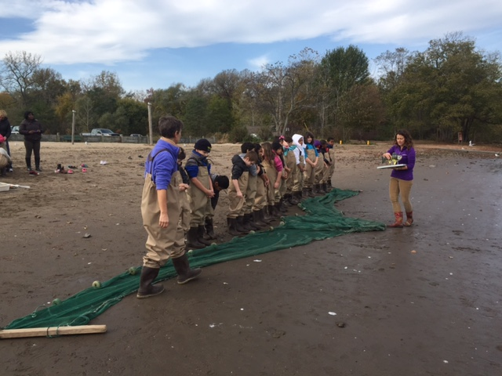 | 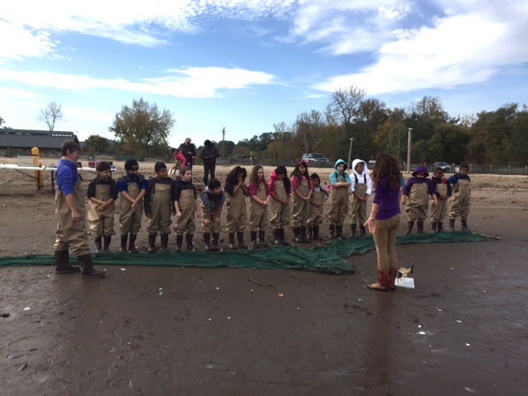

Location: Swimming Beach Kingston Point, City of Kingston, forested, beach and parking lot
Area:, Used for picnics, boating, fishing, swimming, jogging, kayaking
Surrounding Land Use: 75% forested; 20% beach; 5% Industrial/Commercial
Sampling Site: Beach area - shoreline is sandy with some bricks, banks are altered, collected wood debris in the area, rip rap to north along brickyard shoreline. Sandy shoreline 75 feet from shoreline to parking lot, 200 feet wide with boat launch, large amount of brick debris from prior industry
Plants in area: 10% water chestnut
Water depth: 0 depth
River Bottom : sandy

ITEM | Time |  | Reading 1 | Reading 2 | Comments
Physical
Air Temperature | 1:30 PM |  | 66°F  19°C
Wind Speed | 1:20 PM |  |  | 1.5 mph | meter
Cloud Cover | 10:30 -12:30 PM |  | Mostly cloudy 51-75% cover
Weather today | Cold no rain
Weather recently | Windy and cold – 49-63 F
Water Surface | Calm
Water Temperature | Time | Temperature #1 |  | Temperature #2 | Average
Water Depth 0.5 ft. | 1:30 PM | 51°F  11 °C
Chemical
DO
Test tabs
pH – pen
Salinity - Quantab |  |  |  | .
Fish Catch  30’seine X 4 ft. with bag | Number Caught- 15 | Species - 2 |  | Largest Size
11:30 AM | 10 | herring |  | 10 cm | Diversity 2
2 hauls | 5 | Striped Bass |  | 8 cm | Total 15
Tides | 10:50 AM | 0 cm
 | 11:38 AM | 0 cm
Currents | 10:50 AM  11:38 AM  11:55 AM  1:30 PM | Ebb  Ebb  Ebb  Ebb
Core Sample | Description | Rare |  | Common | Abundant
Traffic- Commercial | 10:30 AM | Bouchard |  | Black/Red | Southbound Light
Traffic – Recreational | 11:30 AM | Recreational |  | Yellow | Southbound Light
Other Items | Ring billed gulls (counted 100)  Raven  Lots of bits of brick, we are next to a non-functioning brick factory

