Snapshot Day 10/20/15 Data
Mohawk River Valley
SCHOHARIE RIVER SITE RIVER MILE
Middleburgh, NY
Mollie Burgett, Middleburgh High School & 11 students 11/12th grade
42.599640 Lat and -74.337176 Long
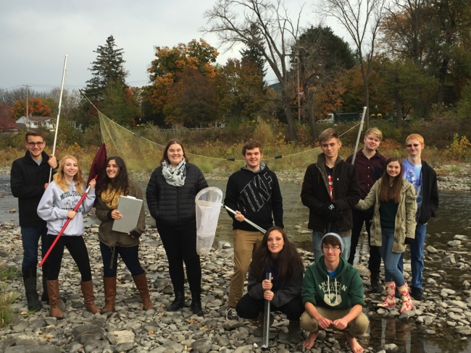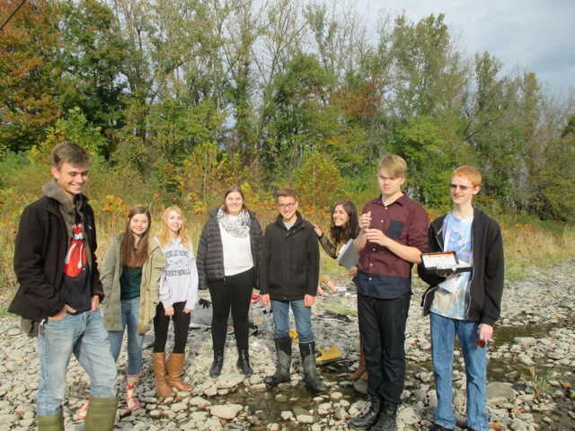
Middleburgh Sampling Team
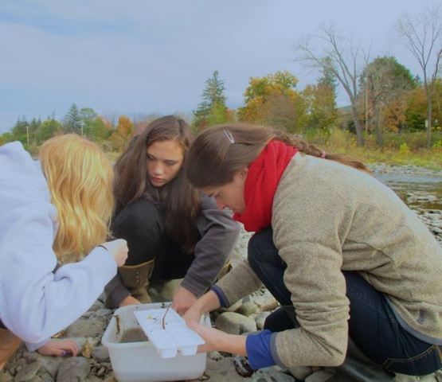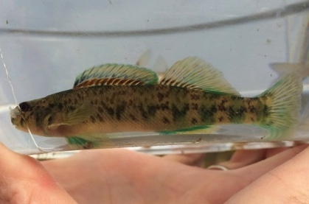
Macroinvertebrate sampling Greensided darter
Location: On the Schoharie Creek by the Bridge Into Middleburgh, Schoharie County
Sample location runs right along river street (one of the main streets in the village) and is
full of cobbles, some grasses and short shrubs under 4 feet tall. The trees along the bank on one side make a break between the road and the creek and the other side divide the creek from farm fields.
Surrounding Land Use: 45% urban/residential, 45% farmland, 10 % forested
Shoreline: Banks altered, Riprap, Concrete blocking, 1 stormdrain of some sort occasionally discharges in to the creek just down from the sample site. Lots of cobbles in stream channel, area covered in vegetation
River Bottom: Mostly rocky although sandy and muddy and brick on ground
Water Depth: 30 cm
Water Conditions: Calm, clear
Plants in water: 90 % algae, covered rocks (cobbles)

ITEM | Time |  | Reading 1 | Reading 2 | Comments
Physical
Air Temperature | 8:40 AM  8:39 AM  9:10 AM |  | 14°C  14°C  10.5°C
Wind Speed |  |  | Beaufort #1 | none
Cloud Cover | 8:40 AM |  | 26-51%
Weather today | 10:00 AM |  | sprinkles /light rain
Weather recently | 40s and some snow
Water Temperature | 9:30 AM | 8°C – 2 ft depth  9°C – ½ ft |  | Riffle
 | 8:45 AM | 8°C – ½ ft.  9  9 |  | Still water
Turbidity 60 cm  Site tube | 8:30 AM | >60 cm clarity
Chemical
DO – drop count – old kit  Riffle | 9:25 AM | 8.5°C |  | 10.4 mg/L | 90%
Still  Old kit | 8:36 AM  8:38 AM  9:05 AM | 9°C |  | 7  16.6 ??  13.6 ?? | 60%  150%  120%
pH – test strips  Average - 6.5 | Still water  9:05 AM  9:20 AM  9:20 AM  9:45 AM | 7  6  6  7 |  | Riffle  9:09 AM  9:30 AM  9:45 AM | 6.5  6  6.5
Flow Rate (no current up here) | Riffle | 92.2 cm/sec  140 cm/sec  14 cm/sec |  | Used stick  Used leaf  Used stick
 | Still water | 14.67cm/sec  46 cm/sec  2.9 cm/sec |  | Used stick  Used leaf  Used leaf
Fish –kick net 9:30 AM | 1 | Greensided darter |  | 6 cm - | DIV – 2  TOTAL- 14
Butterfly net by hand | 13 | Shiners |  | 7 cm
Large Macros | 4 | Rusty Crayfish |  | Invasive – 3 F /1 M | Div – 1  Total 4
Macroinvertebrates | Number | Species |  | 2:00 PM | Diversity 7
Kicknet &hand net | 1 | Fishfly larvae |  |  | Totals 142
 | 104 | Mayfly larvae
 | 11 | Helgramite
 | 7 | Stonefly
 | 2 | Riffle Beetle
 | 1 | Water Penny
 | 17 | Caddisfly
Core Sample | Length | Rare |  | Common | Abundant
 | No soil
Observations | 1 bird, dead vole

