Day in the Life of the Hudson River 10/20/16
(Salt Front ~RM 83)
RIVER MILE -9.1
Steeplechase Pier, Coney Island, Brooklyn NY
Deborah Sarria, Andries Hudde JHS 8th graders
60 students, 8 adults
40.5°N – 73.9°W
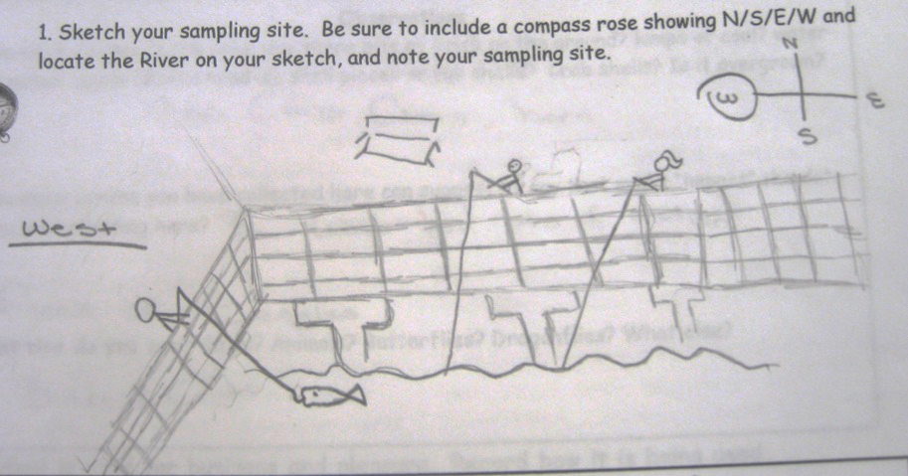
Location: Steeplechase Pier, Coney Island, Brooklyn NY
Surrounding Land Use: Urban/residential 12.5%, Beach 755, Industrial/commercial 12.5%
Sampling Site: Beach areas with pier and riprap shoreline
Plants in area: No plants in the area
River bottom: Sandy
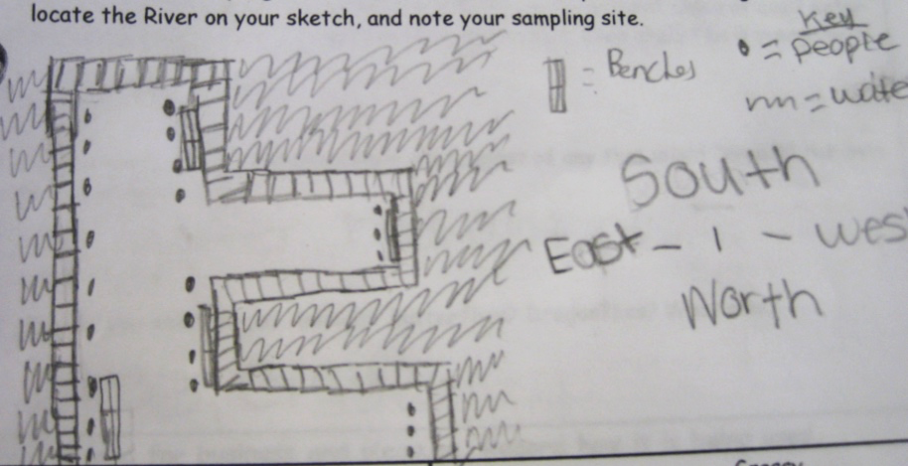
ITEM | Time |  | Reading 1 | Reading 2 | Comments
Physical
Air Temperature | 11:23 AM  12:25 PM |  | 21.7°C  21.9°C | 71°F  71°F
Wind Speed | 10.2 mph |  | East | Water Surface | Choppy
Cloud Cover | Clear |  | Weather Today | No rain
Weather last 3 days | There was no precip in the last 3 days. The cloud cover ranged from clear to part cloudy, Air temperatures 39-59°F
Water Temperature | 10:40 AM | 15°C |  | 59°F
 | 11:10 AM | 18.6°C |  | 65°F
 | 11:49 PM | 18.7°C |  | 66°F
 | 12:15 PM | 18.8 °C |  | 66°F
Turbidity  Sight Tube | 10:30 AM | 78 cm  67 cm  82 cm |  | Average  71.6 cm
 | 11:35 AM | 70 cm  48 cm  68 cm |  | Average  62.0 cm
 | 12:14 PM | 73 cm  70 cm  60 cm |  | 70.7 cm
Chemical
DO  (meter) | 10:40 AM | 15.0°C  18.6  18.7  18.8 |  | 8.6 ppm  8.7  8.7  8.2 | 80 %  90 %  90 %  85 %
pH | 10:40 AM  11:00 AM  11:49 AM  12:15 PM | 7  7  7  7 |  | Average 7
Salinity  (Hydrometer) | 1040 AM  11:15 AM  11:49 AM  12:15 PM | 32 ppt  34 ppt  28 ppt  30 ppt |  | 32 ppt  34 ppt  32 ppt  30 ppt | Avg – 32 ppt  34 ppt  30 ppt  30 ppt
Nitrates | 1040 AM  11:15 AM  11:49 AM  12:15 PM | 0 ppm  0 ppm  0 ppm  0 ppm
Phosphates | 1040 AM  11:15 AM  11:49 AM  12:15 PM | 0.25 ppm  0.25 ppm  0.25 ppm  0.25 ppm
Tides – | 11:28 AM  12:15 PM | set  Rising |  | 3000 cm  2500 cm | ----  11.1 cm/min
Currents | NR
Fish – minnow traps ------- |  | 1  1 |  | Summer Flounder  Northern Sea Robin | Diversity – 2  Total Catch –2
Macroinvertebrates |  | 1  1 |  | Blue Crab-M  Hermit Crab | Diversity – 2  Total Catch –2
Shipping - Commercial | 12:09 PM  12:09 PM | Barge  Tug Boat |  | Westbound  Westbound | Loaded
Recreational | 10:51 AM | Speedboat
Other Items | Flock of sea gulls flying around the pier, Several people fishing off of pier, strong wind kicked up mini sand storms on the beach

