Snapshot Day 10/20/16 Data
(Salt Front ~RM 83)
RIVER MILE 124.5
Nutten Hook, Green County NY
Michelle Vedder-Drew, Mud Creek ELC/Columbia County Soil & Water
Liz Pagnani , TALC
20 students 1st-9th, & 7 adults
GPS Latitude 42.358314 N Longitude -73.788151 W
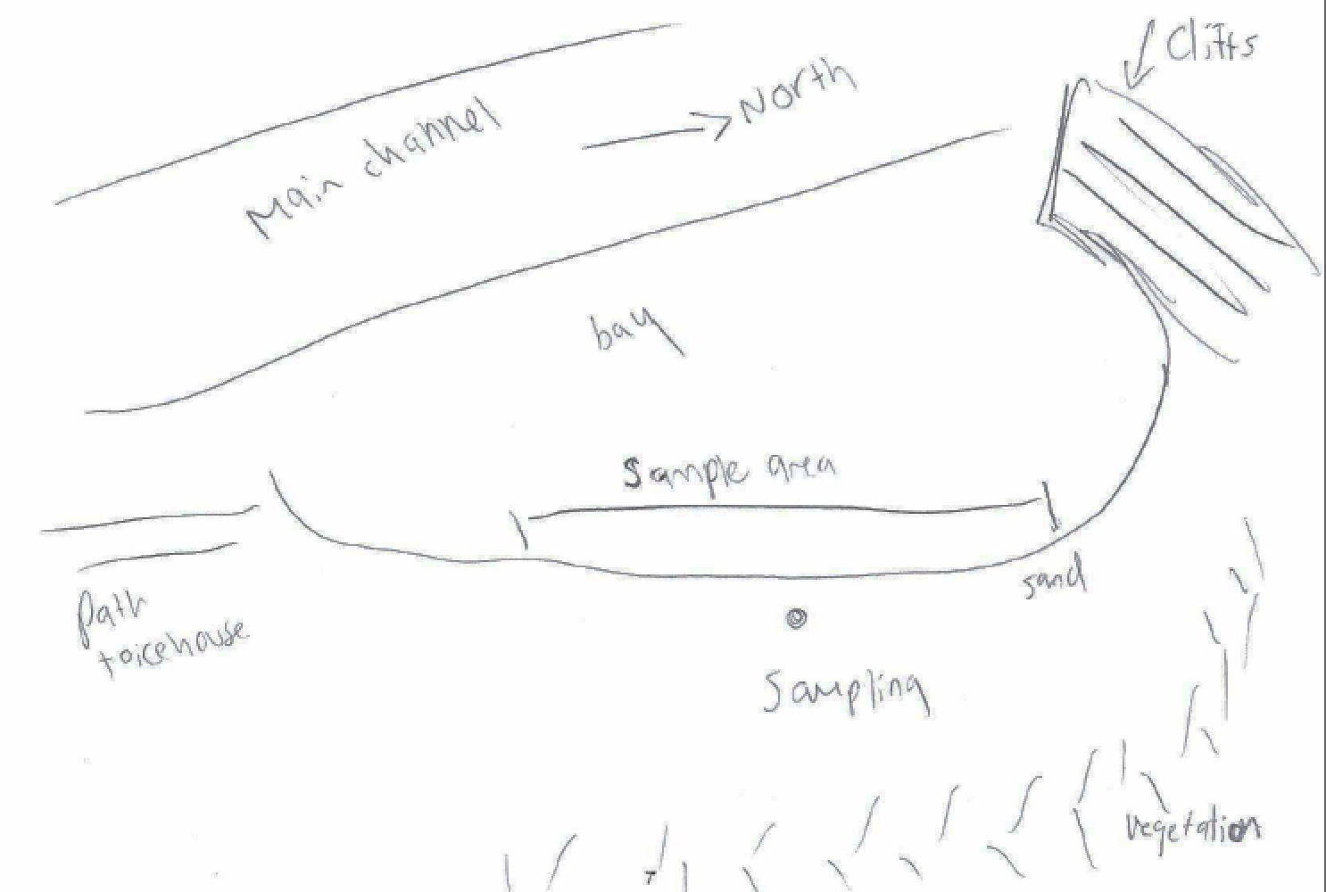

Location: Nutten Hook, Green County, NY
Area: Beach, forested bluff, large marsh behind bluff, DEC public access, used for picnics, water access
Surrounding Land Use: 45% Beach, 55% forested. Shoreline is sandy and rocky, riprap, banks altered in some areas with bulkhead, brick and slag on the ground
Shoreline: Sandy, Muddy
River Bottom: Sandy, Muddy – 3 ft. deep where sampled
Plants in area: none

ITEM | Time |  | Reading 1 | Reading 2 | Comments
Physical
Air Temperature | 1:40 PM |  | 17.7°C | 64°F
Wind Speed | 1:30 PM |  | Beaufort 1 | 2.3 kts
Cloud Cover | 1:30 |  | overcast
Weather today | By 1:50 it started to rain and was raining hard by the end of sampling
Weather recently | Warm and dry – warmer than normal
Water Temperature | 2:44 PM | 17°C |  | 62.6°F
Water calm or choppy | Calm
Turbidity – short site tube | 12:50 PM | 40 JTU  30  50 |  | Average 40 JTU
Chemical
DO  (drop count kit) | NR
pH | NR
Salinity - quantabs | 1:32 PM | 0.2 units |  | 0 ppm
Alkalinity | 1:30 | 40 ppm
Fish Catch | Number Caught | Species |  | length | Seine
40 ft. seine net X 3/8 inch mesh  Fish | 2  5 | Spottail Shiner  Mummichog |  | DIVERSITY 2 | TOTAL CATCH 7
Macro-invertebrates | 2 | Juvenile blue crab |  | DIVERSITY 2 | TOTAL CATCH 2
Tides | 1:15 PM | falling
Currents | 1:20 PM | Still |  | In a small bay | Away from the main channel
Core | Describe | Rare |  | Common | Abundant
1:03 PM | 8 cm | Gravel  Pebbles  Freshwater mussels |  | Mud | Sand
Boat Traffic | 12:55 Recreational nameless Southbound Light
Other Items | Nutten Hook was cloudy and overcast, the Hudson calm and holding its breath for the inevitable rainstorm to come. As we worked through our packets the storm approached. Slowly it began to rain softly before the sky opened up and it began to rain in earnest. We toughed it out and still had a great time! The highlight for the kids included sloshing around in the river in waders and catching two juvenile blue crabs.

