Day in the Life of the Hudson River 10/20/16
(Salt Front ~ RM 83)
RM 140 Papscanee Preserve
Staats Island Rd., Castleton-On-Hudson
Kate Perry, Parker School 2nd & 3rd and 6th & 7th, 32 students & 15 adults
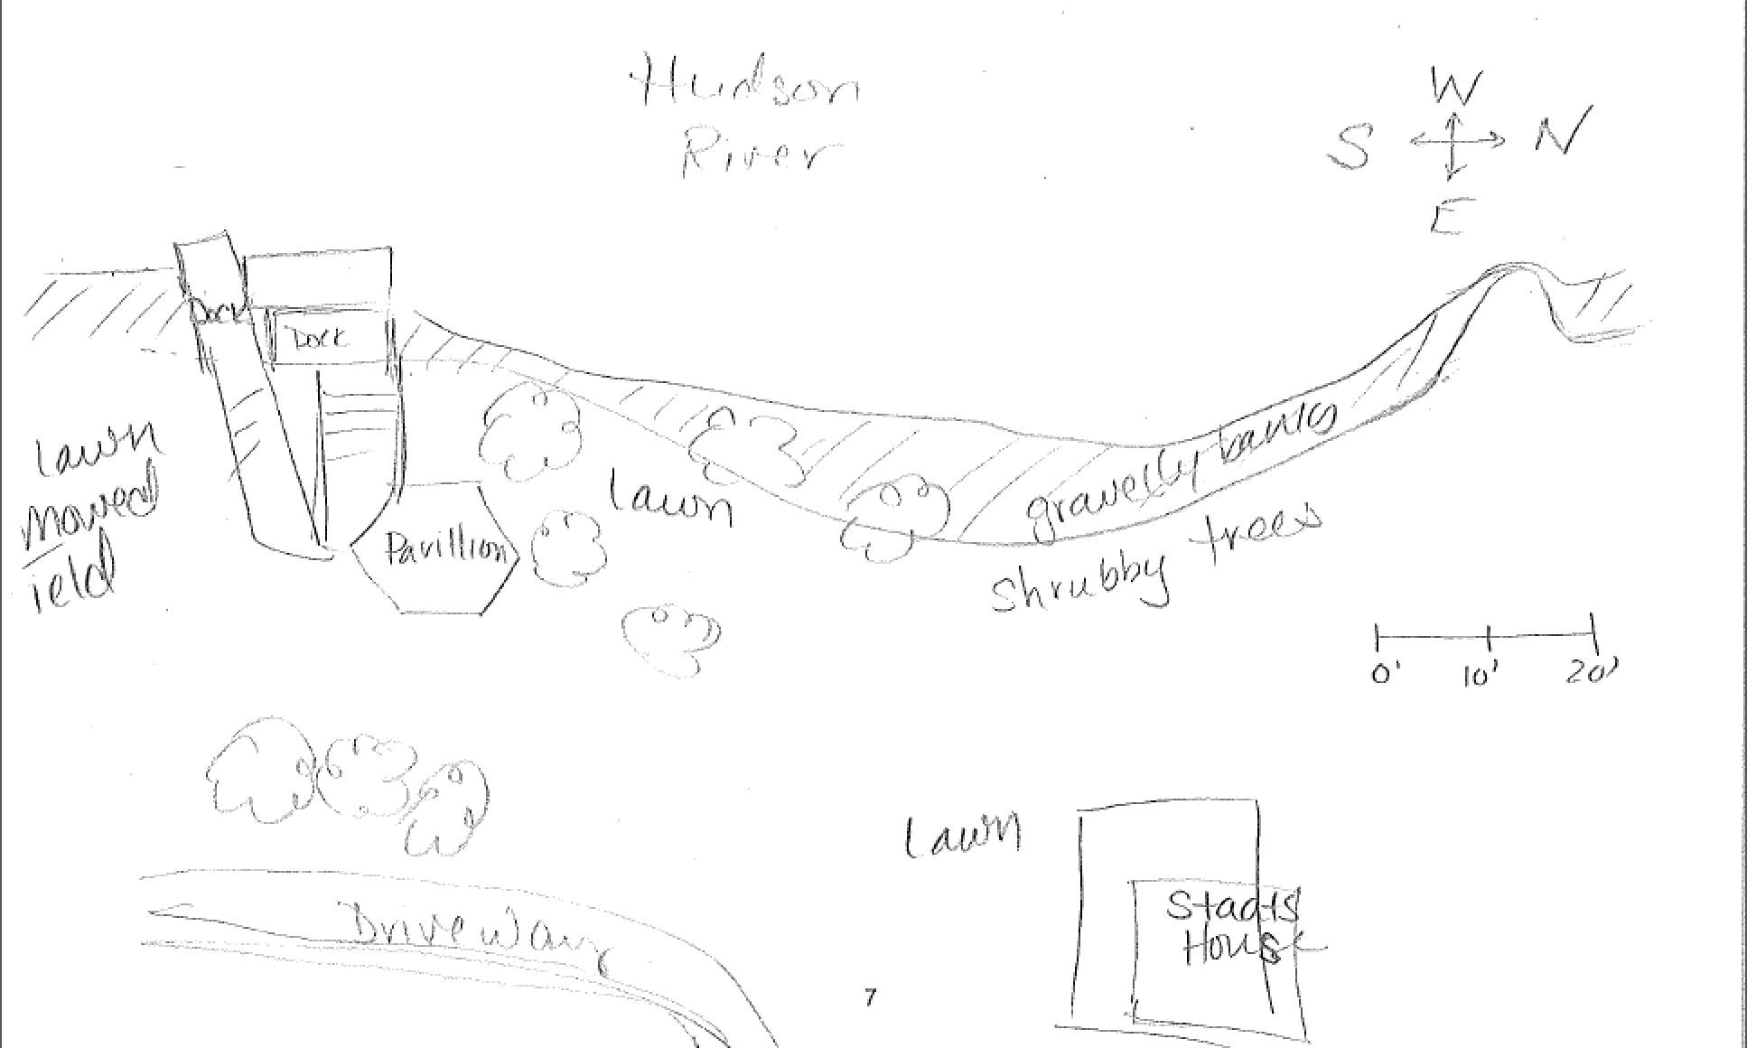
Sampling Site
Location: 150 Stats Island Rd, Staats Island, Castleton-On-Hudson, Rensselaer County
Surrounding Land Use: Urban/Residential 100%
Sampling Site: Open grassy with a dock on the site, pier, brick pieces
Plants in area: plants covered by water at highest tide – otherwise along edge – 5%.
Water milfoil and water celery, and also found 3 devil head seed pods but no water chestnut plants seen. Grasses and reeds present.
Water depth: shore to 45 cm mostly
River Bottom: rocky
NOTE: Fish catch from students listed below. DEC also brought fish including:
1 Striped Bass (15 cm)
1 Walleye (17.5 cm)
1 Black Crappy ( 7 cm)
1 catfish (22 cm)
1 American Eel (15 cm)
1 smallmouth bass (18 cm)
1 Sheepshead (12 cm)
1 Red Horse (18 cm)

All sampling occurred between 9:30-11:00 & 11:30 and 1:00 PM
 | Time |  | Reading 1 | Reading 2 | Comments
Physical
Air Temperature | 10:10 AM  11:01 AM  11:27 AM |  | 19°C  11  15 | 66.2 °F  51.8  59
Wind Speed |  |  | Beaufort 1 | N-NW
Cloud Cover | Partly cloudy with sun 10Am |  | Mostly cloudy by 11AM
Weather last 3 days | Warm and dry
Water Surface | calm
Water Temperature | 10:44 AM  11:05 AM | 16°C X 3  15.5, 16, 16 |  |  | Average 16°C
Turbidity  Long Sight Tube | 10:44 AM  11:05 AM | 41, 40, 40 cm  47, 52, 116 cm |  | AVERAGE | 40.3 cm  70.2 cm
Chemical
DO - drop count | 10:50 AM | 9.5 ppm |  | 16°C | 95% saturated
pH (test strips) | 10:44 AM  11:35 AM | 6, 6, 6  7, 7.5 |  | Avg. pH pen  chemical test | 6  7.25
Salinity -  meter | 11:25 AM | 19, 19 ppm |  | AVERAGE | 19 ppm
quantabs | 11:25 AM | 39 mg/l Cl- |  |  | 70 ppm
Tides | 9:15 AM | 48 cm |  | Down from dock
 | 12:00 PM | 123 cm |  | Down from dock | Falling –  75 cm/165 min OR  2.2 cm/min
Currents | Cm/30 sec | Cm/sec |  | Knots | N/S – Ebb/Flood
10:55 AM | 27 | 0.9 |  | 0.02 | S/Ebb
11:15 AM | 81 | 2.7 |  | 0.05 | S/Ebb
11:30 AM | 113 | 3.8 |  | 0.07 | S/Ebb
There are a few jut outs from the shore and a deck creating a small cove. Many students current data reflects their protected environment.
Sediment Core  20 cm depth | Description | Rare |  | Common
 | 6.5 cm  see sketch below | Mud  Sand  Leaves  Mussels  Brick |  | Gravel  Pebbles
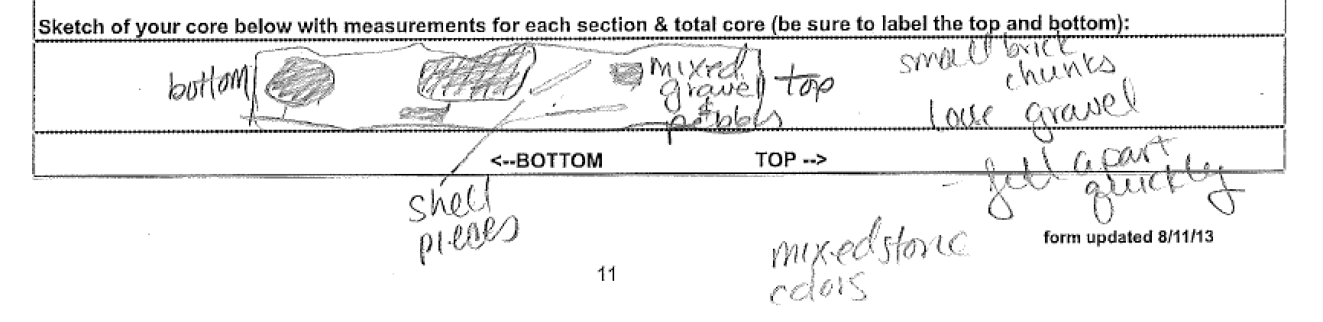
Fishing – seine 20 ft. net & a 40 ft. pull | Count | Species |  | Length largest | Seine #s
10:45 AM | 6 | Spottail Shiner |  | 9 cm | 4 in 1st seine  2 in 2nd seine
 | DIVERSITY 1 | CATCH 6
CPUE | 10:15 AM | 4 fish |  | 40 ft. pull | ~ 0.7 cpue
 | 10:30 AM | 2 fish |  | 40 ft pull | ~ 0.3 cpue
Shipping | Time | Name
 | 10:55 AM | Jane A. Bouchard |  | Oil pumper | N - loaded
 | 11:09 AM | DEC Pontoon – Scott Wells |  | Fishing boat | S - loaded
Other items of interest | Pieces of broken pottery
The beauty of the fall leaves, flowing river and grassy shore greeted us as we arrived at Staats Island. The emerging sunshine dabbled our experimenting, observing and explaining students. Our students found few animals, but were enthralled with the water and the setting of the land. Kate Perry

