Snapshot Day 10/20/16
(Saltfront ~RM 83)
RIVER MILE 14
Inwood Hill Park Nature Center, NYC
Diane Schwartz, Rochambeau Alternative High School, White Plains NY
10th-12th grade, 30 students, 4 adults
Chris Bowser, DEC HREP, HRNEER
Latitude 40°50’N/ Longitude 73°55 W
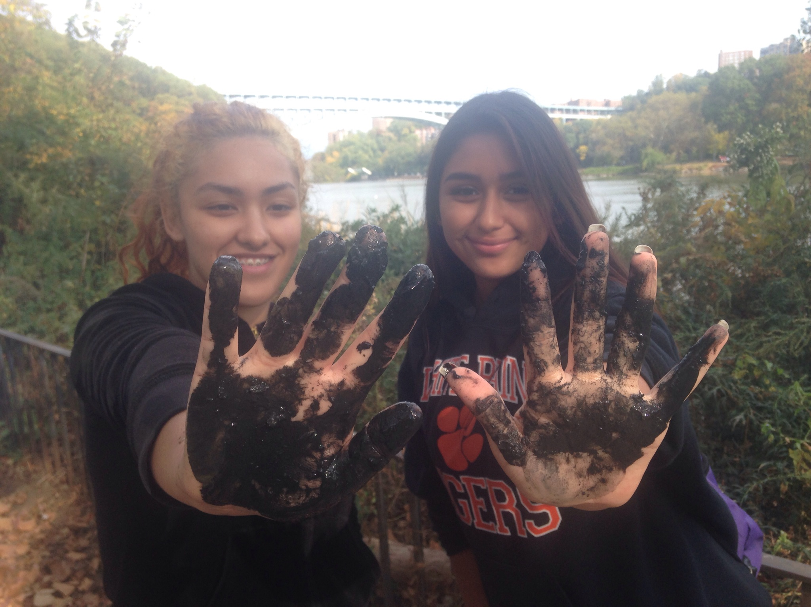 | 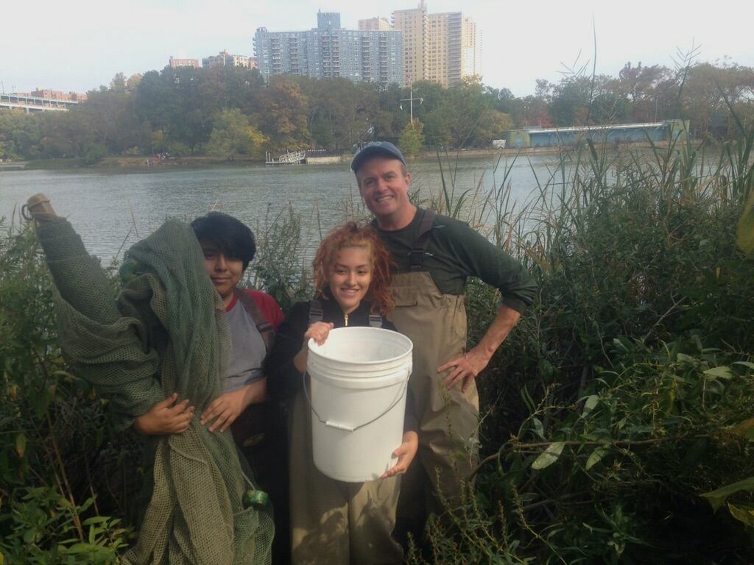
Location: In the cove of Inwood Hill Park
Area: Forested
Surrounding Land Use: Forested 60%; urban residential 40%; park/recreation; Pier, bulk-headed, rip rap shoreline. Forested and used by people for picnics, jogging, sitting on park benches.
Sampling Site: large riprap on shoreline, drainage pipes in area, vegetation
Plants in area:
Water depth: 3-4 feet
River Bottom – muddy
ITEM | Time |  | Reading 1 |  | Comments
Physical
Air Temperature | NR
Wind | NR
Cloud Cover | 26-50% |  | Partly cloudy
Weather today | No rain
Weather recently | Warm and dry
Water surface: | calm
H2O Temp. | AM | 15.5 C |  | 60 f
Turbidity | NR
Chemical
DO | NR
pH | NR
Salinity – hydrom. |  | 18 ppt
Fish Catch | Number Caught | Species |  | CPUE | Seine
Seine | 4 | Atlantic Silverside |  |  | DIV 3  TOTAL 11
 | 6 | Mummichog
 | 1 | White perch
Macroinvert | 1 | Tiny blue crab |  |  | DIV 2
 | 1 | Comb jelly |  |  | TOTALS 2
Great day! Thank you very much Chris. We look forward to getting the data from the day and doing this again next year!!

