Day in the Life of the Hudson River 10/20/16 Data
(Above the Troy Dam and the Head of Tide)
RIVER MILE 154
Peebles Island State Park, Waterford, NY
Laura Murawski, Cohoes High School
Pine Hills Elementary School
59 students – 9th & 10th grade, 5 adults total
42°47.051’N and 73°40.706 W
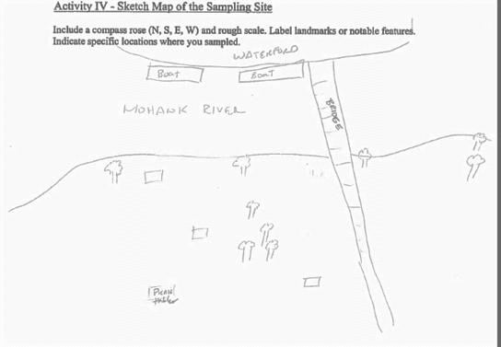
Location: Pavilion at Pebbles Island Park at the confluence of the Hudson River and the Mohawk River, Waterford, NY
Area: park just north of the Troy dam at the pavilion, grassy embankment, rip rap
Surrounding Land Use: 25% forested, 75% grassy
Sampling Site: Park area
Shoreline: riprap
Plants in area: about 20% has plants - unidentified
Water depth: 12 inches
River Bottom description: sandy and rocky
 | Time |  | Reading 1 | Reading 2 | Comments
Physical
Air Temperature | 9:15AM  11:00 AM |  | 51°F  51°F | 10.6°C  10.6°C
Wind Speed | AM |  | Beaufort #1
Cloud Cover | Mostly cloudy
Weather today | Precipitation 0.51 inches – nice in the AM, then cloudy, then heavy rain about noon
Weather recently | Sunny and warm, yesterday was also windy
Water surface | Calm
Water Temperature | 9:15 AM  9:54 AM  10:45 AM | 13°C  11  12 |  | 52°F  51.8  53.6 | X 3  X 2  X 2
Turbidity –  long site tube | 9:08 AM | 98.8 cm  116.8 cm  118.6 cm |  |  | Avg 111.4 cm
Chemical | Time | Water Temp |  | ppm | saturation
DO - drop count | 11:05 AM | 12 °C |  | 9 | 80%
pH – meter | 9:59 AM | 6.5  7.5  6 |  |  | Average 6.7
Fish Catch – 10 ft. net | Number | Species |  | Size largest
8ft – 1/4 inch mesh- 25ft pull | 5 | Spottail shiner |  | 5 cm | 4 seines
 | Diversity 1 | Totals 5
Water Level | Time | Height |  | Change | Change Rate
This is above the head of tide. | 9:15 AM | No change
 | 9:43 AM
 | 10:17 AM
 | 11:07 AM
Water Flow Velocity | Time | Rate of flow |  | Knots | Flow
Mohawk River Flow – there are some large boats in the area that may influence rate of flow | 9:15 AM | 3.4 cm/sec |  | 0.066 | East
 | 10:15 AM | 11.08 cm/sec |  | 0.22
 | 11:00 AM | 9.2 cm/sec |  | 0.18
Sediment Core | Description | Rare |  | Common | Abundant
 | 28 cm length | none |  | Sand | Clay
 | H2S smell |  |  |  | Mud
Boat Traffic - recreational | 9:07 AM  11:30 AM | Kayak  Yacht |  | W  S | Into Mohawk
Commercial | 10:30 AM | Large Boat |  | N
Other | 1 leaned a lot about how to better collect & organize the data for next year, but not bad for the first time.

