Day in the Life of the Hudson River 10/20/16
(Saltfront ~RM 83)
RIVER MILE 17
Mt. St. Vincent College Campus, NYC
Patricia Grove & Tara Anderson – Mt. St. Vincent College – 2 adults, 5 students
Latitude 40°54.46 N Longitude 73°54.41 W
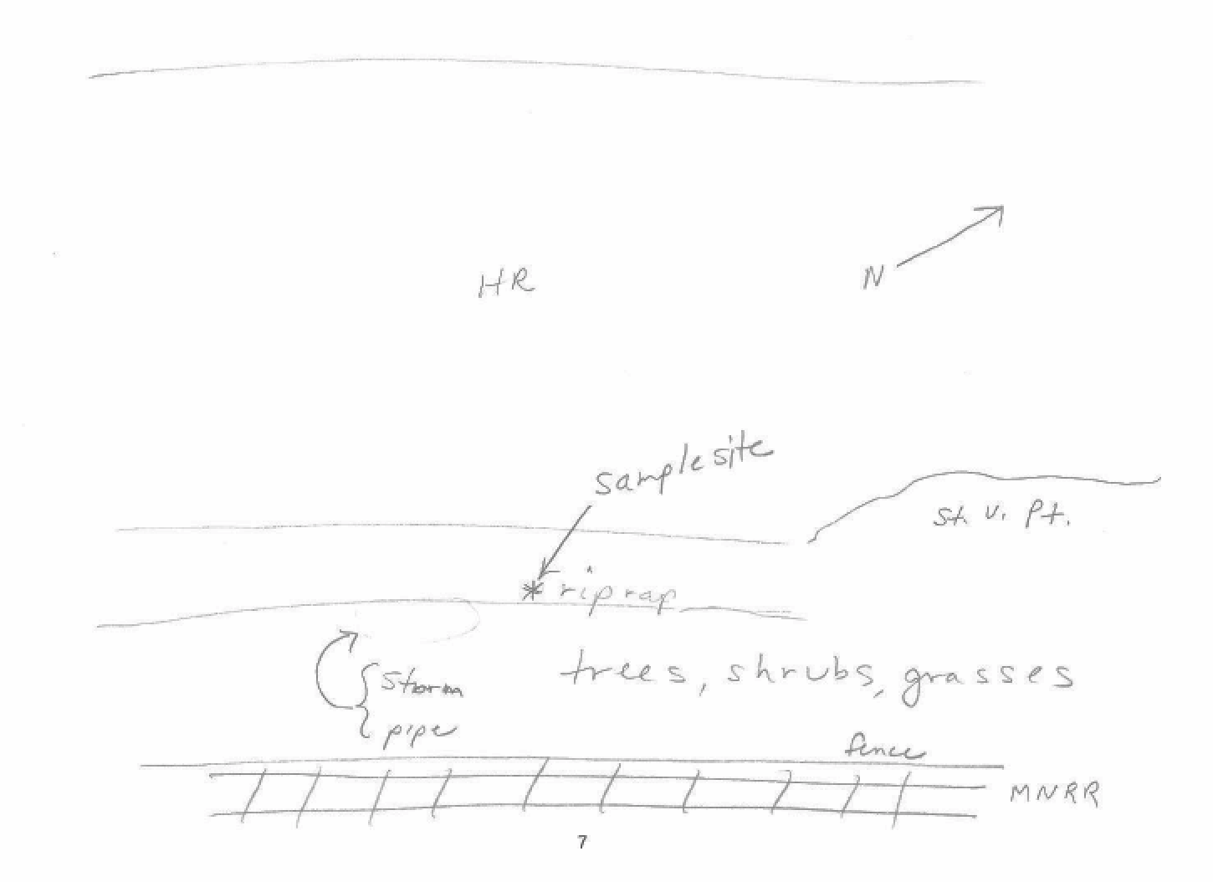
Location: Waterfront of Mt. St. Vincent’s College
Area: Forested, grassy
Surrounding Land Use: Forested 25%, Academic Environment 75%
Sampling Site: Shoreline is 100% rocky –bulkhead, drainage pipes in area, beach area, covered in vegetation, 50 cm storm pipe near site
Plants in water of sampling area: no plants in the water
Plants in the area: No plants in water area
Water depth: NR
River Bottom – sandy/rocky
ITEM | Time |  | Reading 1 | Reading 2 | Comments
Physical
Air Temperature | 1:33 PM  1:07 PM |  | 68° F  64.4 | 20°C  18°C
Wind Speed | 1:30 PM |  | Beaufort #2.7 | 1.5-2.0 kts – gusting to 4.2 kts | S
Cloud Cover | 1:30 PM |  | Partly cloudy
Weather today | No rain
Weather recently | Record high temperatures!
Water Temperature – | 1:08 PM | 20°C  18 |  | 68°F  64.4
Water surface: | calm
Turbidity  Long site tube | 12:40 PM | 21 cm
Chemical
DO  LaMotte kit 7414 | 1:27 PM | 4.0 mg/L |  | Temp 18° C | 40% saturated
pH – LaMotte kit 5858 | 1:39 PM | 10
Salinity -  refractometer | 1:06 PM | 18 ppt  17  18 |  |  | 17.7 ppt
Nitrates | 1:19 PM | 2.0 ppm
Phosphates | 1:34 PM | <1 ppm
Alkalinity | 1:21 PM | 60 ppm  58 ppm |  |  | 59 ppm avg.
Fish Catch | Number Caught | Species |  | Length
Tides | 1:33 PM |  |  | flood
Currents | 1:59 PM | 3.03 cm/sec |  | 0.059 kts | N Flood
Note | St. Vincent Point juts out into the river N of our sampling site
Traffic – commercial | 1:10 PM | Tugboat & Barge |  | South
 | 12:45 PM | Tug & Barge |  | North
Recreational | 1:15 PM |  |  | South
 | 1:42 PM | Speedboat |  | South
 | 1:49 PM | Majestic Princess |  | South
Other observations | Geese | Turkey Vulture |  | Blue Jay

