A Day in the Life of the Hudson River 10/20/16 Data
(Salt Front ~HR RM 80)
RIVER MILE East River 1
Janet Villas, Brooklyn Friends School, 47 eight graders, and 5 adults
Isa Del Bello and staff from the Brooklyn Bridge Conservancy
Latitude 40.704546 – Longitude 73.988771
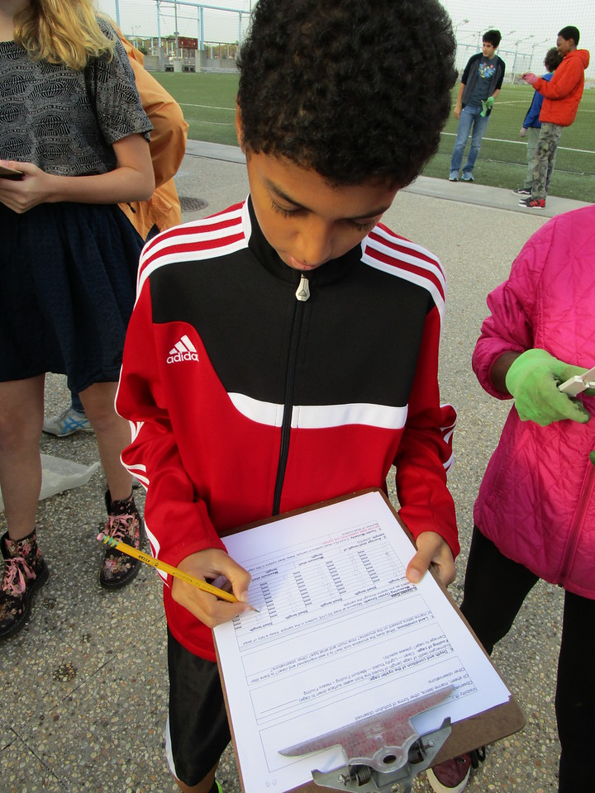 | 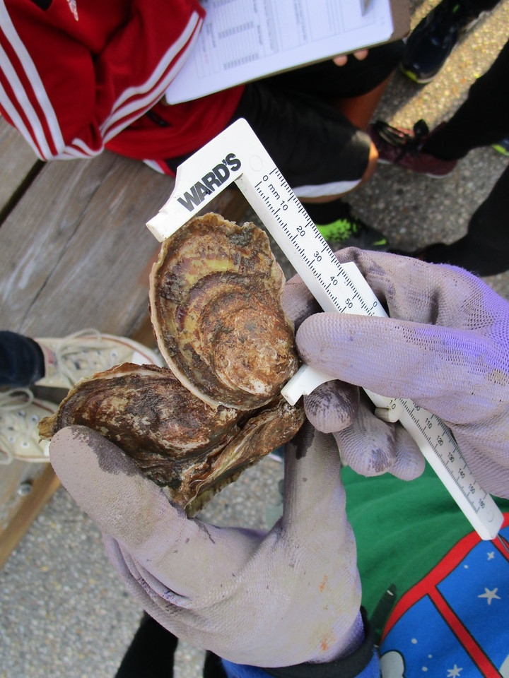 | 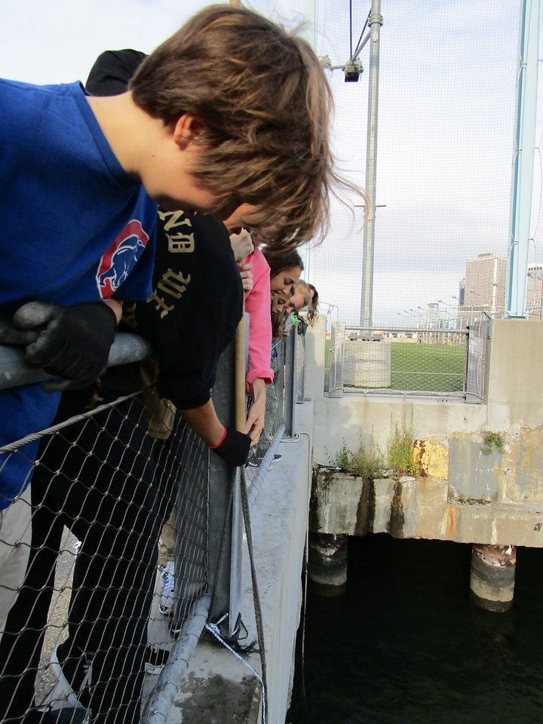
Location: East River, south of the Manhattan Bridge @ the new Brooklyn Bridge Park, Dumbo Section
Area: 100% Urban residential, Park
Surrounding Land Use: pier, grassy
Sampling Site: Sandy beach and riprap, rocky
Plants in area: no plants noted in water
Water depth:
River Bottom: Sandy
ITEM | TIME | 10/16/14 Data | TIME | 10/20/14 Data
Physical
Air Temperature | 8:50 AM | 20 °C  18.5°C | 68°F  65°F | 19.25°C Avg  66.5°F
Wind Speed | Beaufort 2
Cloud Cover | Mostly Cloudy 51-75%
Weather today | cloudy
Weather last 3 days | Dry, dry and hot
Water Surface | Choppy
Water Temp. | 8:50 AM | 18.5°C  18.0  18.5 | 18.3°C average
Turbidity – secchi | 9:10 AM | 100 cm  150 cm  100 cm | 125 cm
Turbidity – long sight tube | 9:00 AM | 55 cm  55cm  55cm | 55 cm | Very clear water today
Chemical
DO -vernier | 9:20 AM | 13.7 ppm | 18.55%
pH - meter | 8:45 AM | 7.6 |  | 8
Salinity – vernier meter | 8:45 AM  later reading | 20.4 ppt  20.4  20.4  21.3 ppt |  | 20.4 ppt
Nitrates | 9:15 AM | 1.0  1.0  1.0 | 1.0 ppm
Fish | 1 | Small bluefish | 10 cm
Tides | 8:50 AM | Coming in
Currents | 8:50 AM | NY harbor – | very busy and very deep so not collected
Boats | So many boats! Ferries, boats, big and small! Way to many to count!!!
Other Items | Oyster cage had blue mussels in it.

