Day in the Life of the Hudson River 10/20/16 Data
(Salt Front ~RM 83)
RIVER MILE 25.4W
Piermont Pier
Margie Turrin & 12 Lamont Scientists, Lamont-Doherty Earth Observatory
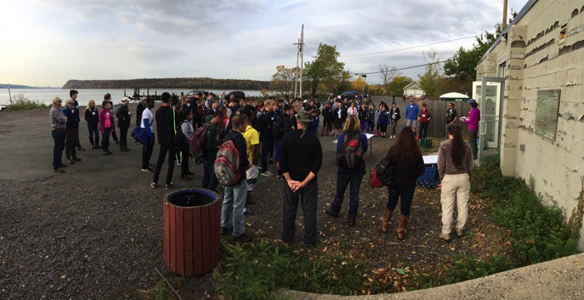
Jen Mazza, Clarkstown South High School, 18 students
Tom Mullane & Brenda King, Pearl River High School, 71 students
Shawn Kapusinsky, Spring Valley High School, 11 students
Julie West, Oak Meadow School, 5 students
Latitude N 41 degrees 02’592 Longitude W 73 degrees 53’789
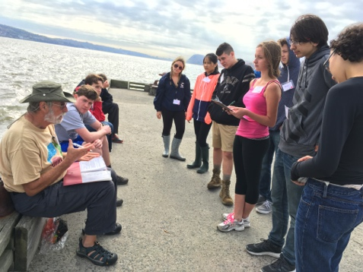 | 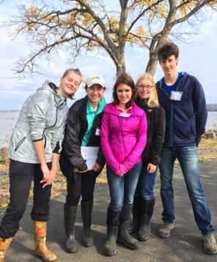
Clarkstown High School | Oak Meadow School
Spring Valley Students | Some Pearl River Students
Location: Piermont Pier, Piermont NY
Area: Man made fishing/shipping pier at the east end, long pier with paved roadway and vegetated strip along both sides
Surrounding Land Use: Urban/residential 80% , Forested 20%
Sampling Site: Pier, roadway in center of whole pier, parking area at end, Plants and trees along side. Shoreline Rip Rap, collected wood in area and piping entering river on the south of sampling site
Plants in area: no submerged aquatic plants in the water
Water depth: Varied by location on the pier and by tide
River Bottom – sandy/rocky bottom with marsh grass growing in or near the water
Plants in area: sumac and other plants 15%; phragmites 85%
ITEM | Group A |  |  |  |  |  |  | Group B
Physical | Weather Today |  |  | Weather Last 3 Days |  |  |  | Weather Today |  |  |  | Weather last 3 days
 | Fair |  |  | Dry and hot |  |  |  | Fair |  |  |  | Dry and hot
Time | Cloud Cover |  |  | Air Temp °C |  |  |  | Cloud Cover |  |  |  | Air Temp °C
9:00 | 75% |  |  | 17.6 |  |  |  | 79% |  |  |  | 20
10:00 | 75% |  |  | 20 |  |  |  | 90% |  |  |  | 18
11:00 | 75% |  |  | 20 |  |  |  | 75% |  |  |  | 20
12:25 | 75% |  |  | 23 |  |  |  | 85% |  |  |  | 22
1:15 | 50% |  |  | 23 |  |  |  | 60% |  |  |  | 22
Time | Wind – Beaufort, Direction |  |  | Wind Anemometer |  |  |  | Wind – Beaufort, Direction |  |  |  | Wind Anemometer
9:00 | 2 N |  |  | 5 |  |  |  | 2 N |  |  |  | 6
10:00 | 2 E |  |  | 6 |  |  |  | 2.5 SE |  |  |  | 4.5-7.1 mph
11:00 | 4 E |  |  | 10 |  |  |  | 3 SE |  |  |  | 10 mph
12:25 | 3 SE |  |  | 10 |  |  |  | 2.5 SE |  |  |  | 5.3 mph
1:15 | 2 SE |  |  | 5 |  |  |  | 2.8 SE |  |  |  | 7.2
Turbidity – | Group A |  |  |  |  |  | Group B
Long Site Tube  All average 4 readings | Time |  | Long Site Tube |  | Secchi |  | Time |  |  | Long Site Tube / |  |  | Secchi
 | 9:15 AM |  | 40 cm |  | 86.5 |  | 9:35 |  |  | 27.2 cm |  |  | 53.1 cm
 | 10:00 AM |  | 33.6 |  | 55.26 |  | 10:14 |  |  | 31.8 cm |  |  | 52.5 cm
 | 10:43 |  | 30.4 |  | 52.6 |  | 11:08 |  |  | 30.7 cm |  |  | 56.75
 | 12:14 |  | 29.7 |  | 34 |  | 12:39 |  |  | 32.8 cm |  |  | 44 cm
 | 13:00 |  | 37.8 |  | 59.8 |  | 13:21 |  |  | 49.9 cm |  |  | 55.7 cm
Chemical
DO | TIME |  |  | DO Reading |  |  |  |  | Water Temp °C |  | % Saturation
Group A | 9:00 |  |  | 12 mg/L  8 mg/L |  |  |  |  | 17.2  17.1 |  | 125%  80%
Group B
 | 10:00 |  |  | NR  9 mg/L |  |  |  |  | 18.0  17.9 |  | NR  94%
 | 11:00 |  |  | 7 ppm  8 ppm |  |  |  |  | 18.0  18.0 |  | 75%  85%
 | 12:00 |  |  | 7 mg/L  10 ppm |  |  |  |  | 19.0  18.0 |  | 80%  105%
 | 13:00 |  |  | 8 mg/L  7 mg/L |  |  |  |  | 19.0  NR |  | 84%  NR
pH | TIME |  |  | Group A |  |  |  |  | Group B
 | 9:00 |  |  | 8.25 |  |  |  |  | 7.0
 | 10:00 |  |  | 8.0 |  |  |  |  | 7.0
 | 11:00 |  |  | 7.5 |  |  |  |  | 7.5
 | 12:00 |  |  | 8.25 |  |  |  |  | 7.0
 | 13:00 |  |  | 7.0 |  |  |  |  | 8.0
Phosphates | TIME |  |  | Group A |  |  |  |  | Group B
 | NR |  |  | NR |  |  |  |  | NR
Nitrates | TIME |  |  | Group A |  |  |  |  | Group B
 | 9:00 |  |  | 0 ppm |  |  |  |  | <1 ppm
 | 10:00 |  |  | NR |  |  |  |  | 0 ppm
 | 11:00 |  |  | 0 ppm |  |  |  |  | 0.15 ppm
 | 12:00 |  |  | 0.05 ppm |  |  |  |  | 0 ppm
 | 13:00 |  |  | 0.01 ppm |  |  |  |  | 0 ppm
Alkalinity | TIME |  |  | Group A |  |  |  |  | Group B
Drop count | 9:00 |  |  | NR |  |  |  |  | 40 ppm
 | 10:00 |  |  | 50 ppm |  |  |  |  | 51 ppm
 | 11:00 |  |  | 80 ppm |  |  |  |  | 70 ppm
 | 12:00 |  |  | 40 ppm |  |  |  |  | 74 ppm
 | 13:00 |  |  | 84 ppm |  |  |  |  | 70 ppm
*Salinity | Refracto. |  |  | Hydrometer Glass  Hydrometer |  |  |  |  | Quantab ppm cl⁻ |  | *Quantabs ppm total salinity
9:00 | 15 ppt  13 ppt |  |  | 1.090 (?)  11.9 ppt |  |  |  |  | NR  NR |  | NR  NR
10:00 | 14 ppt  14 ppt |  |  | NR  12.2 ppt |  |  |  |  | 4944 ppm |  | 8932 ppm
11:00 | 14 ppt  15 ppt |  |  | 17.4 ppt  13.6 ppt |  |  |  |  | 6526 mg/L  4944 ppm |  | 11790 ppm  8932 ppm
12:00 | 14 ppt  13.5 ppt |  |  | 13.7 ppt  13.5 ppt |  |  |  |  | 4425 ppm  4944 ppm |  | 7994 ppm  8932 ppm
13:00 | 13.85 ppt  15 ppt |  |  | 14 ppt  12.4 ppt |  |  |  |  | 5608 ppm |  | 10131 ppm
Tides-  Time | Group A  Pier to water |  |  | Flood/Ebb |  |  |  |  | Group B  Pier to water |  | Flood/Ebb
9:06 AM | 196 cm |  |  | Flood |  |  |  |  | 215.2 cm |  | Flood
10:14 AM | 155 cm |  |  | Flood |  |  |  |  | 185 cm |  | Flood
10:41 AM | 141 cm |  |  | Flood |  |  |  |  | 172 cm |  | Flood
12:23 PM | 102 cm |  |  | Flood |  |  |  |  | 124 cm |  | Flood
1:03 PM | 110 cm |  |  | ~Still |  |  |  |  | 110 cm |  | Flood
Currents | Group A |  |  |  |  |  |  |  | Group B
Time | Rate of Flow | Type |  |  |  |  |  |  | Rate of Flow |  | Type
9:00 | 9.6 cm/sec  0.2 kt | Flood |  |  |  |  |  |  | 27.3 cm/sec |  | Flood
10:00 | 27.2 cm/sec  0.5 kt | Flood |  |  |  |  |  |  | 63.6 cm/sec |  | NR
11:00 | 68.0 cm/sec  1.3 kt | NR |  |  |  |  |  |  | 42 cm/sec |  | Flood
12:25 | 59.5 cm/sec  1.0 kt | Flood |  |  |  |  |  |  | 62.8 cm/sec  1.22 kt |  | Flood
1:15 | NR | NR |  |  |  |  |  |  | 54.67 cm/sec  1.06 kt |  | Flood
Fish Catch  Northside of pier (2 Seining Groups ) | Number Caught | Species |  |  |  |  |  |  | Measure of largest |  | TIME & CATCH
Rotation #1 Group A | 5 | Striped Bass |  |  |  |  |  |  | 12 cm |  | 9:48
FISH | 60 | Atlantic Silverside |  |  |  |  |  |  | 8 cm |  | DIV 2  TOTAL 65
MACRO | 3 | Blue Crab |  |  |  |  |  |  | 3 cm |  | DIV 2
 | 30 | Comb Jelly |  |  |  |  |  |  | 3.5 cm |  | TOTAL 63
Rotation #2 Group A | 6 | Striped Bass |  |  |  |  |  |  | 10 cm |  | 9:53
FISH | 9 | Atlantic Silverside |  |  |  |  |  |  | 9 cm |  | DIV 3  TOTAL 11
 | 1 | White Perch |  |  |  |  |  |  | 20 cm
 | 1 | Bay Anchovy |  |  |  |  |  |  | 4 cm
MACRO | 1 | Blue Crab |  |  |  |  |  |  | 5 cm |  | DIV 2
 | 10 | Comb Jellies |  |  |  |  |  |  | 3 cm |  | TOTAL 11
Rotation #3 Group A | 13 | Atlantic Silverside |  |  |  |  |  |  | 12 cm |  | 10:50
FISH | 2 | White Perch |  |  |  |  |  |  | 17 cm |  | DIV 5
 | 3 | Striped Bass |  |  |  |  |  |  | 13 cm |  | TOTAL 21
 | 1 | Bay Anchovy |  |  |  |  |  |  | 4 cm
 | 2 | Blue Fish |  |  |  |  |  |  | 19 cm
MACRO | 1 | Sand Shrimp |  |  |  |  |  |  | 3 cm |  | DIV 2
 | 2 | Blue Crab |  |  |  |  |  |  | 5 cm |  | TOTAL 3
Rotation #4 Group A | 119 | Atlantic Silverside |  |  |  |  |  |  | 9 |  | 12:20  DIV 3
FISH | 1 | White Perch |  |  |  |  |  |  | 11 |  | TOTAL 125
 | 1 | Striped Bass |  |  |  |  |  |  | 9
MACRO | 4 | Blue Crab |  |  |  |  |  |  |  |  | DIV 1  TOTAL 4
Rotation #1 Group B | 19 | Atlantic Silverside |  |  |  |  |  |  | 11 cm |  | 9:30  DIV 2
FISH | 1 | Striped Bass |  |  |  |  |  |  | 20 cm |  | TOTAL 20
MACRO | 1 | Blue Crab |  |  |  |  |  |  | 2.5 cm |  | DIV 2
 | 2 | Comb Jellies |  |  |  |  |  |  | 2 cm |  | TOTAL 3
Rotation #2 Group B | 4 | Striped Bass |  |  |  |  |  |  | 10.6 cm |  | 10:00
FISH | 2 | White Perch |  |  |  |  |  |  | 4.1 cm |  | DIV 1  TOTAL 2
MACRO | 1 | Sand Shrimp |  |  |  |  |  |  | 12.5 cm |  | DIV 1  TOTAL 1
Rotation #3 Group B  FISH | 1 | Atlantic Silverside |  |  |  |  |  |  | 8.2 cm |  | 11:00  DIV 1  TOTAL 1
MACRO | ~500 | Comb Jellies |  |  |  |  |  |  | 2 cm |  | DIV 1  TOTAL >500
Rotation #4 Group B | 12 | Atlantic Silverside |  |  |  |  |  |  | 12 cm |  | DIV 1  TOTAL 12
Rotation #5 Group B | 2 | Atlantic Silverside |  |  |  |  |  |  | 8 cm |  | DIV 1  TOTAL 2
GRAND TOTAL | FISH  MACRO | TOTAL  TOTAL |  |  |  |  |  |  | 261  >585 |  | F - DIV 5  M - DIV 3
Sediment Cores | Time | Length |  |  |  | Oxid Top |  |  | Grain Size |  | Other Items
Group A  South of pier | 9:00 AM | 8 cm  Top  3.5 cm  Bottom 4.5 cm |  |  |  | NO |  |  | Top –  - mud  - gravel  - sand  __________  Bottom - Clay |  | Wood  Oyster  Brick  Iron Pyrite
Group B  South of pier | 9:00 AM | 12 cm  Top  6 cm  Bottom  6 cm |  |  |  | NO |  |  | Top –  - clay  __________  Bottom –  - sand  - gravel |  | Brick  Coal  Worm
Group A  South of pier | 10:00 AM | 20 cm  Top  5 cm  Bottom  15 cm |  |  |  | NO |  |  | Top Mud with gravel  _________  middle clay_  ________  Bottom Sandy Mud |  | Shell  Fin of fish  Red rock  Wood  Coal
Group B  South of pier | 9:50 AM | No layers - homogeous |  |  |  | No |  |  | Sand  Clay |  | Roots  Wood  Brick  Coal
Group A  South of pier | 11:00 AM | 2 cm no layers |  |  |  | NO |  |  | Sand  Gravel  Pebbles |  | leaves
Group B  South of pier | 10:30 AM | 7 cm  Top  3 cm  Bottom  4 cm |  |  |  | Yes |  |  | Clay/Sand |  | Coal  Slag  Brick  Roots
Group A  South of pier | 12:00 Noon | 4 cm |  |  |  | No |  |  | Sand with gravel |  | Brick  Wood  Roots  Leaves  Brick  Coal  Glass
Group B  South of pier | 12:00 Noon | Homogenous |  |  |  | No |  |  | Sand  Gravel |  | Brick  Coal
Group A  NORTH of pier | 1:00 PM | 10.5 cm |  |  |  | No |  |  | Sand with some gravel and pebbles |  | brick
Group B  South of pier | 12:45 PM | 3 layers  Sand  Gravel  Sand |  |  |  | No |  |  | Sand & gravel |  | Brick
Other Observations | Overcast day that ended with rain just as students were leaving.

