Day in the Life of the Hudson River 10/20/15 Data
(Salt Front ~ RM 80)
RIVER MILE 30.4 – Nyack Beach Hook Mountain State Park
Peter Park, Nyack College, 6 students, 7 adults
Nancy Arias & Jillian Decker, Rockland Community College, 4 students, 6 adults
41°07’10.85”N 73°54’45.40”W
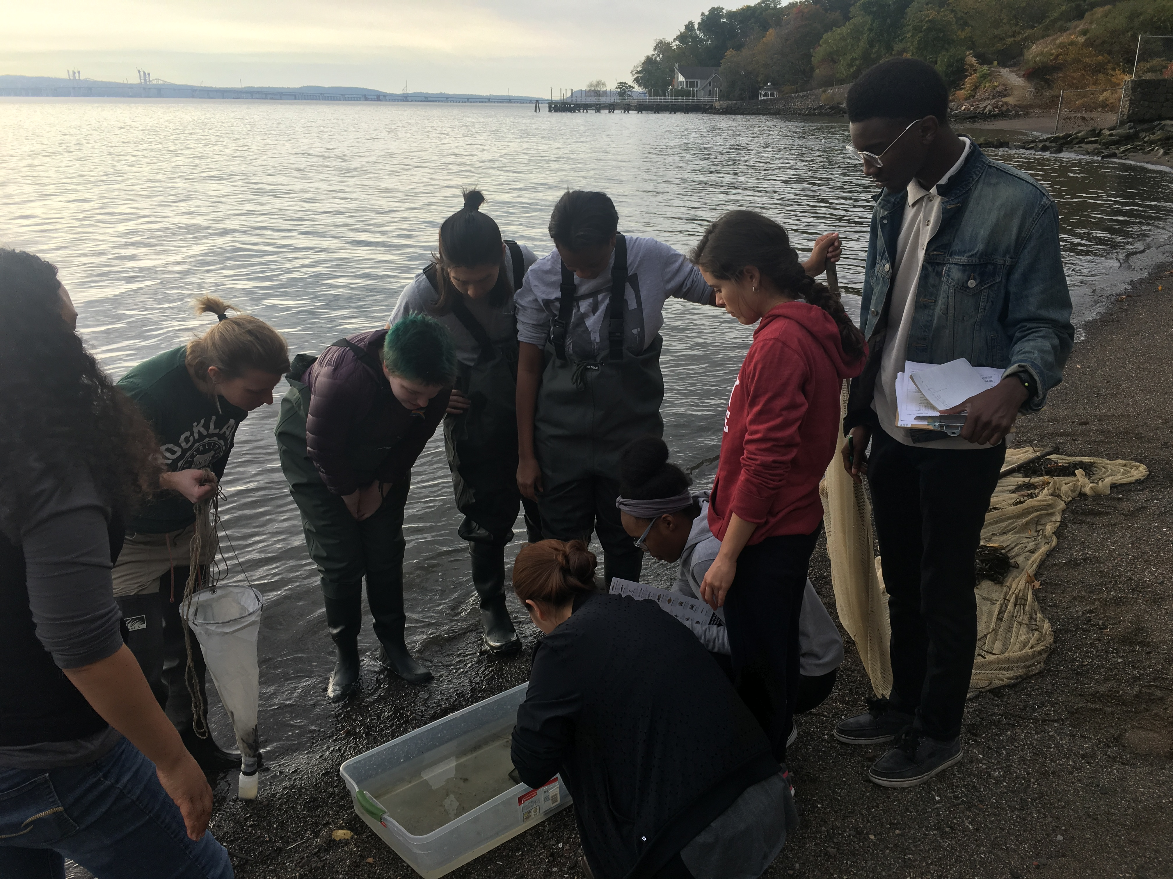

Location: Nyack South Beach, Upper Nyack, Rockland County NY
Area: Park/Boat launch, near Hook Mountain Sandy Beach by the large sitting stairs, Surrounding Land Use: 40% forested, 10% industrial/commercial, 40% beach – used for recreation & picnics
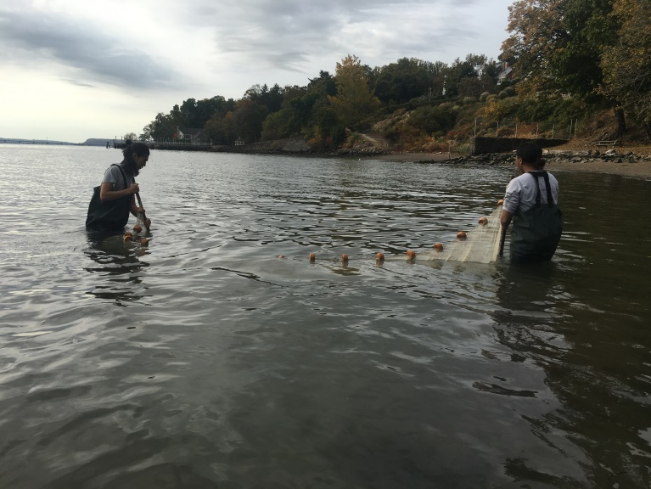
Sampling Site: Beach – sandy and rocky at edges, muddy offshore, covered with vegetation beyond the beach, stone wall, riprap shore, collected wood debris.
Piping coming into river south of sampling site
Water depth:
River Bottom –sandy inshore (<3 ft depth) muddy offshore (>3 ft. depth), some scattered large rocks (<2 ft. length inshore)
Plants: None growing in area but water celery came up in the seine net

ITEM | Time | Reading 1 | Reading 2 | Comments
Physical
Air Temperature | 10:28 AM  10:36 AM  10:56 AM | 18.3°C  18.9-19.4°C  18.3°C | 65°F  66-67°F  65°F
Wind Speed |  |  |  | N
Cloud Cover | overcast
Weather today | No rain
Weather last 3 days | Warm and dry
Water Temperature | 10:28 AM  10:36 AM  10:56 AM | 20-20.6°C  18.9-19.4°C  20°C | 68-69°F  66-67°F  68°F
Turbidity –  Long site tube | NR
Chemical
DO  Drop count | 11:20 AM | 10 ppm
pH  Colormetric kit | NR
Salinity - refractometer | 9:18AM  9:55AM | 11 ppt
Fish Catch  9:30-11:30 |  | Number Caught | Species | Latin Name
Seine 20 ft.  6 Hauls |  | 9 | Atlantic Silverside | Menidia menidia
 |  | 2 | Striped Bass | Morone saxatilis
Fish Diversity 6 |  | 18 | Northern Pipefish | Synanathus fuscus
Total Catch 36 |  | 2 | White Perch | Morone americana
 |  | 4 | Bay Anchovy | Anchog mitchilli
 |  | 1 | Banded Killifish | Fundulus diaphanus
MACROINVERT |  | 1 | Clamworm (Sandworm) | Nereis sp.
DIVERSITY = 5 plus shells |  | Too numerous to count | Blue Crab | Callinectes sapidus
TOTALS = Too numerous to count | ( nearly double sand shrimp) | Too numerous to count but | Shore Shrimp | Palaemonetes spp.
 |  | Too numerous to count | Sand Shrimp | Crangon septemspinosa
 |  | 1 | Dragonfly nymph | Odenata
 |  |  | Shells of hard clam | Mercenaria mercenaria
Tides | Time | Change in Time | Change in Height | Rate of change Flood/Ebb
 | 9:26 - 9:55 AM | 29 mins | 18 mm | 0.62mm/min  Flood
 | 9:55-10:21 AM | 27 mins | 15 mm | 0.56mm/min Flood
 | 10:21-10:45 AM | 24 mins | 15 mm | 0.63mm/min Flood
Currents
Distance Travelled | Time | Distance from Shore | Current Speed (cm/s) | Flood/Ebb
78.74 cm | 30 sec | 15 ft. | 2.62 cm/s | Flood
457.2 cm | 30 sec | 20 ft | 15.24 cm/s | Flood
147.32 cm | 30 sec | 40 ft | 1.93 cm/s | Flood
106.68 cm | 30 sec | 55 ft | 1.4 cm/s | Flood
71.12 cm | 30 sec | 90 ft | 0.93 cm/s | Flood
Observations | Grey moth ~1 inch anterio-posterior length  Male monarch butterfly ~2 inch anterio-posterior length
FISH CATCH IMAGES:
Northern Pipefish & Atlantic Silversides

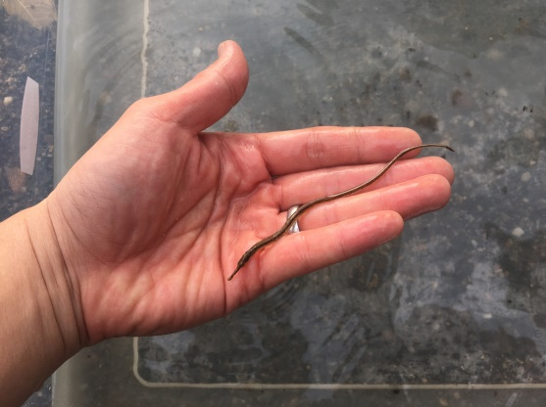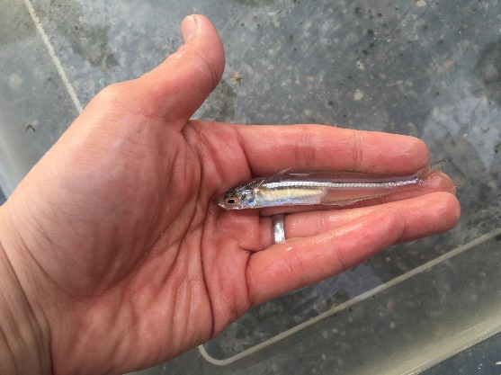

White Perch & Striped Bass
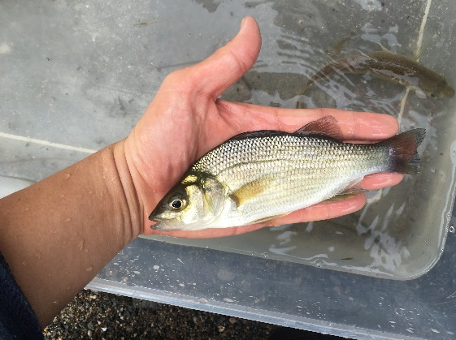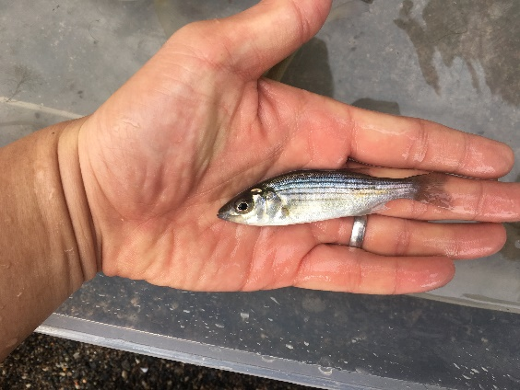
Bay Anchovy & Banded Killifish
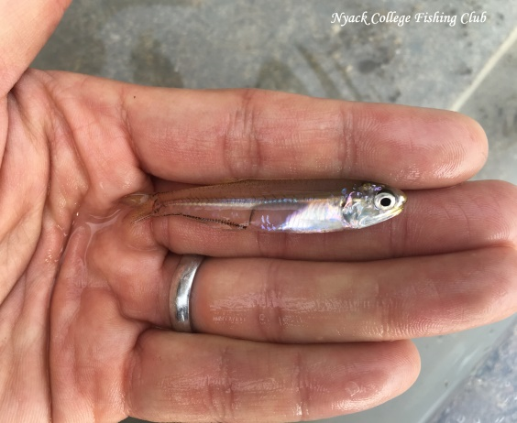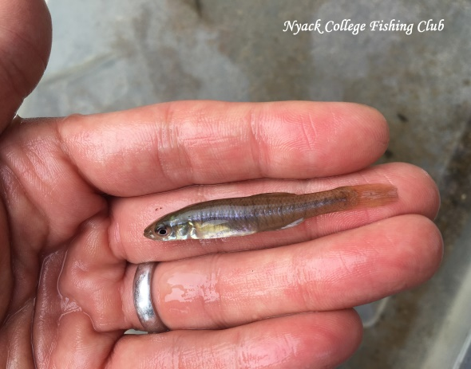

Hard Clam Shell & Blue Crab
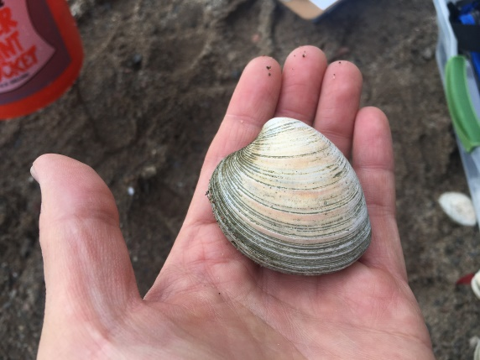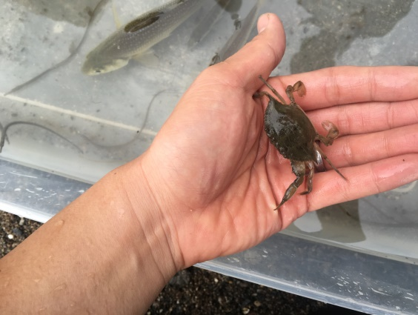
Sand Shrimp & Shore Shrimp
