Day in the Life of the Hudson River 10/20/16 Data
(Saltfront ~ RM 83)
RIVER MILE 58
Plum Point/Kowawese, New Windsor, Orange County, NY
Rebecca Foster-Faith, Bishop Dunn Memorial,
Jenny Brinker, Museum of the Hudson Highlands,
33 seventh graders , 3 adults
GPS Latitude 41.463 Longitude -74.015
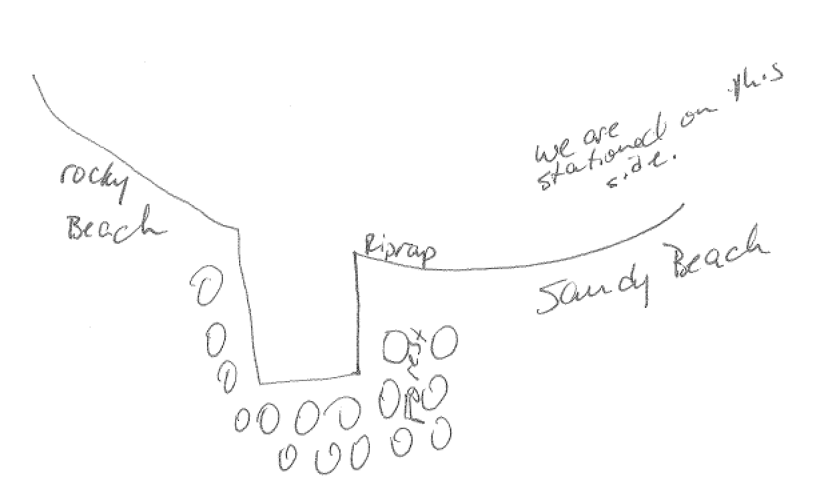

Location: Southern Sandy beach at Kowawese, Plum Point, New Windsor, Oran
ge County, Public Shore, Picnic Area
Area: Sandy beach bordered by forested area and parking lot. Used for picnic, fishing, kayaking
Surrounding Land Use: Beach 50%, Forested 50%
Shoreline: 75% rocky, 20% muddy, 5% sandy
Sampling Site: sandy beach (cove), rip rap in area of sampling site, debris in the area such as broken concrete, docking with forested piece behind
Plants in area: < 50%, type not recorded
Water depth: NR
River Bottom – sandy, rocky

ITEM | Time |  | Reading 1 | Reading 2 | Comments
Physical
Air Temperature | 9:34 AM  10:27 AM  11:52 AM |  | 16.2°C  20.6  16.7 | 61°F  69  62
Wind Speed | 9:52 AM  11:54 AM  12:30 PM |  | Beaufort #1  Beaufort #3  Beaufort #3 | NR  8 mph  8.8 mph | North
Cloud Cover | Mostly cloudy |  | 51%-75% | By 11:54AM overcast >75%
Weather today | No rain
Weather recently | Very warm – unusually so – 70 degrees plus
Water Surface | choppy
Water Temperature | 10:25 AM | 14.5°C  58 °F |  | 11:45 AM |  | 15°C  59 °F
Water Surface
Turbidity  Short sight tube | 10:02 AM | 60, 70, 40 |  | 85 JTUs
Chemical
DO | TIME | Temp |  | DO |  | % Sat
DO – drop count test kits  *expect air bubble | 9:59 AM  10:55 AM  12:10 PM  12:56 PM | 20°C  17°C  17°C  17°C |  | 11 ppm  15 ppm*  9 ppm  12 ppm |  | 120%  150 %  85%  125%
pH – test strip | 9:42 AM | 6
Salinity – Quantab | Time | Quantab units |  | Chloride |  | Total Salinity
 | 10:31AM  12:38 PM  12:06 PM | 9.6 units ?  5.8 units HR  5.4 units HR |  | Assume LR  1506 ppm  1281 ppm |  | Assume topped out  2721 ppm  2314 ppm
Nitrates | AM readings | All below detection ‘0’
Fish Catch | Species | Count |  | Size of largest |  | Totals
FISH | Spottail Shiner | 8 |  |  |  | DIVERSITY 4  TOTALS -18
 | Herring | 2
 | Striped Bass | 4
 | Darter | 4
MACRO | Blue Crab – M | 2 |  |  |  | DIVERSITY – 1  TOTALS - 2
Tides | 9:27 AM  9:45 AM  10:20 AM  11:46 AM  12:27 PM | 39.6  36.6  42.67  85.34  94.5 |  | Set point  Falling  Rising  Rising  Rising
Currents | Time | Cm/30 sec |  | cm/sec |  | Kts | N/S/F
 | 9:30 AM  10:23AM  11:40 AM  12:30 PM | 792.5  45.72  396.24  396.27 |  | 26.4  1.52  13.2  13.21 |  | 0.51  0.03  0.26  0.26 | Flood  Ebb  Flood  Flood
Shipping Recreational | 12:27 PM  12:47 PM | Paddleboat  Sailboat |  |  |  | Northbound  Southbound

