Day in the Life of the Hudson River 10/20/16 Data
(Salt Front ~RM 83)
RIVER MILE 92
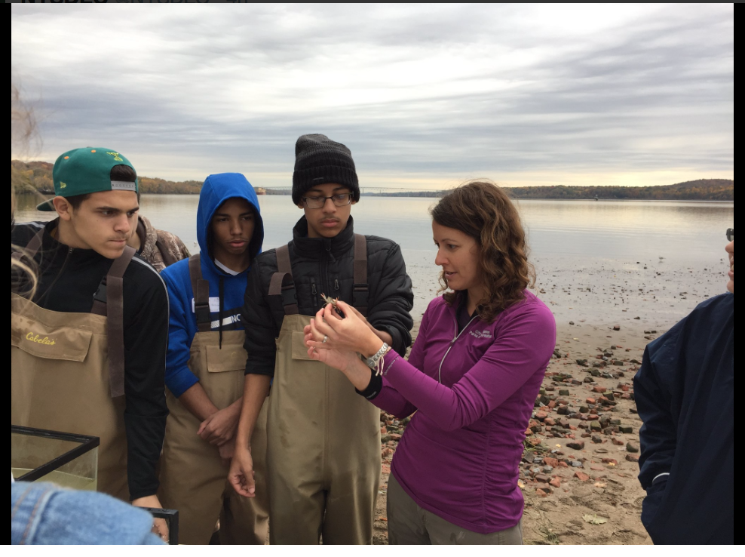
Kingston Point Park, Kingston, Ulster County
Julie Noble, KC Keegan-Twonbly, Forsyth Nature Center (Site Hosts)
Kingston High School, 7 students, 2 adults
GPS Latitude 41°55.48 N Longitude 73°57.55 W
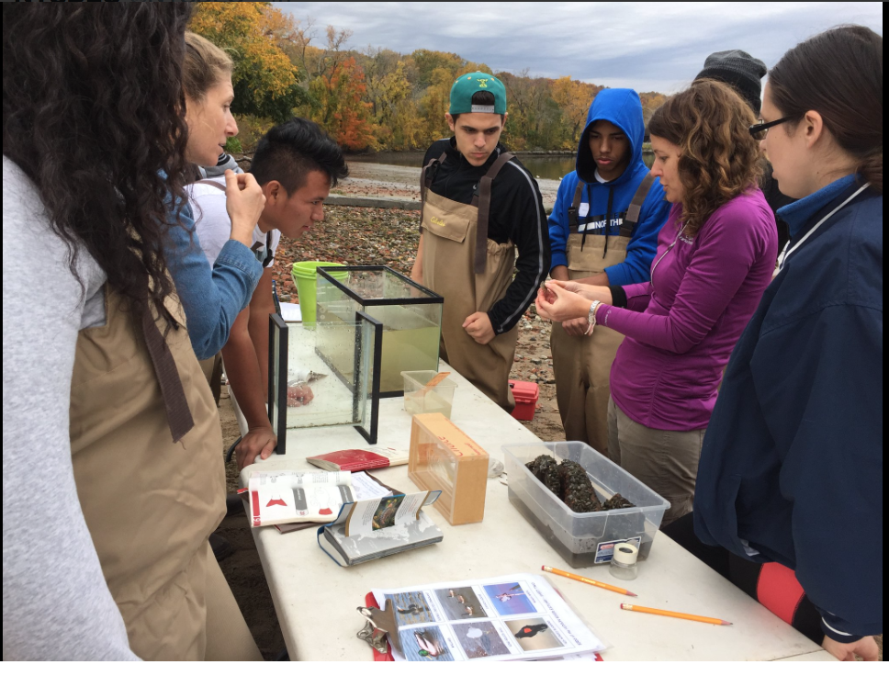 | 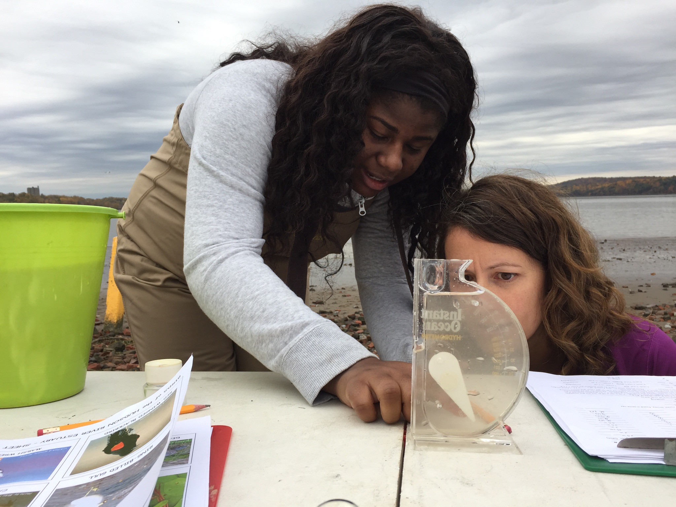
Location: Swimming Beach Kingston Point, City of Kingston, forested, beach and parking lot
Area:, Used for picnics, boating, fishing, swimming, jogging, kayaking
Surrounding Land Use: 5% forested; 85% beach; 10% Industrial/Commercial
Sampling Site: Beach area - shoreline is sandy with some bricks, banks are altered, collected wood debris in the area, rip rap to north along brickyard shoreline. Sandy shoreline 75 feet from shoreline to parking lot, 200 feet wide with boat launch, large amount of brick debris from prior industry
Plants in area: 2% duckweed, spatterdock, water chestnut, water celery
Water depth: 0.4 depth
River Bottom : sandy

ITEM | Time |  | Reading 1 | Reading 2 | Comments
Physical
Air Temperature | 12:50 PM |  | 65°F  18.3°C
Wind Speed | 12:50 PM |  | #1 Beaufort | N
Cloud Cover | 12:50 PM |  | overcast >75% cover
Weather today | Cloudy
Weather recently | Sunny – 84 F
Water Surface | Calm
Turbidity | Water clear up to ~ 1 meter – sand created turbidity the more we walked in it the more turbid it became.
Water Temperature | Time | Temperature #1 |  | Temperature #2 | Average
Water Depth 2 ft. | 1:00 PM | 60°F  21 °C
Chemical
DO  Test tabs | 1:15 PM | 7 ppm |  | 21 C | 81% saturated
pH – color match kit | 1:15 PM | 7
Salinity - hydrometer | 11:56 AM | 1.006  1.004  1.005 |  | Above the salt front - trace
Fish Catch  30’seine X 4 ft. with bag – 20 ft haul | Number Caught- 15 | Species - 2 |  | Largest Size
10;45-11:45 AM | 11 | Pumpkinseed fish |  | 5 cm | DIV 5
 | 3 | Bluegill Sunfish |  | 5 cm | TOTAL 28
 | 8 | Alewife y-o-y (Herring) |  | 6.5 cm
 | 3 | Striped Bass |  | 8 cm
 | 3 | Banded Killifish |  | 5 cm
Macro Catch | 4 | Blue Crab |  | Male | DIV 3
 | Abundant | Scuds |  |  | Totals 4 +
 | Abundant | Zebra Mussels
Tides | 10:00 AM  10:50 AM  11:36 AM  12:06 PM  12:34 PM  1:02 PM | Ebb  Ebb  Rise  Rise  Rise
Currents | NR
Core Sample | Description | Rare |  | Common | Abundant
 | 15 cm  grey color | Brick |  |  | Sand
Traffic- Commercial | 10:40 AM  11:38 AM  12:30 PM | A87 Barge  UBC Seattle- Barge  Barge |  | Black  Red  Green | N - loaded  S – light  S - light
Traffic – Recreational | 11:02 AM  11:10 AM | Speedboat  ‘Unplugged’ |  | White  White | South  North
Other Items | 10:40 AM Belted Kingfisher (1)  11:15 AM Ring Billed Gulls (35)
 | Beach ~ 1/3 covered with brick parts, 1/8 covered with water chestnut seed pods, few shell pieces

