Day in the Life of the Hudson River 10/12/17 Data
(Saltfront ~ RM 65)
RIVER MILE 19.5
JFK Marina, Yonkers
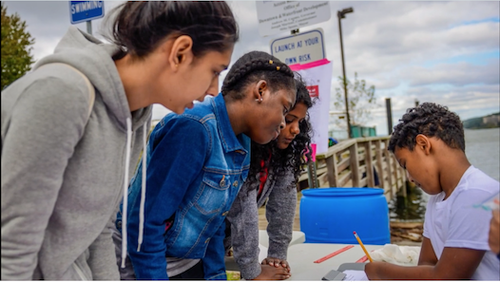
Kelly Jakob, Riverside High School & Museum School 5th-12th grade 100 students, 10 adults
Latitude 40°59’52”N, Longitude 73°53.03”W
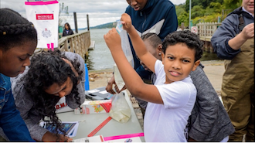 | 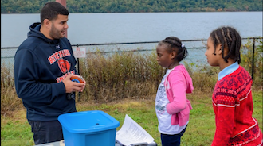

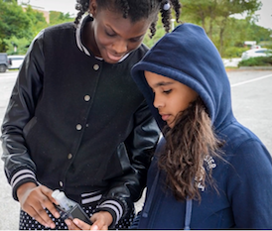
Location: JFK Marina, Yonkers waterfront, Westchester, NY
Area: Waterfront marina with a north facing boat ramp for seining and a wooden walkway along the edge.
Surrounding Land Use: 40% grassy park fenced from the water, 60% cement boat ramp on the northside and large parking lot.
Sampling Site: bulkheaded waterfront, cement ramp for seining,
Plants in area: no
River Bottom:

SAMPLED FROM 9-1PM
ITEM | TIME |  |  |  |  | Comments
Physical
Air temperature | NR | Wind Speed |  | NR
Weather today | Overcast, cool breezy and a bit damp in the AM
Weather recently | A small amount of rain but warm
ITEM |  |  |  |  |  | Comments
Turbidity – secchi | NR
Water temp. | AM |  | °F |  | °C
Chemistry
pH – color kit | 9:17 AM  9:39 AM  9:43 AM  9:58 AM |  | 8.0  7.0  8.0  7.5 |  |  | Average 7.6
 | 10:01AM  10:11 AM |  | 8.0  8.0 |  |  | Average 8.0
 | 11:40 AM  11:43 AM  11:48 AM  11:52 AM |  | 8.0  7.7  10.0  8.0 |  |  | Average 8.4
 | 12: 01 PM  12:14 PM  12:16 PM  12:19 PM  12:21 PM  12:29 PM  12:30 PM  12:40 PM  12:42 PM  12:47 PM  12:59 PM |  | 8.5  8.0  8.5  8.0  7.7  8.0  7.7  8.5  7.5  8.0  8.0 |  |  | Average 8.0
DO – Hach kit | Time* |  | H2O Temp |  | Test # | DO* mg/L
*most numbers too high – must have had a sampling bubble or not swirled after sampling  7 mg/L is approximately what we would expect | No specific times recorded  Sampling from  9-1PM |  | NR°C |  | Test 1  Test 2  Test 3  Test 4  Test 5  Test 6  Test 7  Test 8  Test 9  Test 10  Test 11 | 20 mg/L  26  20  26  17  15  7  15  15  7  7
Salinity –refract. | NR
Fish Catch  Seine 10 ft. net | Number |  | Species |  | Average length
 | 63 |  | Atlantic Silversides |  | 7.6 cm | DIV 2  TOTAL 65
 | 2 |  | Striped Bass |  | 7 cm
Macroinvert. Catch | 2 |  | Blue crab |  | 4 cm | DIV 3  TOTAL ~112
 | >60 |  | Moon Jellies |  | 1-4 cm
 | >150 |  | Ctenaphore - Comb Jelly |  | 1-6 cm
Tide | Start Time |  | Water Height - cm
 | 9:00 AM  11:00 AM  11:25 AM  11:55 AM  12:06 PM  12:35 PM  12:54 PM |  | 0  16  31  47  48  62  69

