A NATIONAL DEEPWATER GULF OF MEXICO INITIATIVE:
EXPLORATION AND TECHNOLOGY DEVELOPMENT
IN THE DEEP AND ULTRA-DEEPWATER
OF THE GULF OF MEXICO

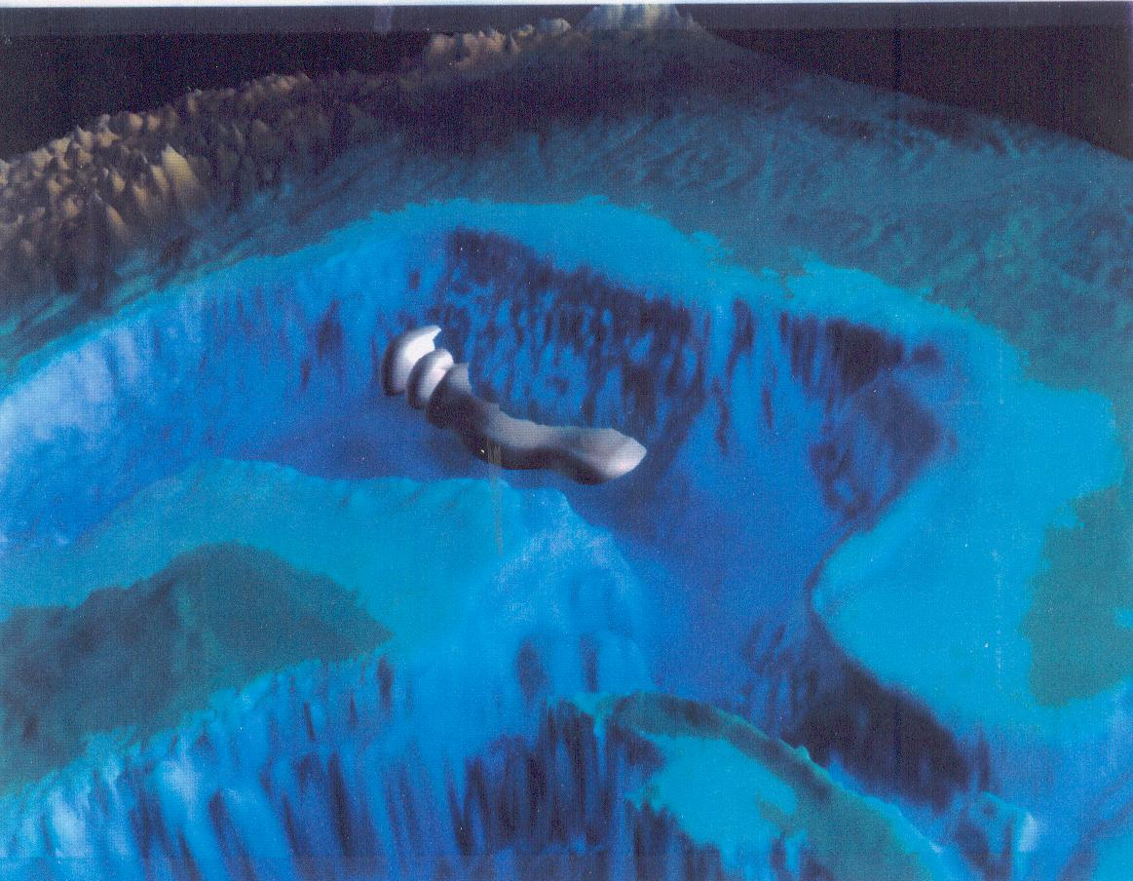

A White Paper
submitted to the United States
Department of Energy
Office of Fossil Energy
by the
Applied Earth Sciences Institute
Lamont-Doherty Earth Observatory
Columbia University in the City of New York
Palisades, New York 10964
12/16/94

SUMMARY OVERVIEW

One of the world’s most promising untapped areas of gas and oil in the world may lie in the U.S. Gulf of Mexico (GOM), in its deep and ultra-deepwater. Already, the Gulf of Mexico, including onshore and shelf, is the most prolific gas and oil province in the country, surpassing the North Slope of Alaska in production-to-date and remaining reserves. Whether large volumes of undiscovered hydrocarbons exist in the deep and ultra-deepwater GOM is critical not only to the energy dependence of the country, but also to its long-term economic security.

Industry estimates of the hydrocarbon reserve potential of the deep and ultra-deepwater are as high as 20 billion barrels crude oil equivalent. However, the true exploration and production potential of the deep (1,500-4,000 feet) and ultra-
deepwater (extending to >10,000 feet) remains largely a mystery. This document and the companion White Paper “High Risk Technologies for Development of the Deepwater Gulf of Mexico” propose a coordinated, national Deepwater Gulf of Mexico Initiative that would answer the following questions necessary for the future planning and policy-making of the nation:

• Do Large Volumes of Hydrocarbons Exist in these U.S. Territorial Waters?

• Can We Invent the Technologies Necessary to Bring this Vital Energy Source to Market?

THE CHALLENGES

Buoyed by technology advances, industry has made a number of significant discoveries along the northern edge of the shallow salt massif that covers much of the subsurface in the deep and ultra-deepwater of the Gulf of Mexico. A number of discoveries have been announced, adding 3.2 billion barrels of oil equivalents to the nations reserves, although production is currently obtained from only five projects, so far. Challenges to the ingenuity of the country are that many shallow water exploration and production technologies do not work in water deeper than these announced discoveries. For example, the salt “canopy” (actually an amalgam of intermixed salt extrusion events) masks potential hydrocarbon-bearing deposits from sophisticated, three-dimensional, seismic imaging techniques that have been so successful in shelf exploration. Fully 45% of the surface area of the deepwater is obscured by shallow salt. Also, the geology of the deepwater is different and perhaps more prospective than that in shallower water GOM. The ultra-deepwater contains gigantic structures thought to be cored by carbonates and chalks, which are prolific in other settings in the world. These carbonates underlie the turbidite sands that are producing record volumes and flow-rates in shallower slope fields such as Auger.

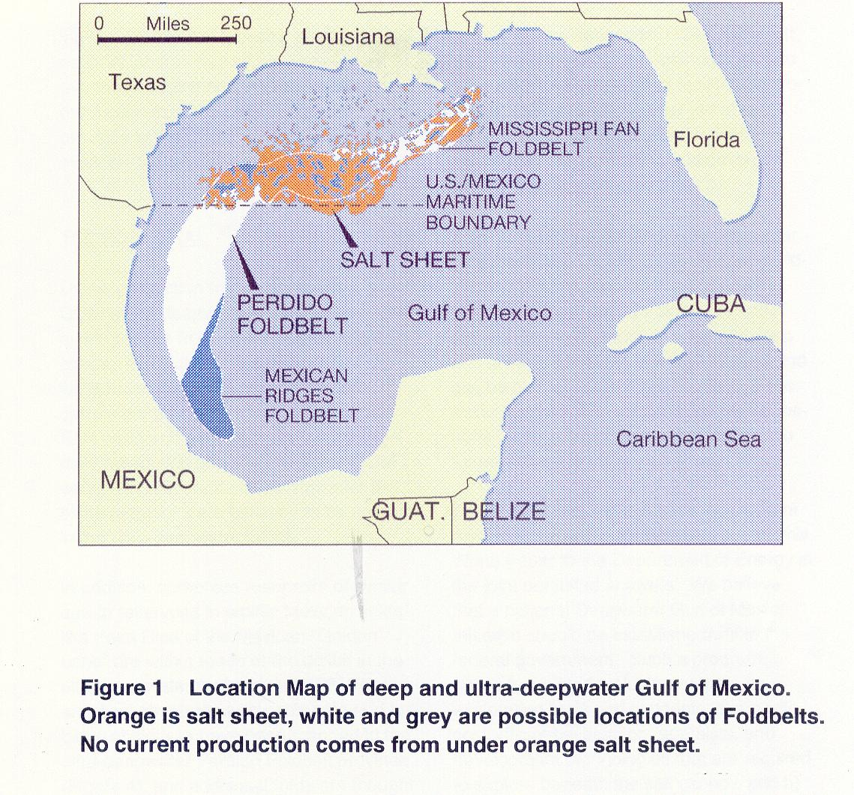

The nation must invent the new technologies and techniques necessary to begin evaluating the resource potential of promising deep and ultra-deepwater formations, and to discover the means by which this critical national asset can be brought to market. We believe that success will come only through a united national effort involving the expertise of industry, academia and national laboratories across the country. If the nation begins now and is successful, production from the ultra-deepwater province in the Gulf of Mexico could be available to the nation beginning in 2006.

THE POTENTIAL

Unlike production from most shallow water GOM wells, deepwater reservoirs produce hydrocarbons from often-prolific turbidite sands. Production rates from deepwater wells have soared as high as 13,000+/- barrels per day, on par with some Middle East wells and several times the average daily production of a shallow water GOM wells. Similar world-class deepwater turbidite reservoirs are believed to be present in the ultra-deepwater GOM.

In addition, carbonate reservoirs of similar age to reservoirs in prolific Mexican fields like Poza Rica of the Mexican “Golden Lane” are within reach of the drillbit in the ultra-deepwater realm of the GOM. Large anticlinal structures with carbonate and turbidite objectives have been mapped in the ultra-deepwater Perdido Foldbelt province, and additional folds are thought to exist under salt throughout the ultra-deepwater of the GOM. Structures of this magnitude and type have yielded many billions of barrels of hydrocarbons in other parts of the world.

Recent technological advances in seismic imaging and interpretation techniques allow explorers to target prospects with greater precision than ever before. While major hurdles remain, progress has been made in the identification of technologies that must be further developed to make exploration and production of hydrocarbons from the deep and ultra-deepwater GOM viable. It is fortunate that both the methodologies to advance exploration and to facilitate hydrocarbon extraction have emerged at the same time, creating an unprecedented opportunity for exploration and development in the ultra-deepwater GOM.

What is the true deep and ultra-deepwater potential of the GOM? Do additional world-class structures such as those currently mapped in the Perdido Foldbelt lie under the salt obscuring most of the Gulf’s deep and ultra-deepwater province? Can oil and gas be economically produced from these water depths? The answers to these questions have far reaching implications to the future wellbeing of the nation as a whole.

These difficult questions have brought many of America’s technology leaders to submit this White Paper to the Department of Energy in the joint pursuit of answers. We believe that a national Deepwater Gulf of Mexico Initiative should be established within the federal government. Such a program would focus on developing a) the new exploration tools and concepts, along with cost-efficient evaluation, appraisal, and development technologies that are required to explore beneath the salt canopy, and b) the new production techniques and tools to deliver the newly discovered oil and gas to markets in the United States. A national Deepwater Gulf of Mexico Initiative could provide the U.S. with a rich, new petroleum province, adding potentially significant volumes to the U.S. reserve base and helping to ensure the nation’s energy security and technological leadership far into the future.

THE JUSTIFICATION

The domestic oil and gas industry is facing a tremendous challenge to profitably explore, discover, appraise and develop new gas and oil reserves in the United States to offset a precipitous, long-term decline in domestic production. Significant hydrocarbon reserves must be discovered within the borders of the United States by the end of the 20th century to make any impact on this decline. The deep and ultra-deepwater Gulf of Mexico offers structures and prospects of sufficient size to impact the market before the second decade of the next century.

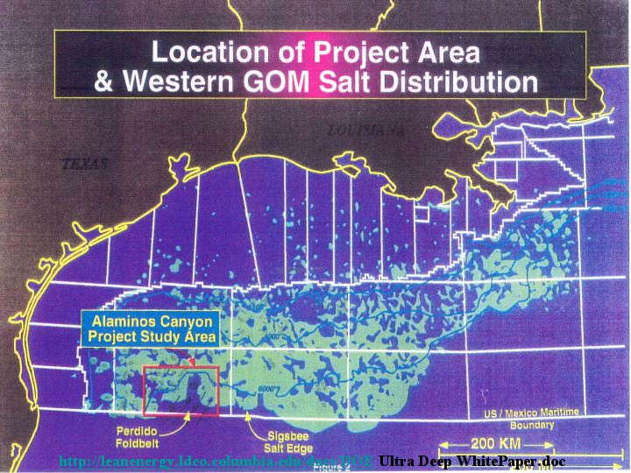

Before plans to explore and produce ultra-deepwater reserves can move forward, however, many technical and economic hurdles must be overcome. Of key importance are assessments of reservoir producibility, hydrocarbon quality and the ultimate recoverable reserves volumes. A discovery containing volumes approaching 2 billion barrels crude oil equivalent (BBOE) is believed to be required to support any ensuing development project in the ultra-deepwater GOM, which may cost upwards of $2-5 billion dollars.

Industry alone will not be driven to test these structures until years from now because of economic realities of the current low price environment, and competition for resources overseas. Consequently, we propose a joint industry, academic, national laboratory, cost-sharing initiative to drive the invention and development of the new technologies necessary to explore for and produce new ultra-deepwater reserves. A key component of our proposed program is that only with such a national effort will full development of these reserves occur. With a national Initiative, up to 20 billion barrels might be ultimately produced, whereas without such a concerted effort, only a few billion barrels, if any, will reach the U.S. marketplace. Should the initiative be funded, we anticipate first ultra-deepwater production approximately 10 years after the first discovery well, comparable to that of known deepwater fields such as Auger.

The deepest water production currently obtained from United States Gulf of Mexico waters is from that Auger field, located in Garden Banks Block 426, approximately 214 miles southwest of New Orleans, Louisiana, which recently went on production and is currently flowing at daily rates of 55,000 barrels of oil and 105 million cubic feet of gas. The Auger field is located in 2,860 feet of water. In comparison, the deepest water gas and oil well currently producing in the world today is Petrobras’ Marlim 3-MRL-4 well located in 3,369 feet of water in the Campos basin, offshore Brazil. The national Initiative proposed here and in the accompanying White Paper will a) re-establish the United States as the worldwide leader in deepwater expertise (Brazil and Norway are acknowledged technical competitors today), b) increase industry activity in the deepwater Gulf of Mexico and c) stimulate industry exploration interests in the ultra-deepwater province.

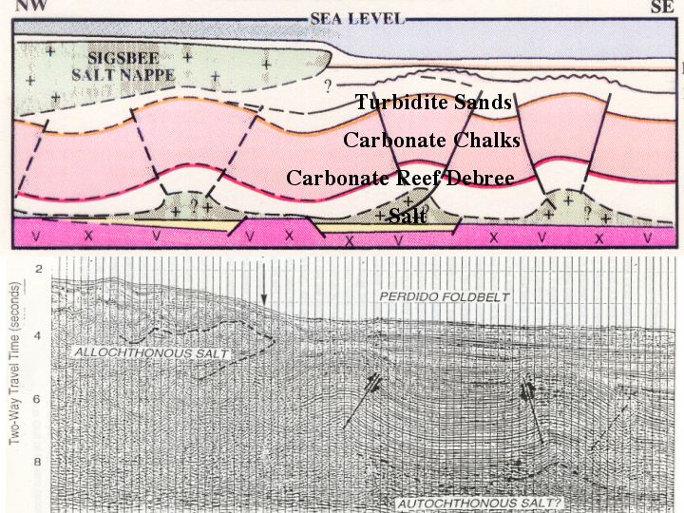

A large number of new American jobs would result from a successful completion of our proposed project, just as other deepwater projects have created jobs. For example, the engineering, fabrication, and deployment of the deepwater Auger Tension Leg Platform alone employed over 900 separate vendors in 33 states, and the work centered in the Gulf Coast region and along the U.S. industrial and high-tech corridors. If one were to include subcontractors utilized by Auger’s direct vendors both the number of vendors and states would dramatically increase.

As nearshore Gulf of Mexico operations wind down, deepwater projects will become increasingly important to the maintenance of a healthy and viable domestic energy industry. A recent DRI study concluded that jobs created as a result of full exploration and development of the deepwater potential would reach a peak of between 80,000 and 100,000 by the late 1990’s. Between 50,000 and 70,000 of these jobs would be sustained well into the next century. Furthermore, the study verified the economic activity created by full deepwater development would result in a net reduction in the federal deficit of 10 billion dollars a year by the year 2000, for a total reduction of $200 billion by 2017.

THE OPPORTUNITY

Enormous quantities of domestic gas and oil exist in reservoirs in the shallow waters (<1,500 feet) of the Gulf of New Mexico. However, the major realm for future exploration is in the deepwater (1,500-4,000 feet), and what we call the ultra-deepwater (4,000 to >10,000 feet). The current production capabilities and technologies of U.S. oil companies are confined to reservoirs in water depths of less than 4,000 feet, and exploration efforts are focused on those depths, as well.

Our nation needs the answers to the questions posed by this White Paper quickly, in order to assure proper policy planning for Congress and Agencies over the next 20 years. Current industry estimates of offshore gas and oil in deep and ultra-deepwater range upwards to 20 billion barrels crude oil equivalents. No other Program of the federal government addresses such large potential hydrocarbon reserve volumes. In order to give a vision of projects that might be cost-shared with industry under this national Initiative, we describe below the hydrocarbon prospectivity of the deep and ultra-deepwater GOM, and describe exemplary technologies that must be invented to make exploration of this province a reality. In addition, we are submitting an accompanying unsolicited proposal for a “Flagship” project within this national Initiative that would drill a rank wildcat well in potentially world-record water depths in the ultra-deepwater GOM. The mission is to launch the national Initiative with a project that will immediately test the prospectivity of the massive structures at the foot of the salt canopy, and then extend the exploration beneath the adjoining salt sheet.

PROSPECTIVITY OF THE DEEPWATER GOM

Well data from more than 165 rank wildcat wells, 110 appraisal and field wells, 17 discoveries totaling 3.2 billion barrels of oil equivalents (BBOE), and 1,000 proprietary seismic crew months already portray the deepwater Gulf of Mexico as a significant oil and gas province of world class magnitude (see appendix). Salt is the dominant structural element of the deepwater GOM petroleum system. Horizontal velocities of salt movement are in the cm+/year range, making this supposedly passive margin as tectonically active as most plate boundaries of the world. The present day sea floor of the continental slope is pockmarked by intraslope basins and dissected by canyons and faults as a product of this salt “extrusion” to the south in response to the sediment load from the Mississippi River delta.

Hydrocarbon Source and Charge

Hydrocarbon source rocks are rich and widespread in the Gulf of Mexico. Thermal maturity modeling demonstrates that source rocks have entered the oil window throughout most of the deep and ultra-deepwater province. Expelled hydrocarbons migrate along vertical entry points at salt flanks and regional faults until permeable reservoir sands are encountered. Hydrocarbons are trapped in a variety of structural and stratigraphic settings that include: Salt flank (Bullwinkle), salt /fault (Auger), fault (Vancouver), salt thrust (Jolliet), stratigraphic (Ram-Powell), and combination salt/fault/stratigraphic (Mars). The hydrocarbon mix is fairly even between oil and gas. Much of the free gas discovered in the deepwater to date is bacterial methane, though large thermal gas accumulations have been tested in the Viosca Knoll area. In contrast to shelf crudes, most deepwater oils are moderately sour (0.5-2.0 wt. % sulfur). API gravity ranges from 15 to 60 API, with most crudes falling between 25 and 35 API. In contrast, ultra-deepwater oils recovered at seafloor seeps are similar to the sweet, low sulfur, high gravity oils more typical of the shelf.

Natural hydrocarbon seeps and mud volcanoes at the sea floor attest to present day migration of hydrocarbons and fluids along faults throughout the deepwater. More than 180 seafloor seeps from across the western Gulf of Mexico slope have been reported. Hydrocarbon seeps are not restricted to the present day. The world’s first Pliocene paleoseep was discovered in a drillhole in Auger field.

Deepwater Reservoir Rocks

The Mississippi, Rio Grande, and other rivers to the east and west have supplied vast quantities of sand to the deepwater GOM. The sediment has been trapped in salt bounded, intraslope basins and transported to unconfined settings downdip. Gravels have been discovered not only in cores taken from the Mississippi Fan in Leg 96 of the DSDP but also from Miocene rocks at a depth of more than 17,000 feet in Mississippi Canyon, more than 100 miles downdip from the time-equivalent shelf margin. More than 440 net feet of Miocene and Pliocene oil bearing sands in 14 stacked pay horizons in the Mars basin (Mississippi Canyon 807) amply support a model for voluminous sand supply to the deepwater and the capability of turbidity currents transport sands great distances.

Porosities over 30 percent and permeabilities greater than one darcy in deepwater turbidite reservoirs have been commonly cited. Compaction and diagenesis of deepwater reservoir sands are minimal because of relatively recent and rapid sedimentation. Sands at almost 20,000 feet in the Auger field (Garden Banks 426) still retain a porosity of 26% and a permeability of almost 350 md. Pliocene and Pleistocene turbidite sands in the Green Canyon 205 field have reported porosities ranging from 28 to 32% with permeabilities between 400 md and 3 darcies.

The high production potential of deepwater reservoirs is documented by recent results at the Auger field. Flow rates at Auger from turbidite sands have been reported as high as 13,000 barrels of oil per day, far surpassing the previous Gulf of Mexico record of 9,100 barrels of oil per day. Extended production tests reported to date are very encouraging even in thin-bedded turbidite sands. Flow rates from cm thick beds in the Tahoe field (Viosca knoll 783) located in 1,500 feet of water were 29 MMCF/D and 974 BBLS condensate/day. Nine wells from thicker Pliocene turbidite sands at Bullwinkle Field (Green Canyon 65) have consistently produced more than 4,000 BOPD and flow rates greater than 3,000 BOPD were reported in Jolliet field (Green Canyon 184). Connectivity in sheet and channel sands is predicted to be high for deepwater turbidite reservoirs and recovery efficiencies are predicted to be in the 40-60% range.

PROSPECTIVITY OF THE ULTRA-
DEEPWATER GOM

The ultra-deepwater province of the Gulf of Mexico is believed to be as prospective as the deepwater province. Turbidite reservoirs like those currently producing in the deepwater are believed to exist in the ultra-deepwater. In addition, carbonate reservoirs, similar in age to the prolific carbonates in many Mexican fields are within reach of the drillbit in the ultra-deepwater. Large compressional structures with both turbidites and carbonate objectives have been mapped in the Perdido Foldbelt region of the ultra-deepwater and this foldbelt is believed to continue under the Sigsbee salt nappe. These observations raise many questions:

Where, in the ultra-deepwater GOM are the most prospective carbonate and turbidite reservoirs? Are the carbonate sequences observed on seismic in the Perdido Foldbelt province analogous to the highly prolific carbonate reservoirs in Mexican Golden Lane fields? Do similar structures extend beneath the salt canopy? Most importantly, do large accumulations of gas and oil reside in the subsurface below the ultra-deepwater of the GOM? And if so, are these reservoirs adequate in size, configuration, and quality to warrant the multi-billion dollar outlays necessary for field development?

Overview of BAHA Exploration Project

The Perdido Foldbelt is located in the southern half of the Alaminos Canyon protraction area in the ultra-deepwater of offshore Texas. Water depths range from 7,200’ to >10,000’ feet, and these extreme water depths pose a major technical challenge to the evaluation of the hydrocarbon potential of this province, to say nothing of our capabilities of producing hydrocarbons once a discovery is made. The Perdido compressional belt is defined by a series of large, sub-parallel northeast-southwest trending box folds that extend south into Mexican waters and north beneath the salt canopy, where they can no longer be imaged with existing seismic technologies. The geometry of the Perdido Foldbelt is typical of compressional folds formed above a weak detachment layer that is believed to be the Jurassic Louann salt. Fold amplitude and structural elevation decrease basinward, suggesting an absence of salt in the southern portion of the play area. Perdido Foldbelt formation is believed to have been caused by gravity sliding in Middle Oligocene to Lower Miocene time, and this timing is constrained by correlation to Deep Sea Drilling Program (DSDP) cores #90 and #91. Objectives in the Perdido Foldbelt play include Oligocene Frio-equivalent turbidites, Paleocene Wilcox-equivalent turbidites, Upper Cretaceous chalks (possibly fractured) and middle to lower Cretaceous carbonates, which may be analogous to the prolific fore-reef debris reservoirs like the Tamabra of the Poza Rica field in Mexico’s Golden Lane.

Expected charge in the Perdido Foldbelt is light, sweet oil. Seafloor oil seeps are present over many of the Perdido structures and a chemosynthetic community has been recorded on the south flank of one of the largest opportunities in the trend. Geochemical analyses of seafloor oil seeps in the Perdido Foldbelt area indicate that the crude quality is better than oil from seeps located on the upper slope to the east. Oil analyzed from active

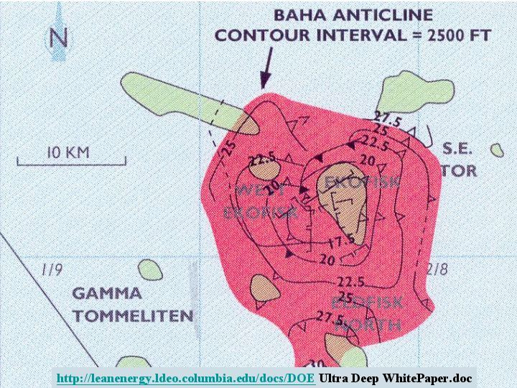

surface seeps in the Perdido Foldbelt area is low in sulfur and metals. Thermal maturity modeling conducted in the Perdido region indicates that the mid-Cretaceous is currently in the oil window and that most of the Perdido folds were in place at the time of maximum oil expulsion.

Prospects in the frontier Perdido Foldbelt play present a tremendous opportunity because of their sizes. Several multi-billion barrel (undiscounted) prospects have been identified, and other prospects are believed to extend under the salt canopy. One prospect in the play covers a 10 OCS block area (+57,000 acres) and over 14,000 feet of stratigraphic section for this prospect is within structural closure, more than ten times greater than at Ekofisk, the largest and most prolific of the North Sea fields in Europe. However, none of the Perdido Foldbelt objectives has yet been penetrated in the deepwater Western Gulf of Mexico and as a consequence, reservoir and seal are the key risks for the play. Only by drilling wildcat wells, and extending the well results into regional analyses using geophysical techniques will the prospectivity of the ultra-deepwater GOM be established.

EXEMPLARY EXPLORATION TECHNOLOGIES

Exploration and subsequent development of deep and ultra-deepwater fields will require new technologies such as dual-use military gravity gradiometry, cost efficient well evaluation/appraisal technologies, and research into gas and oil field production technologies required to bring such discoveries to full development. It is critically important that a mechanism be set up to facilitate government involvement in collaborative efforts with industry and academia for the invention and development of these new technologies. Challenges to the capabilities of existing technologies come from the excessive water depths, the obscuring salt canopy, and the new geology represented by the deep carbonates that might be highly fractured and significantly geopressured. In addition, meaningful government participation would assure information and technology transfer that would benefit the nation’s industrial base as a whole. Below, we describe exemplary technologies required to explore beneath the salt canopy and in the ultra-deepwater GOM.

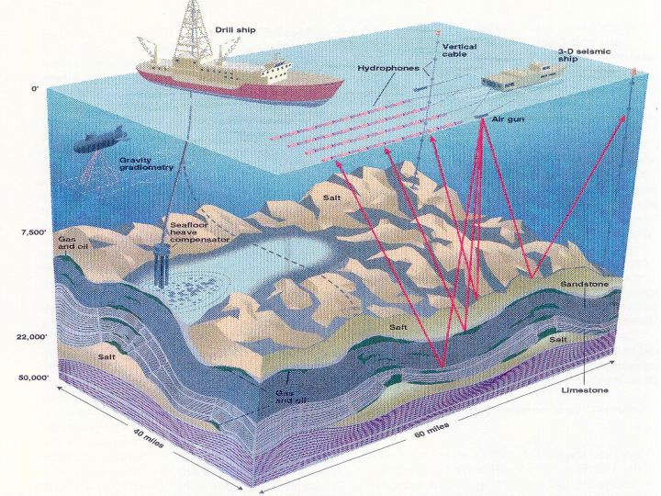

Dual-Use Military Technology: Gravity Gradiometry

A unique focus of this White Paper is to utilize technologies developed within the defense efforts of the United States over the last decade, and apply these to domestic gas and oil industry needs. Gravity gradiometry developed by Bell Aerospace for the U.S. Navy is a specific example of a dual-use exploration technology which, if we can develop its application to sub-salt imaging, may significantly improve the current approaches to gas and oil exploration under salt.

• Gravity Gradiometry measures full gravity tensor (5 independent components- the rate of change in gravity in different directions is measured). Gravimetry technology currently employed by the oil industry only measures the down (vector) component of the total field.

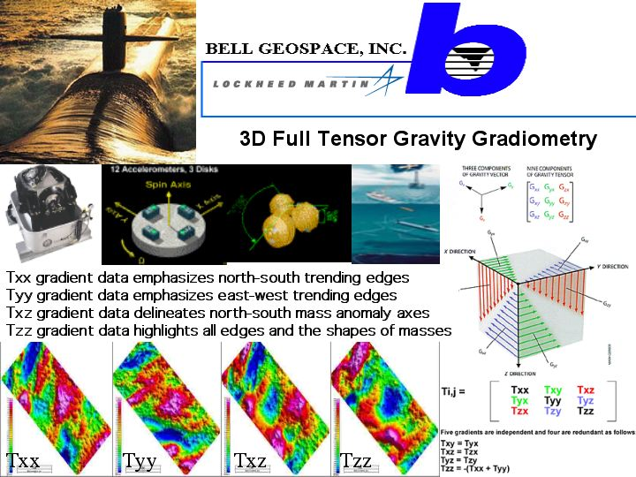

• Order of magnitude increased vertical gravity resolution is expected over existing technology.

• Gravity Gradiometry technology should be very useful for determining salt geometries, including edge detection and base-of-salt image enhancement.

Measurement-, Logging- and Seismic-While-Drilling

New technologies must be developed for detection at and beneath the drillbit of geopressures, lithologies, physical properties and fluid compositions.

• National Lab and Service Company Expertise will be utilized to further develop MWD, LWD, and SWD technologies. It is particularly important to calibrate well results to regional and 3-D seismic data sets.

Vertical Cable 3-D Seismic Surveys

Because of the extreme water depths and ruggedness of the top-of-salt surface, imaging beneath the salt canopy in the ultra-deepwater GOM requires the development of new seismic technologies such as vertical cable seismic surveying.

• Vertical cable deployment allows the acquisition of true 3-D field records (cable remains stationary), as well as true 3-D pre-stack depth migration processing. Seismic data so acquired exhibits good signal to noise ratio (no surface noise or cable feather problems).

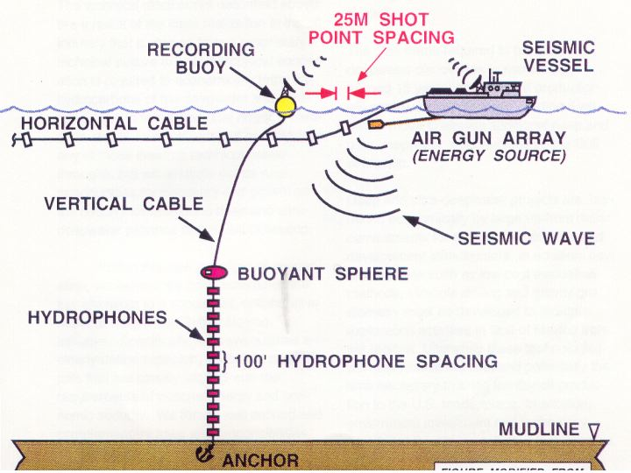

• Vertical cable technologies allow the acquisition of long offset data, and costs are 1/3 less than conventional 3-D surveys (surface vessel only deploys airguns).

Slimhole Drilling and Evaluation Technologies

The major expense in deep and ultra-deepwater exploration is the drilling of the wells themselves. Fully 50% of all costs are drilling related. New technologies such as slimhole drilling, logging and testing, are required to cut these costs.

• Slimhole Drilling Technology combines conventional oil-field drilling technology with mining exploration diamond drilling techniques. This technology has not been used to date in the deepwater exploration arena.
•Slimhole technologies must be applied to appraisal and development wells, allowing for significant drilling cost savings.
• New logging and testing tools capable of operating in 5-inch diameter boreholes and smaller must be developed.

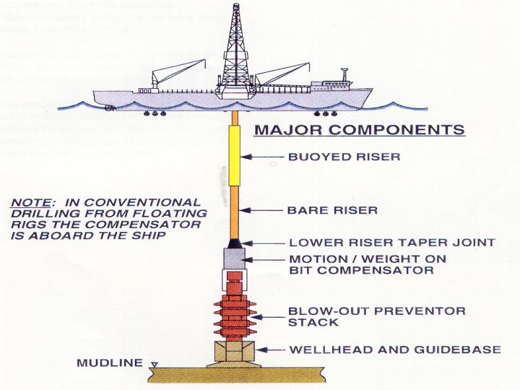

SYNERGY AND COOPERATION:
A NEW PARADIGM

The technical disclosures described above are a result of the clear realization in the oil industry that a change from a proprietary technical culture to one of technical cooperation is required to economically bring the hydrocarbons of the deepwater and ultra-deepwater to the nation. The ongoing paradigm shift is as significant and as difficult as any of those creating technical breakthroughs, but will similarly create new opportunities for discovery and growth as the nation moves into the deep and ultra-deepwater province of the Gulf of Mexico.

Within this new paradigm of cooperation, we believe we have assembled the key elements to a successful, collaborative national Deepwater Gulf of Mexico Initiative. Specifically, we have outlined a clearly defined mission, goals and principals that are closely aligned with the requirements of national energy and economic security.
We foresee well defined and complementary roles and responsibilities for the industry, academia and national labs. Our objectives are achievable and measurable within a time frame that can critically improve the near and far-term outlooks for energy and economic security for the nation. We are committed to minimal redundancy and red tape, open communication among the participants, and rapid technology transfer to the industry as a whole.

The deepwater and ultra-deepwater GOM represents one of the most significant untapped oil exploration opportunities in the world. A synergistic team consisting of industry, academia and government labs must be formed to assess the development potential of this province. This collaborative team must invent new technologies in an attempt to better understand the petroleum system, and to get the discovered hydrocarbons to market.

The time frame required to bring deepwater discoveries to market may exceed 15 years, and U. S. oil production will continue to significantly decline if we do not move to assess additional deep and ultra-deepwater opportunities in the Gulf of Mexico.

Deep and ultra-deepwater projects are burdened economically by large up-front dollar commitments for exploration activities and development infrastructure. In addition, new technologies such as low cost evaluation methods, slimhole drilling and gravity gradiometry must be developed to facilitate exploration activities in Gulf of Mexico frontier regions. Ultimately these technologies will help reduce the cost and potentially the time necessary to bring frontier oil production to the U.S. marketplace. In addition, government investment and technology transfer of the aforementioned technologies will help the United States gain the technical edge in the highly competitive international fields of deepwater hydrocarbon exploration and drilling technology. As many as 100,000 new, high paying American jobs would result from the implementation of this recommended national Deepwater Gulf of Mexico Initiative. Deep and ultra-deepwater exploration and development would demonstrably reduce the federal deficit, while at the same time increasing the energy and economic security of the nation.

INFORMATION:

This White Paper was produced by:

Applied Earth Sciences Institute
Lamont-Doherty Earth Observatory
Columbia University in the City of New York
Palisades, New York 10964

For information, call Roger N. Anderson at (845) 365-8335

The DRI report can be obtained from McGraw-Hill and is entitled “National Economic Impact of an Oil/Gas Production Tax Credit to Facilitate Deepwater Exploration and Development” and was published on June 24, 1993.


