Snapshot Day 10/12/06 Data
(Salt Front RM 52.5)
RIVER MILE 14
Inwood Hill Park
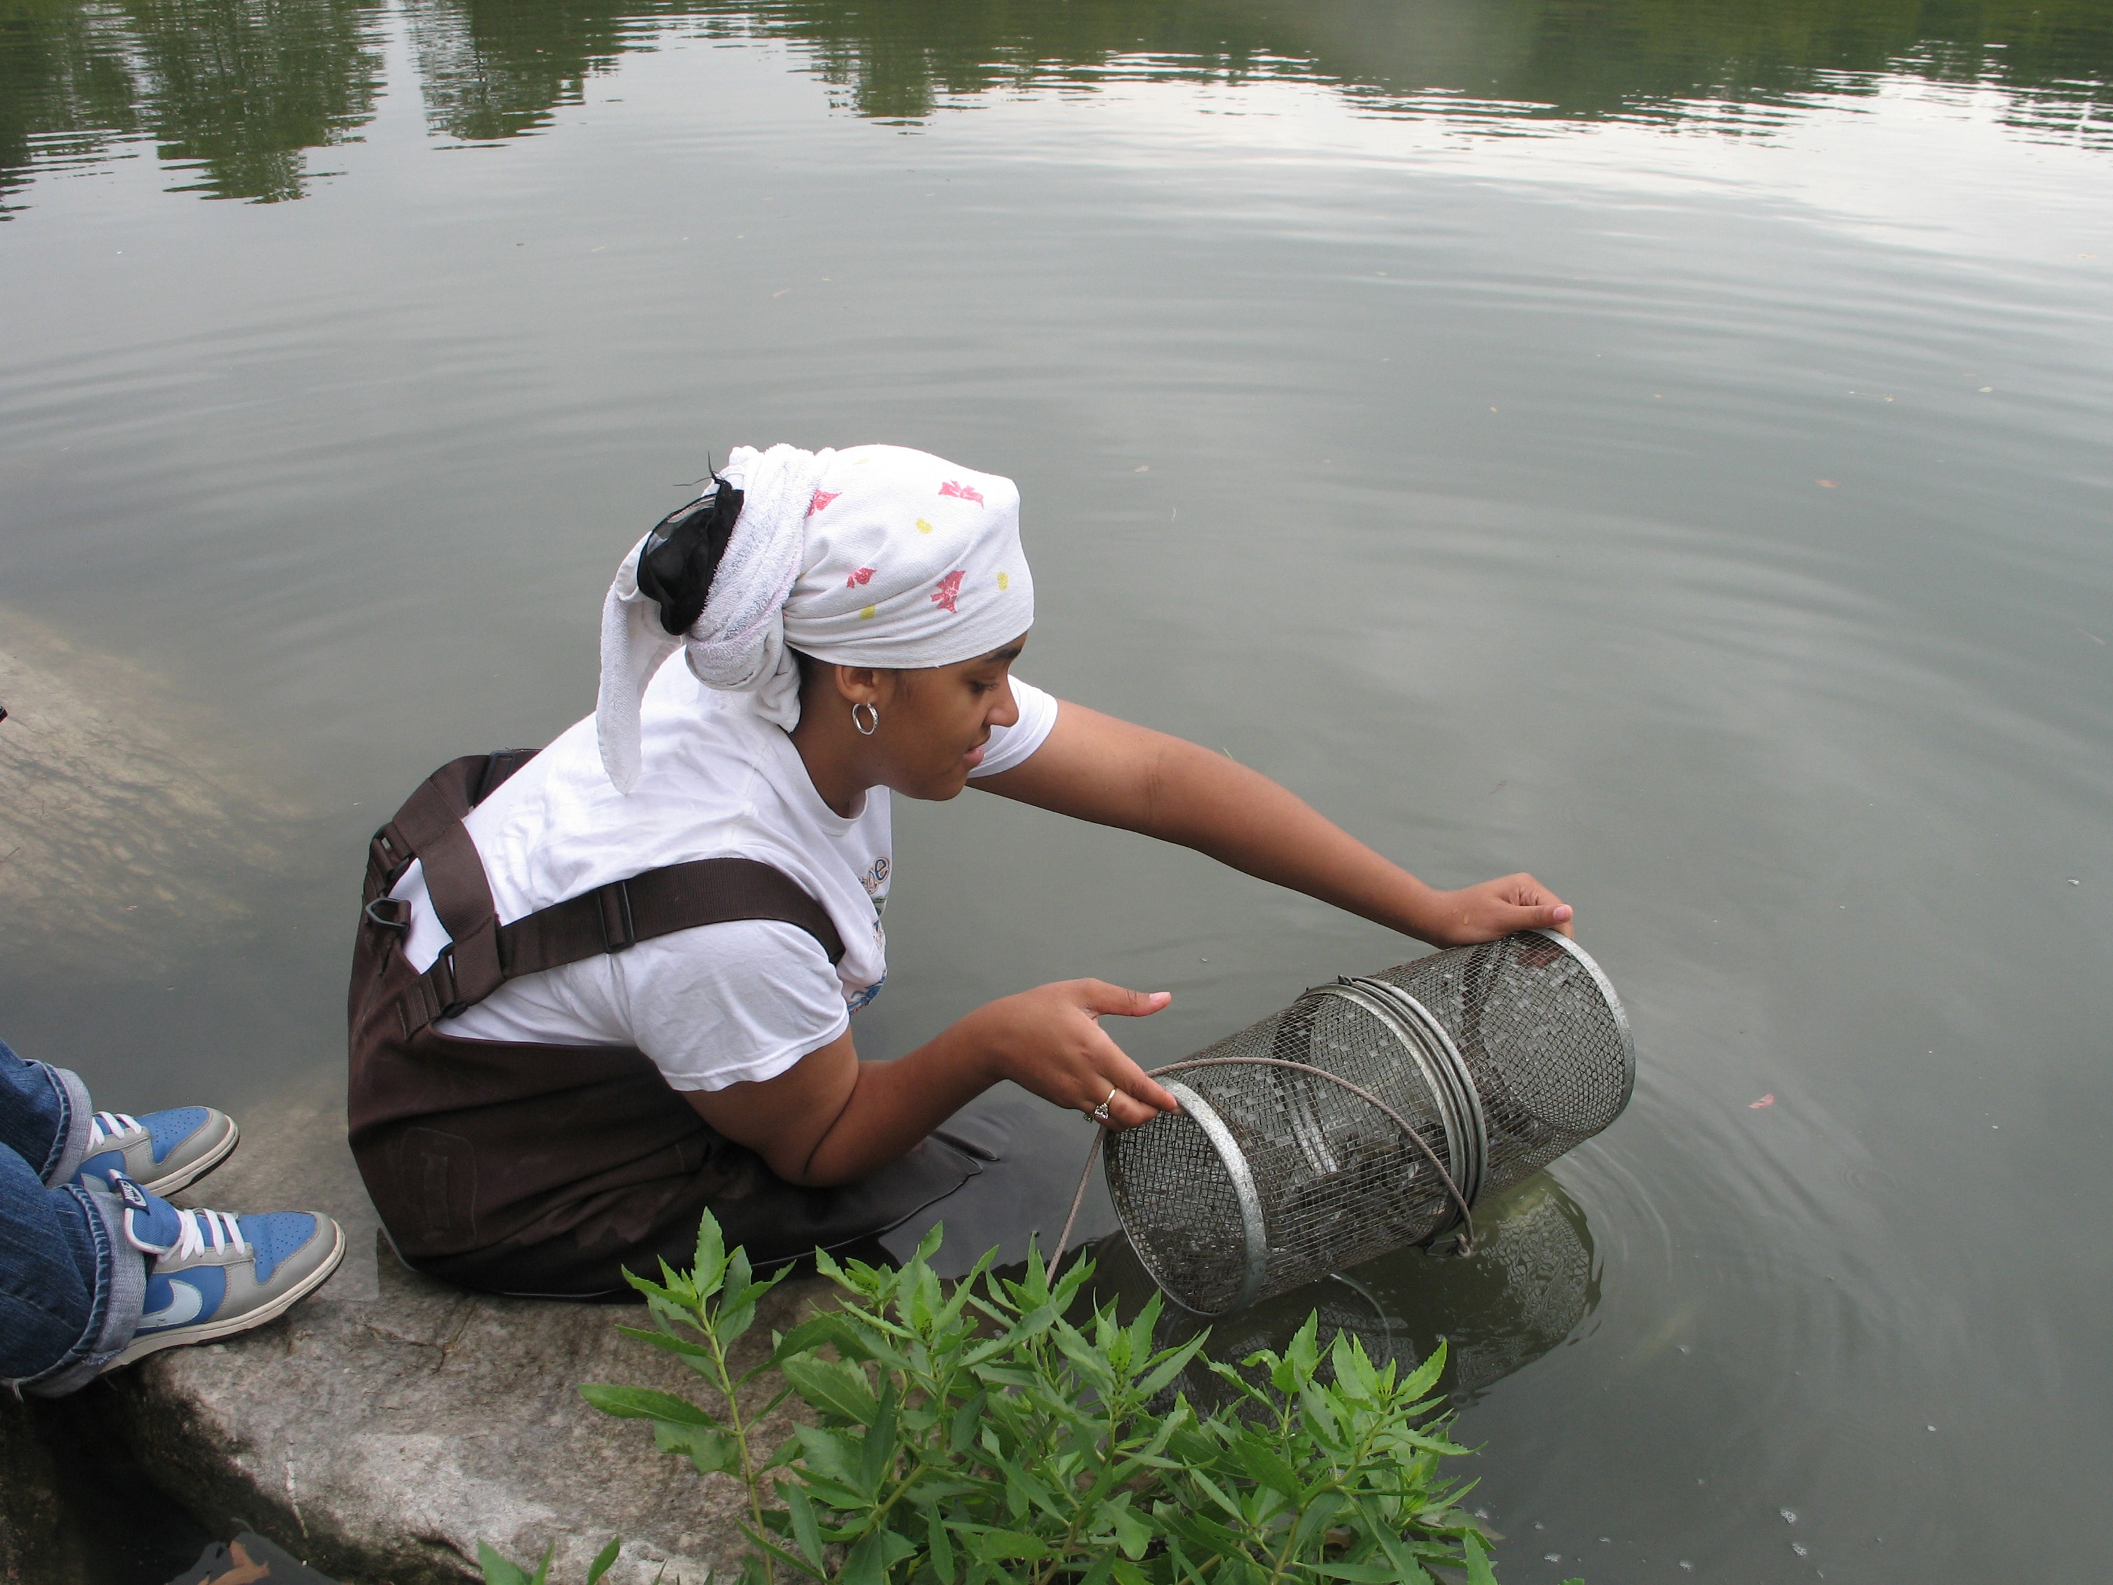
Latitude 40°50’N/ Longitude 73°55’W
New York City Park Rangers
Susan Vincent and the Young Women’s Leadership School – 12th grade
Location: In the cove of Inwood Hill Park
Area: Forested
Surrounding Land Use: Forested 80%, Urban residential 10%, Industrial Commercial 5%, Other 5% . Forested and used by people for picnics, park use, walking dogs, kids playing soccer. It’s like a public park.
Sampling Site: It is a salt marsh. Under 5 ft. the bottom is muddy, area covered with vegetation, banks altered, large riprap on shoreline, collected wood/debris in area
Plants in area: The plants are growing in and on the water. They cover less than half the area. Kate the ranger says the vegetation doesn’t grow here naturally. All the plants at the park sampling area are exotic.
Water depth: 5 feet where seining; 3 feet where minnow pots deployed
River Bottom – muddy

ITEM | Time |  | Reading 1 | Reading 2 | Comments
Physical
Air Temperature | 6:00 AM |  | 20°C  65 °F | 3:00 PM | 27°C  71 °F
Wind Speed | 2 knots |  | East
Cloud Cover | Partly cloudy
Weather today | No rain but drizzly and cloudy, cooler
Weather recently | Mon & Tues hot and sunny, yesterday (Wed) rain, wind and cold
Water Temperature | 11:32 AM | 66.38°F  19.1 °C |  |  | YSI meter
 | 11:38 AM | 66.38°F  19.1 °C
 | 11:59 AM | 68.54°F  20.3 °C
Turbidity  (Site tube)_ | 12:06 PM | 53.2 inches/  135.13 cm |  | 55 inches/  139.7 cm | 56.4 inches/  143.26 cm
Chlorophyll | 11:42 | Didn’t match |  | Filtered120cc
Sediment Core description | Clay abundant | Mud common |  | Wood common | Macro’s rare
 | Roots in core | 6 inches long |  | No real layers – just patches of dark | Surprised to see no odor – not organic decomposition
Chemical
DO  (drop count kit) | 11:38 AM | 9.5 mg/L |  | Temp.20.3° C | 94% saturated
pH | 1:02 PM | 7.8 |  | 8.0 | Indicator sol.
Phosphate
Nitrate |  | 10 ppm and below
Alkalinity
Salinity | 11:32 AM | 11:04 |  | 9.8 ppt | YSI meter
 |  |  |  | 10 ppt
 |  |  |  | 10 ppt
Fish Catch | Number Caught | Species |  | CPUE | Seine & Minnow traps
Used seine 20 ft. X 30 ft. & minnow traps | 1 | Atlantic Silversides |  |  | Seine 1 caught 1 fish
Seined | 2  1 | Comb jellies  White perch |  |  | Seine 2 caught 1 fish, 2 comb jellies
Minnow traps & entry to cove | 0
Minnow trap by the dock | 227 | mummichogs |  |  | 365 total mummichogs
Minnow trap in front of Nature Center | 138 | mummichogs
Tides | 11:34 AM | 5 cm |  | Flood/rising
 | 11:49 AM | 20 cm |  | Flood/rising
 | 12:04 PM | 35 cm |  | Flood/rising
 | 12:19 PM | 30 cm* |  | Flood/rising | * Possibly a wave influenced this reading
 | 12:34 PM | 33 cm |  | Flood/rising
 | 12:49 PM | 39 cm |  | Flood/rising
 | 1:04 PM | 43 cm |  | Flood/rising
 | 1:19 PM | 48 cm |  | Flood/rising
 | 1:34 PM | 53 cm |  | Flood/rising
Currents | 40 cm/ 60 secs | .666 cm/sec |  | North/flood | 0.8 knots
 | 120 cm/60 secs | 2 cm/sec |  | North/flood | 2.4 knots
 | 160 cm/60 sec | 2.6 cm/sec |  | North/flood | 3.2 knots
 | 183 cm/60 sec | 3.05 cm/sec |  | North/flood | 3.66 knots
 | 190 cm/60 sec | 3.16 cm/sec |  | North/flood | 3.8 knots
Nature Center is located on a peninsula where the Harlem River meets the Hudson River. Currents can move very swiftly in this area.
Traffic | 12:23 PM | Circle Line Boat |  | Northbound | Loaded with passengers
Other observations | Lots of ducks and geese around.  Train Station nearby (Metro North) with train passing every hr.  Lots of grass and plants still out even with weather starting to change.  Little fish seen around rocks hiding or looking for food.

