Snapshot Day 10/12/06 Data
(Salt Front RM 52.5)
RIVER MILE 18
Cynthia Fowx, Jen Mokkos & Vicki Garufi, Beczak Environmental Education Center
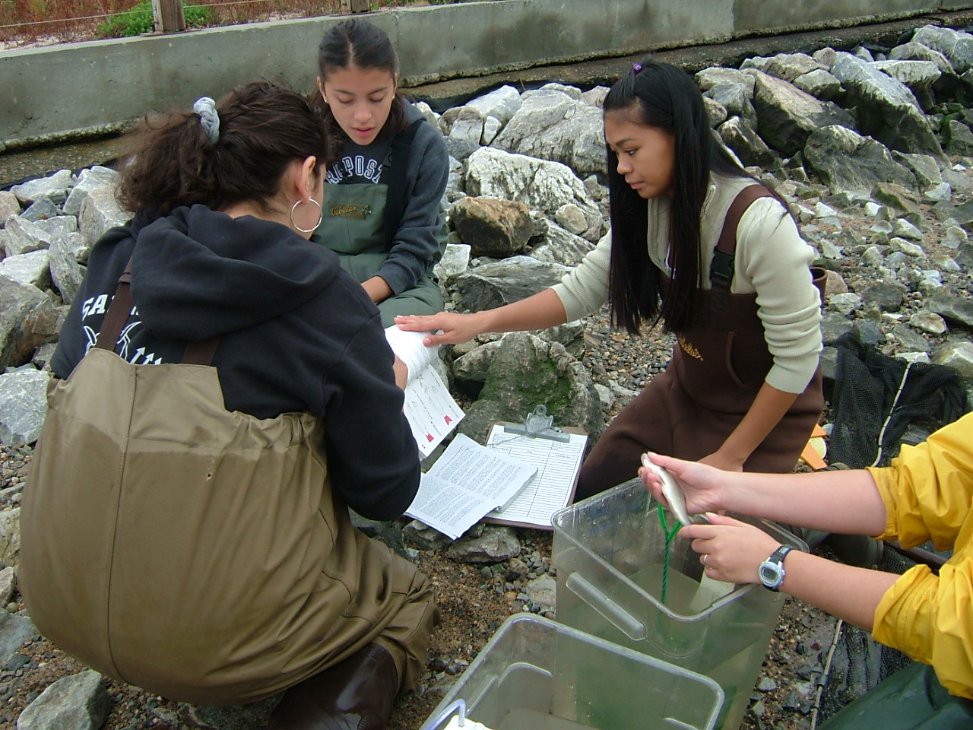
Harry Hall - Saunders Trade & Technical High School
(12 students) 10th and 11th grade
Location: Seining beach, Beczak Center, Yonkers in Westchester County
Area: Used for FISHING, picnics, boats, seining and education programs
Surrounding Land Use: Urban/residential 50%, Forested 1%, Beach 20%, industrial/commercial 10%; other 19% (• note - difference in last year descrition of site due to change in area assessed for the surrounding land use – not in the area itself.)
Sampling Site: beach, marsh area covered with vegetation, sandy area, banks altered, large riprap on shoreline, collected wood/debris in area –
Plants in area: no plants in the water
Water depth: 12 inches
River Bottom – muddy, rocky

ITEM | Time |  | Reading 1 | Reading 2 | Comments
Physical
Air Temperature | 10:12 AM |  | 26°C  78°F |  | °C  °F
Wind Speed | 11-16 knots |  |  |  | Water little choppy
Cloud Cover | Mostly cloudy
Weather today | overcast – no rain
Weather recently | Rainy and cool
Water Temperature | 9:30 AM | 18.8°C  65.8°F |  | 18.6°C  65.5°F | 18.2°C  64.8°F
•note this brief drop in temperature – cold current? | 10:00 AM | 14.6°C  58.3°F |  | 14.6°C  58.3°F | 14.7°C  58.5°F
 | 10:30 AM | 18.3°C  64.9°F |  | 18.3°C  64.9°F | 18.2°C  64.8°F
 | 11:00 AM | 18.0°C  64.4°F |  | 18.3°C  64.9°F | 18.3°C  64.9°F
Turbidity | 9:43 AM | 60 JTU |  | 60 JTU | 80 JTU
Chlorophyll | 10:12 AM | 0.3
Chemical
DO  (drop count kit) | 9:50 AM | 18°C |  | 7.16 mg/L | 74.1% saturated
pH | 9:21 AM | 7 |  | 6 | 7
Phosphate | 10:40 Am | 0 |  | 1 mg/L | 1 mg/L
Nitrate | 10:09 | 1 mg/L |  | 1 mg/L | 1 mg/L
Alkalinity | 10:58 | 0 |  | 0 | 0
Salinity | 9:40 AM | 7.3 ppt |  | 7.3 ppt | 7.3 ppt
Fish Catch | Number Caught | Species |  | CPUE | Seine
Seine net 30 feet , 1.4 inch mesh | none |  |  |  | Seine 1  9:28 AM (40’pull)
 | 2 | Atlantic Silverside |  | 182.85 | Seine 2  9:33 AM (40’ pull)
 | 2 | White perch |  | 182.85 | Seine 3  9:43 AM (40’ pull)
 | 1 | Comb jellies
 | 3  1  1 | Atlantic Silversides  Striped Bass  White Perch |  |  | Balance of seines
Tides | 9:56
 | 10:16 | 21 cm |  | rising | *Differences in measures duing rising tide can be due to wave action
 | 10:21 | 30 cm |  | rising
 | 10:51 | 20.5 cm |  | rising
 | 11:09 | 32 cm |  | rising
 | 11:28 | 32 cm |  | rising
Currents
 | 1800 cm/60 secs. | 30 cm/sec |  | .6 knots | North/Flood
 | 1560 cm/60 secs. | 26 cm/sec |  | .52 knots | North/Flood
 | 1116 cm/60 secs | 18.6 cm/sec |  | .37 knots | North/flood
Traffic | Sailboats | southbound
 | Several barges & cargo ships | No times noted
Other Items | 9 seagulls

