Snapshot Day 10/12/06 Data
(Salt Front RM 52.5)
RIVER MILE 28
Nyack Memorial Park
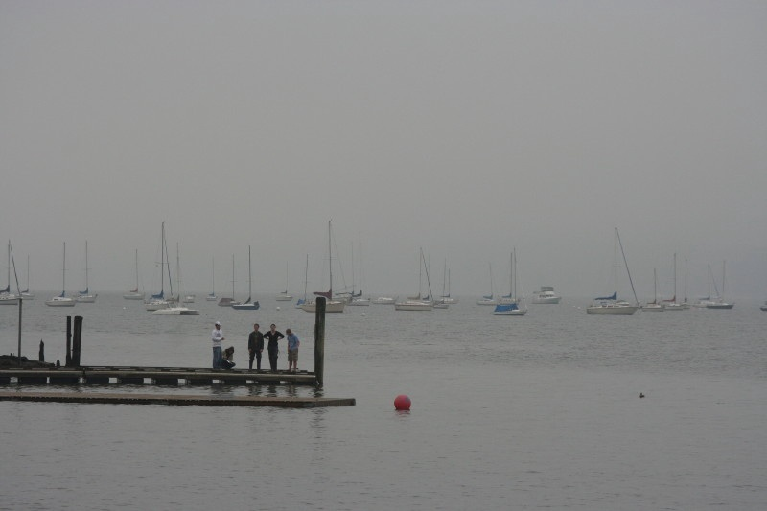 | 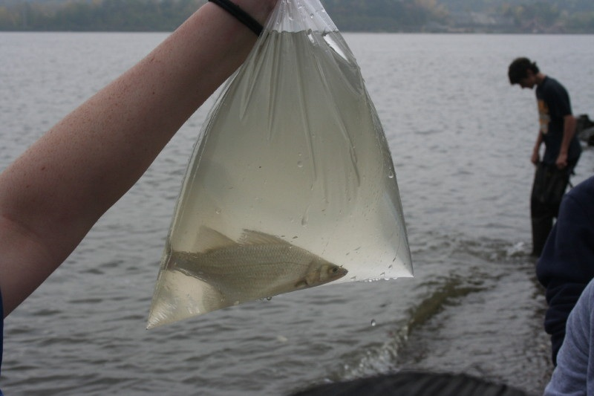

Tom Perry Nyack High School APES Class
Latitude 40°05.243’N, Longitude 73°54.988 ‘W
Location: Nyack Park where Nyack Brook feeds in
Area: Open and grassy, has a parking lot, used for picnics, fishing
Surrounding Land Use: 100% park
Sampling Site: beach, banks altered, riprap on shoreline, bulkhead
Plants in area: no water plants in area
Water depth: varied
River Bottom – sandy/muddy bottom , water calm
ITEM | Time |  | Reading 1 | Reading 2 | Comments
Physical
Air Temperature | 9:30 AM |  | 18°C  °F
Wind Speed | 1 knot |  | South | Light breeze
Cloud Cover | overcast
Weather today | drizzle
Weather recently | Heavy rain last night
Water Temperature | 9:30 AM | 18.2°C ramp |  | 16.4 °C top | 17.9 °C bottom
Turbidity | 9:30 AM | 30.25 cm |  | Old pier | secchi
 |  | 50.0 cm |  | Boat launching ramp
Chlorophyll | 9:30 AM | 0.5
Chemical
DO | 9:30 AM | 6.8 mg/L |  | 18.2°C | 70%
pH | 9:30 AM | 7.0 |  | pH paper
Phosphate | 9:30 Am | <1.0 mg/L ramp |  | <1.0 mg/L top | <1.0 mg/L bottom
Nitrate | 9:30 AM | 0.15 mg/L (ramp) |  | 0.04 mg/L  (top) | 0.02 mg/L  (bottom)
Alkalinity
Salinity (meter) | 9:30 AM | 3.6 ppt ramp |  | 0.4 ppt top | 1.6 ppt bottom
Fish Catch  @ mouth of Nyack Brook & Hudson River | Number Caught | Species |  | CPUE | Seine
 | 21 | Atlantic Silversides |  | Menidia menidia
 | 1 | Banded Killifish |  | Fundulus diaphanus
Other Catch |  | Glass Shrimp
Tides | 9:30 AM | 20 cm depth
 | 10:00 AM | 29 cm |  | rising
 | 10:30 AM | 50 cm |  | rising
 | 11:00 Am | 65 cn |  | rising
Currents
Sediment Cores  Pier description | 14 cm core | 7 cm Top layer  Light & liquidy |  | 1 cm Second layer  dark brown and sandy | 5.5 cm 3rd layer  most carbonated, black
Mud description | Very carbonated, dark, decomposing, liquidy. Came out easily
Sand Description | Very compact, rocky, big chunks of gravel, difficult to get out, many air bubbles
Other Items  STRATIFICATION STUDY | Did a transect study from Nyack Brook out to the Hudson River. Found a stratification in the “Zone of Mixing” – an estuary within an estuary.  Found colder fresher water moving toward the river on the surface (See results above), with warmer saltier water pushing in along the bottom.  HEADING EAST FROM THE BROOK OVER TOP  16.6 °C and 16.8 °C temp.  0.5 ppt and 0.5 ppt salinity  HEADING WEST FROM THE HUDSON BELOW  17.9 °C and 17.2 °C temp.  2.1 ppt and 2.2 ppt salinity
TRANSECT STUDY  NYACK BROOK OUT TO HUDSON RIVER measured every 10 meters | Distance | Salinity |  | Temp °C | DO mg/L
 | 0 | 0.4 |  | 16.4 | 8.25
 | 10 | 0.4 |  | 16.4 | 7.9
 | 20 | 0.5 |  | 16.4 | 7.1
 | 30 | 0.5 |  | 16.4 | 6.8
 | 40 | 0.5 |  | 16.4 | 6.8
 | 50 | 0.5 |  | 16.4 | 7.15
 | 60 | 0.5 |  | 16.5 | 7.7
 | 70 | 0.5 |  | 16.6 | 7.3
 | 80 | 0.6 |  | 17.1 | 7.5
 | 130 | 7.6 |  | 17.9 | 8.2
 | RAMP | 3.6 |  | 18.2 | 6.8

